# Asp core kudvenkat

* Core aplikacije pocinju kao koonzolne aplikacije iz main metode fajla program.cs

### InProcess hosting

**InProcess hosting in ASP.NET Core**  
To configure InProcess hosting, add <AspNetCoreHostingModel> element to the app's project file with a value of InProcess  
**<AspNetCoreHostingModel>InProcess</AspNetCoreHostingModel>**  
  
When we create a new ASP.NET Core project using one of the available project templates, the project defaults to the in-process hosting model for all IIS and IIS Express scenarios.  
  
In case of InProcess hosting, CreateDefaultBuilder() method calls UseIIS() method and host the app inside of the IIS worker process (w3wp.exe or iisexpress.exe).

* From a **performance standpoint**, InProcess hosting delivers significantly higher request throughput than OutOfProcess hosting
* In the case of IIS, the process name that executes the app is **w3wp** and in the case of IIS Express it is **iisexpress**
* **Iis Express je light weight verzija IIS**
* To get the process name executing the app, use System.Diagnostics.Process.GetCurrentProcess().ProcessName
* When we are run the project from Visual Studio it uses IISExpress by default.
* IIS Express is a lightweight, self-contained version of IIS, optimized for application development. We do not use it for production. In production we use IIS.
* We will discuss deploying ASP.NET Core applications on IIS in our upcoming videos.

**With out of process hosting**

* There are 2 web servers - An **internal web server** and an **external web server**. We will discuss out of process hosting in detail in our next video.
* The internal web server is **Kestrel** and the external web server can be IIS, Nginx or Apache.
* With **InProcess hosting**, there is only **one web server** i.e the IIS that hosts the asp.net core application.
* So, **we do not have the performance penalty** of proxying requests between internal and external web server.

**What is Kestrel**  
Kestrel is a cross-platform web server for ASP.NET Core. It is supported on all platforms and versions that .NET Core supports. It is included by default as internal server in ASP.NET Core. Kestrel can be used, by itself as an edge server i.e Internet-facing web server that can directly process the incoming HTTP requests from the client. In Kestrel, the process used to host the app is **dotnet.exe.**  
  
When we run a .NET Core application using the .NET Core CLI (Command-Line Interface), the application uses **Kestrel as the web server**.   
  
**The .NET Core CLI is a cross-platform tool** for developing .NET core applications. Using the CLI we can

* Create a new project, configuration file, or solution based on the specified template
* Restore the dependencies and tools required for a .net core project
* Build a project and all of its dependencies
* Run a project etc...

There are a broad range of things that we can do with the .NET Core CLI. **To run our asp.net core application using the .NET Core CLI.**

* Fire up Windows Command Prompt
* Change the directory to the folder that contains your asp.net core project and execute dotnet run command
* C:\Projects\EmployeeManagement\EmployeeManagement>**dotnet run**

After the .NET Core CLI builds and runs the project, it shows the URL using which we can access the application. In my case the application is available at http://localhost:5000   
  
In case of Kestrel, the process used to host and execute the app is **dotnet.exe**. So when we navigate to **http://localhost:5000**, we will see the process name **dotnet** displayed.

### Out of process hosting

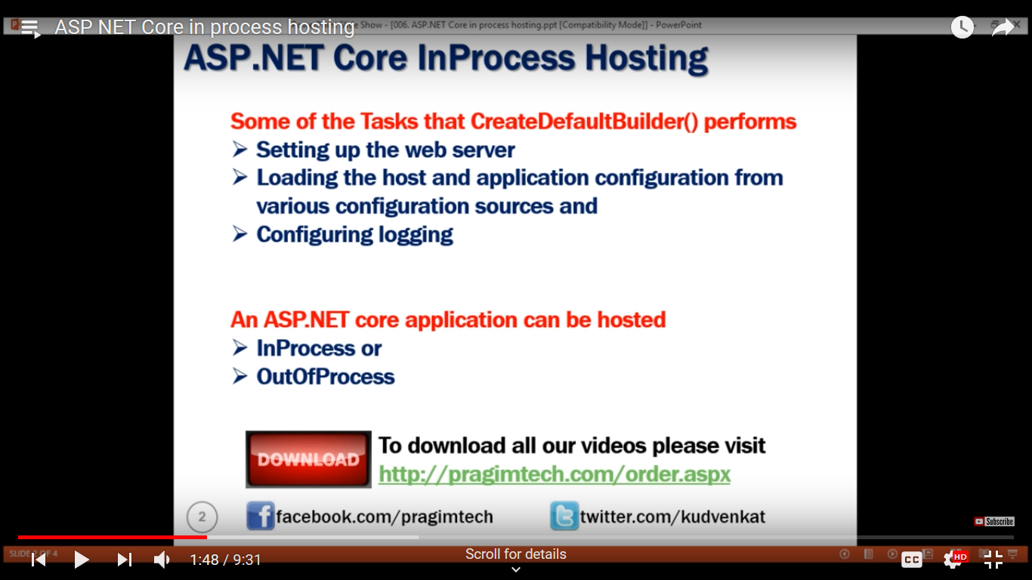  
  
There are 2 ways to configure **Out of Process hosting**   
  
**Option 1 :** Add <AspNetCoreHostingModel> element to the app's project file with a value of OutOfProcess

<AspNetCoreHostingModel>OutOfProcess</AspNetCoreHostingModel>

**Option 2 :** The default is OutOfProcess hosting. So if we remove the <AspNetCoreHostingModel> element from the project file, OutOfProcess hosting will be used by default.   
  
With **out of process hosting**

* There are 2 web servers - An an internal web server and an external web server.
* The internal web server is Kestrel and the external web server can be IIS, Nginx or Apache. We discussed Kestrel in detail in Part 6 of ASP.NET Core Tutorial.

Depending on how you are running the asp.net core application, the external web server may or may not be used.    
  
**Kestrel is a cross-platform web server** that is embedded in your ASP.NET Core application. With Out of Process Hosting model, Kestrel can be used in one of the following 2 ways.   
  
**Kestrel can be used as the internet facing web server** that process the incoming HTTP requests directly. In this model we are not using an external web server. Only Kestrel is used and it is this server that faces the internet, to directly handle the incoming HTTP requests. When we run the asp.net core application using the .NET core CLI, Kestrel is the only web server that is used to handle and process the incoming HTTP request.   
  
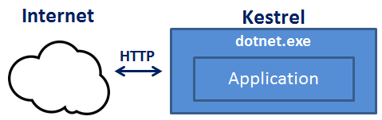  
  
**Kestrel can also be used in combination with a reverse proxy server**, such as IIS, Nginx, or Apache.   
  
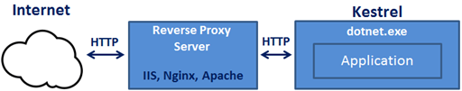  
  
**If Kestrel can be used by itself as a web server, why do we need a reverse proxy server.**  
With **Out of Process Hosting**, using a reverse proxy server is a good choice as it provides an additional layer of configuration and security. It might integrate better with the existing infrastructure. It can also be used for load balancing.    
  
So, with a reverse proxy server in place, it receives incoming HTTP requests from the network and forwards them to the Kestrel server for processing. Upon processing the request, the Kestrel server sends the response to the reverse proxy server which then ultimately sends the response to the requested client over the network.   
  
We will discuss **Deploying ASP.NET Core application to IIS** and using IIS as a reverse proxy server in our upcoming videos. When we run an asp.net core application directly from Visual Studio it uses by default IIS Express. Since we have configured our application to use Out of Process hosting, IIS Express in this case acts a reverse proxy server.   
  
**IIS Express** takes the incoming HTTP request and forwards it to Kestrel for processing. Kestrel process the request and sends the response to IIS Express. IIS Express, in turn sends that response to the browser.   
  
With **Out of Process Hosting**, whether you use a reverse proxy server or not, it is the Kestrel server that hosts the application and process the request. The reverse proxy server if used, takes the incoming HTTP request and forwards it to the Kestrel server. Similarly it takes the response from the Kestrel server and sends it to the client. So the name of the process that hosts the application is dotnet.exe.   
  
**Use the following code to get the process name**

System.Diagnostics.Process.GetCurrentProcess().ProcessName

When we run the asp.net core project using the .NET Core CLI, by default it ignores the hosting setting we specified in the csproj file. So the AspNetCoreHostingModel element value in the **csproj file** is ignored.    
  
Irrespective of the value you specified (InProcess or OutOfProcess), it always uses OutOfProcess hosting and Kestrel is the web server that hosts the application and handle the http requests.   
  
**One common question :** Can we run an asp.net core application without using the built in kestrel web server.  
The answer is YES. If we use the InProcess hosting model, the application is hosted inside of the IIS worker process (w3wp.exe or iisexpress.exe). Kestrel is not used with InProcess hosting model.

### launchsettings json file

* You will find this file in the **"Properties"** folder in the project root folder.
* The settings in this file are used when we run this ASP.NET core project either from Visual Studio or by using .NET Core CLI.
* This file is **only used on local development machine**. We do not need it for publishing our asp.net core application.
* If there are certain settings that you want your asp.net core application to use when you publish and deploy your app, store them in **appsettings.json file**. We usually store our application configuration settings in this file.
* We can also have **environment specific appsettings.json files**. For example, appsettings.Staging.json for the staging environment. In ASP.NET Core, in addition to appsettings.json file, we also have other configuration sources like Environment variables, User Secrets, Command Line Arguments and even our own custom configuration source.
* More on these different configuration sources and appsettings.json file in our next video.

**Lanuch Profiles in ASP.NET Core**   
  
At the moment, the following are the settings in **launchSettings.json file**

{

"iisSettings": {

"windowsAuthentication": false,

"anonymousAuthentication": true,

"iisExpress": {

"applicationUrl": "http://localhost:48118",

"sslPort": 0

}

},

"profiles": {

"IIS Express": {

"commandName": "IISExpress",

"launchBrowser": true,

"environmentVariables": {

"ASPNETCORE_ENVIRONMENT": "Development"

}

},

"EmployeeManagement": {

"commandName": "Project",

"launchBrowser": true,

"environmentVariables": {

"ASPNETCORE_ENVIRONMENT": "Development"

},

"applicationUrl": "http://localhost:5000"

}

}

}

Notice, we have 2 profiles - **IIS Express** and **EmployeeManagement**   
  
When we run the project from Visual Studio by pressing **CTRL + F5** or just **F5**, by default, the profile with "commandName": "IISExpress" is used. On the other hand, if we run the project using .NET Core CLI (dotnet run), the profile with the  "commandName": "Project" is used.    
  
However, we can change which profile to use by clicking on the dropdownlist in Visual Studio   
  
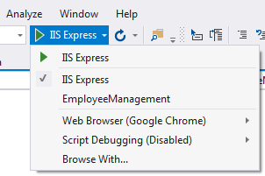  
  
The value of the **commandName** property can be any one of the following.

* Project
* IISExpress
* IIS

This value along with the value of **AspNetCoreHostingModel** element in the project file, specifies the internal and external web server (reverse proxy server) to launch.

|  |  |  |  |
| --- | --- | --- | --- |
| **commandName** | **AspNetCoreHostingModel** | **Internal Web Server** | **External Web Server** |
| Project | Hosting Setting Ignored | Only one web server is used - Kestrel | |
| IISExpress | InProcess | Only one web server is used - IIS Express | |
| IISExpress | OutOfProcess | Kestrel | IIS Express |
| IIS | InProcess | Only one web server is used - IIS | |
| IIS | OutOfProcess | Kestrel | IIS |

You can change the settings in **launchSettings.json** file by directly editing the file or we can also change the settings using the Graphical User Interface (GUI) provided by Visual Studio.   
  
**To access the GUI**

* Right click on the project name in Solution Explorer in Visual Studio and select **"Properties"** from the context menu.
* Click on the **"Debug"** tab on the project **"Properties"** window

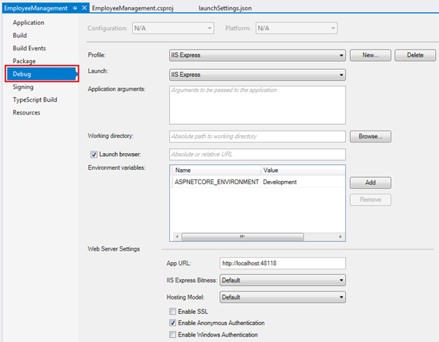  
  
Using the GUI we can change the settings in **launchSettings.json file**. Notice, the Environment Variable **"ASPNETCORE_ENVIRONMENT"** is set to **"Development"**. We can change this value to **Staging** or **Production** depending on whether we are running this project in Staging or Production environment.    
  
We can also add new environment Variables. These environment variables are available throughout our asp.net core application and we can include code that conditionally executes depending on the value of these environment variables.   
  
**For example**, consider the following code in the **Configure()** method in **Startup.cs** file

public void Configure(IApplicationBuilder app, IHostingEnvironment env)

{

if (env.IsDevelopment())

{

app.UseDeveloperExceptionPage();

}

// Rest of the code...

}

**Developer Exception Page** is only displayed if the environment is **Development**. We will discuss environment variables and developer exception page in detail in our upcoming videos.

### ASP NET Core appsettings json file

Asdasd

**Configuration Sources in ASP.NET Core**   
  
In previous versions of ASP.NET, we store application configuration settings, like database connection strings for example, in **web.config** file. In ASP.NET Core application configuration settings can come from the following **different configurations sources.**

* Files (appsettings.json, appsettings.{Environment}.json, where {Environment} is the app's current hosting environment)
* User secrets
* Environment variables
* Command-line arguments

**appsettings.json file :** In the asp.net core project that is generated by the **"Empty"** project template we already have a file with name **appsettings.json**. I have modified this file to include a new setting with the key - **MyKey**.

{

"Logging": {

"LogLevel": {

"Default": "Warning"

}

},

"AllowedHosts": "*",

"MyKey": "Value of MyKey from appsettings.json"

}

**Accessing configuration information**   
  
To access configuration information in the **Startup** class, inject the IConfiguration service provided by the Framework. Startup class is in Startup.cs file.

public class Startup

{

private IConfiguration _configuration;

// Notice we are using Dependency Injection here

public Startup(IConfiguration configuration)

{

_configuration = configuration;

}

public void ConfigureServices(IServiceCollection services)

{

}

public void Configure(IApplicationBuilder app, IHostingEnvironment env)

{

if (env.IsDevelopment())

{

app.UseDeveloperExceptionPage();

}

app.Run(async (context) =>

{

await context.Response.WriteAsync(_configuration["MyKey"]);

});

}

}

**Dependency Injection**   
  
In previous versions of ASP.NET Dependency Injection was optional and to configure it we have to use frameworks like Ninject, StructureMap etc. **In ASP.NET Core Dependency Injection is an integral part.** Dependency Injection allow us to create systems that are loosely coupled, extensible and easily testable. We will discuss Dependency Injection in detail in our upcoming videos.   
  
**ASP.NET Core IConfiguration service**

* IConfiguration service is setup to read configuration information from all the various configuration sources in asp.net core
* If you have a configuration setting with the **same key in multiple configuration sources**, the later configuration sources override the earlier configuration sources
* CreateDefaultBuilder() method of the WebHost class which is automatically invoked when the application starts, reads the configuration sources in a specific order.
* To see the order in which the configuration sources are read, please check out ConfigureAppConfiguration() method on the following link  
  <https://github.com/aspnet/MetaPackages/blob/release/2.2/src/Microsoft.AspNetCore/WebHost.cs>

Upon inspecting the file, you will see, the following is the default order in which the various configuration sources are read

1. appsettings.json,
2. appsettings.{Environment}.json
3. User secrets
4. Environment variables
5. Command-line arguments

You can change this order if you want to or even add your own custom configuration sources in addition to all the existing configuration sources. We will discuss setting up custom configuration source in our upcoming videos.

### Middleware

RECAP: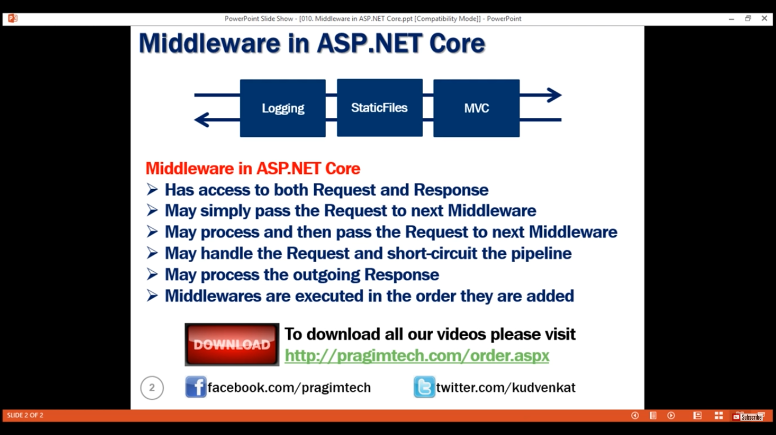

**What is Middleware in ASP.NET Core**  
In ASP.NET Core, Middleware is a piece of software that can handle an HTTP request or response. A given middleware component in ASP.NET Core has a very specific purpose. For example we may have a middleware component that authenticates a user, another piece of middleware to handle errors, yet another middleware to serve static files such as JavaScript files, CSS files, Images etc.    
  
  
It is these middleware components that we use to setup a request processing pipeline in ASP.NET Core. It is this pipeline that determines how a request is processed. The request pipeline is configured as part of the application startup by the Configure() method in Startup.cs file.  The following is the code in Configure() method.

public void Configure(IApplicationBuilder app, IHostingEnvironment env)

{

if (env.IsDevelopment())

{

app.UseDeveloperExceptionPage();

}

app.Run(async (context) =>

{

await context.Response.WriteAsync("Hello World!");

});

}

As you can see, the code in the Configure() method that is generated by the empty project template sets up a **very simple request processing pipeline** with just two pieces of middleware.   
  
UseDeveloperExceptionPage is one middleware and the second middleware is setup using the Run() method. As it stands right now with this very simple request processing pipeline, all our application can do is write a message to the response object that will be displayed by the browser. We will come back and understand the code in this method in detail in our next video. For now let’s understand what is middleware and how it works in asp.net core.   
  
The following diagram helps us understand middleware components and how they fit in a request processing pipeline   
  
  
  
In ASP.NET Core, **a Middleware component has access to both - the incoming request and the outgoing response.** So a Middleware component may process an incoming request and pass that request to the next piece of middleware in the pipeline for further processing. For example, if you have a **logging middleware**, it might simply log the time the request is made and pass the request to the next piece of middleware for further processing.  
  
**A middleware component may handle the request and decide not to call the next middleware in the pipeline.** This is called short-circuiting the request pipeline. Short-circuiting is often desirable because it avoids unnecessary work. For example, if the request is for a static file like an image or css file, the StaticFiles middleware can handle and serve that request and short-circuit the rest of the pipeline. This means in our case, the StaticFiles middleware will not call the MVC middleware if the request is for a static file.  
  
A middleware component may handle an incoming HTTP request by generating an HTTP response. For example, **mvcmiddleware** in the pipeline handles a request to the URL **/employees** and returns a list of employees. As we progress through this course, in our upcoming videos we will be including the **mvcmiddleware** in the request processing pipeline of our application.   
  
**A middleware component may also process the outgoing response**. For example, the logging middleware component may log the time the response is sent. In addition it may also calculate the over all time taken to process the request by computing the difference between request received and response sent times.   
  
**Middleware components are executed in the order they are added to the pipeline**. Care should be taken to add the middleware in the right order, otherwise the application may not function as expected. In our upcoming videos, we will discuss with an example, what happens if the middleware components are not added to the processing pipeline in the correct order.   
  
**The middleware components are available as NuGet packages**. This means updates are now handled by NuGet, providing the ability to update each middleware separately.   
  
Depending on your application requirements you may add as many or as few middleware components to the request processing pipeline. For example, if you are developing simple web application with a few static HTML pages and images, then your request processing pipeline may contain just **"StaticFiles" middleware**.   
  
On the other hand, if you are developing a secure data driven web application then you may need several middleware components like StaticFiles middleware, Authentication middleware, Authorization middleware, MVC middleware etc.    
  
The point that I am trying to make is, you have complete control over configuring the request processing pipeline. This also means from a memory and performance standpoint you only pay for the middleware components you have in your request processing pipeline.   
  
Now that we have a basic understanding of what middleware components are and how they fit in a request processing pipeline, in our next video, we will understand, how to configure a request processing pipeline for our ASP.NET Core application using middleware components

### Configure ASP.NET Core request processing pipeline

In this video we will discuss **configuring a request processing pipleline for asp.net core application** using the middleware components.   
  
  
As part of the application startup, **Configure()** method sets up the request processing pipeline.

public class Startup

{

    public void ConfigureServices(IServiceCollection services)

    {

    }

    public void Configure(IApplicationBuilder app, IHostingEnvironment env)

    {

        if (env.IsDevelopment())

        {

            app.UseDeveloperExceptionPage();

        }

        app.Run(async (context) =>

        {

            await context.Response.WriteAsync("Hello World!");

        });

    }

}

**At the moment we have 2 middlewares in the pipeline**

* UseDeveloperExceptionPage() and
* another middleware that is registered using the Run() method.

**UseDeveloperExceptionPage Middleware :** As the name implies, this middleware responds with the developer exception page, if there is an exception and if the environment is Development. We will discuss this DeveloperExceptionPage middleware and the  different environments in our upcoming videos.   
  
The second middleware that is registered using the Run() method, can only write a message to the Response object. At the moment, this is the middleware that responds to every request.   
Doesn’t matter what your request path is. All requests will be handled by this one piece of middleware and the response we get is the string message that the middleware is writing to the Response object. The response is plain text and not html. We can confirm this by inspecting the page source. Notice we do not have any html tags in the source. It’s just, plain text.   
  
Even if you have a file with name **foo.html** and if you include the path to that file in the request, our application will not be able to serve that static file. This is because, at the moment our request processing pipeline does not have the middleware that can serve static files like html files, images, css and JavaScript files. As we progress through this course we will add the required middleware to be able to serve static files.   
  
**Consider the following code in the Configure() method.**

app.Run(async (context) =>  
{  
    await context.Response.WriteAsync("Hello World!");  
});

**Code Explanation**

* We are using Run() method to add middleware to our application's request processing pipeline
* If you hover the mouse over the Run() method, from the intellisense you can see that this Run() method is implemented as an extension method of IApplicationBuilder interface. This is the reason we are able to invoke this Run() method on IApplicationBuilder object app.
* The parameter that we are passing to the Run() method is a RequestDelegate which we can see from the intellisense.
* RequestDelegate is a delegate that has HttpContext object as a parameter.
* It is through this HttpContext object, the middleware gains access to both the incoming http request and outgoing http response.
* At the moment, we are passing request delegate inline as an anonymous method using a lambda. If you are new to the concept of delegates and lambda, please check out the following 3 videos from our [C# tutorial](https://www.youtube.com/playlist?list=PLAC325451207E3105).
  + [C# Delegates](https://www.youtube.com/watch?v=D2h46fvQX04)
  + [C# Delegates Usage](https://www.youtube.com/watch?v=vBOzvNO8lvk)
  + [Lamda Expression in C#](https://www.youtube.com/watch?v=LDgQ-spnrYY)
* Instead of passing the request delegate inline as an anonymous method, we can define the request delegate in a separate reusable class.
* With this Run() extension method we can only add a terminal middleware to the request pipeline.
* A terminal middleware is a middleware that does not call the next middleware in the pipeline

**Consider the following code**

app.Run(async (context) =>  
{  
    await context.Response.WriteAsync("Hello from 1st Middleware");  
});  
  
app.Run(async (context) =>  
{  
    await context.Response.WriteAsync("Hello from 2nd Middleware");  
});

* We have 2 middlewares registered using the Run() method
* Upon running this project, we only see the response from the first middleware
* We do not see the response from the second middleware
* This is because, a middleware that is registered using the Run() method cannot call the next middleware in the pipeline
* So, the middleware that we register using Run() method is a terminal middleware

If you want your middleware to be able to call the next middleware in the pipeline, then register the middleware using **Use()** method as shown below.

app.Use(async (context, next) =>  
{  
    await context.Response.WriteAsync("Hello from 1st Middleware");  
    await next();  
});  
  
app.Run(async (context) =>  
{  
    await context.Response.WriteAsync("Hello from 2nd Middleware");  
});

Notice, **Use()** method has 2 parameters. The first parameter is the HttpContext context object and the second parameter is the Func type i.e it is a generic delegate that represents the next middleware in the pipeline.   
  
Now, consider the following code

public void Configure(IApplicationBuilder app, IHostingEnvironment env,  
                ILogger<Startup> logger)  
{  
    app.Use(async (context, next) =>  
    {  
        logger.LogInformation("MW1: Incoming Request");  
        await next();  
        logger.LogInformation("MW1: Outgoing Response");  
    });  
  
    app.Use(async (context, next) =>  
    {  
        logger.LogInformation("MW2: Incoming Request");  
        await next();  
        logger.LogInformation("MW2: Outgoing Response");  
    });  
  
    app.Run(async (context) =>  
    {  
        await context.Response.WriteAsync("MW3: Request handled and response produced");  
        logger.LogInformation("MW3: Request handled and response produced");  
    });  
}

* ILogger<Startup> is injected into the Configure() method
* CreateDefaultBuilder() that is called by the Main() method configures logging
* You can verify this on their GitHub page using the link below  
  <https://github.com/aspnet/MetaPackages/blob/release/2.2/src/Microsoft.AspNetCore/WebHost.cs>
* Please check the method ConfigureLogging()
* You will find that, loggers for Console, Debug and EventSource are configured
* We are using the logger instance provided by the Dependency Injection system to log the information
* If you run the project using the .NET Core CLI, you can see the logged information on the Console window
* If you run the project directly from Visual Studio, you can see the logged information in the output window. Select ASP.NET Core Web Server from the dropdownlist in the output window.
* You will see that, the information is logged in the following order
  + **MW1: Incoming Request**
  + **MW2: Incoming Request**
  + **MW3: Request handled and response produced**
  + **MW2: Outgoing Response**
  + **MW1: Outgoing Response**

Now relate the above output, with the following diagram from MSDN to understand what's happening. 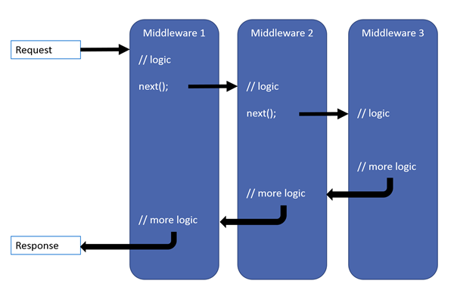

* Remember a middleware in asp.net core has access to both the incoming request and the outgoing response
* The request first arrives at Middleware1 which logs (MW1: Incoming Request) so we see this message first.
* Then Middleware1 calls next(). Calling next() invokes Middleware2 in the pipeline.
* Middleware2 logs (MW2: Incoming Request). So we see (MW2: Incoming Request) after (MW1: Incoming Request).
* Then Middleware2 calls next() which invokes Middleware3.
* Middleware3 handles the request and produces a response. Hence, the next message that we see is (MW3: Request handled and response produced)
* So, at this point the pipeline starts to reverse itself.
* The control is then given to Middleware2 and the response produced by Middleware3 is passed to it. Middleware2 then logs (MW2: Outgoing Response) which is what we see next.
* Finally Middleware2 gives control to Middleware1.
* Middleware1 logs (MW1: Outgoing Response) which is what we see finally.

**So here are the 3 very important points to keep in mind regarding the request processing pipeline**

* Everything that happens before the next() method is invoked in each of the middleware components, happen as the request travels from middleware to middleware through the pipeline and this is represented by the **incoming arrow**.
* When a middleware handles the request and produces response, the request processing **pipeline starts to reverse**.
* Everything that happens after the next() method is invoked in a middleware component, happens as the response travels from middleware to middleware through the pipeline and this is represented by the **outgoing arrow**.

I hope you now have a good understanding of the request processing pipeline in asp.ent core.

### Static files in asp.net core

In this video we will discuss, **how to make ASP.NET Core application serve static files such as HTML, Images, CSS and JavaScript files**   
  
  
**Static Files**

* By default, an asp.net core application will not serve static files
* The default directory for static files is wwwroot and this directory must be in the root project folder

Copy and paste an image in **wwwroot** folder. let's assume the name of the file is banner.jpg. To be able to access this file from the browser we use  
  
http://{{serverName}}/banner.jpg   
  
In our case we are running on our local machine so the URL would be the following. The port number may be different on your machine.   
  
http://localhost:49119/banner.jpg   
  
On my machine when I navigate to the above URL, I still see the response produced by the middleware I have registered using the Run() method. I do not see the image banner.jpg.   
  
This is because, at the moment our application request processing pipeline does not have the required middleware that can serve static files. The middleware that we need is UseStaticFiles() middleware.    
  
Modify the code in Configure() method to add UseStaticFiles() middleware to our application's request processing pipeline as shown below.

public void Configure(IApplicationBuilder app, IHostingEnvironment env)  
{  
    if (env.IsDevelopment())  
    {  
        app.UseDeveloperExceptionPage();  
    }   
  
    // Add Static Files Middleware  
    app.UseStaticFiles();   
  
    app.Run(async (context) =>  
    {  
        await context.Response.WriteAsync("Hello World!");  
    });  
}

Instead of having all files types like images, css and JavaScript files flat in the wwwroot folder, it is common to have separate folders for css, images and JavaScript under wwwroot as shown below. Consider the following folder hierarchy.   
  
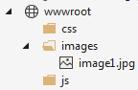  
  
To be able to access **image1.jpg** from the browser we use   
http://localhost:49119/images/image1.jpg   
  
**Serving static files outside of wwwroot folder**   
  
By default, UseStaticFiles() middleware only serves the static files that are in wwwroot folder. We can also server static files outside of the wwwroot folder if you want to.   
  
**Serving a default document**   
  
Most web applications have a default document and it is the document that is displayed when a user visits the root URL of your application. For example, you have a file with name default.html and you want to serve it when the user visits the root url of your application i.e http://localhost:49119/   
  
At the moment, on my machine when I navigate to the root URL, I see the response produced by the middleware I have registered using the Run() method. I do not see the content of the default document default.html. To be able to serve default page we have to plug in the UseDefaultFiles() middleware in our application's request processing pipeline.   
  
// Add Default Files Middleware  
app.UseDefaultFiles();  
// Add Static Files Middleware  
app.UseStaticFiles();   
  
**Please Note :** UseDefaultFiles must be called before UseStaticFiles to serve the default file. UseDefaultFiles is a URL rewriter that doesn't actually serve the file. It simply rewrites the URL to the default document which will then be served by the Static Files Middleware. The URL displayed in the address bar still reflects the root URL and not the rewritten URL.   
  
The following are the default files which UseDefaultFiles middleware looks for  
index.htm  
index.html  
default.htm  
default.html   
  
If you want to use another document like **foo.html** for example as your default document, you can do so using the following code.   
  
// Specify foo.html as the default document  
DefaultFilesOptions defaultFilesOptions = new DefaultFilesOptions();  
defaultFilesOptions.DefaultFileNames.Clear();  
defaultFilesOptions.DefaultFileNames.Add("foo.html");  
// Add Default Files Middleware  
app.UseDefaultFiles(defaultFilesOptions);  
// Add Static Files Middleware  
app.UseStaticFiles();   
  
**UseFileServer Middleware**   
  
UseFileServer combines the functionality of UseStaticFiles, UseDefaultFiles and UseDirectoryBrowser middleware. DirectoryBrowser middleware, enables directory browsing and allows users to see files within a specified directory. We could replace UseStaticFiles and UseDefaultFiles middlewares with UseFileServer Middleware.   
  
// Use UseFileServer instead of UseDefaultFiles & UseStaticFiles  
FileServerOptions fileServerOptions = new FileServerOptions();  
fileServerOptions.DefaultFilesOptions.DefaultFileNames.Clear();  
fileServerOptions.DefaultFilesOptions.DefaultFileNames.Add("foo.html");  
app.UseFileServer(fileServerOptions);  
  
The important point to note here is the pattern that we use to add middleware to our application's request processing pipeline. In most cases we add middleware using the extension methods that start with the word **USE**. For example,

* UseDeveloperExceptionPage()
* UseDefaultFiles()
* UseStaticFiles()
* UseFileServer()

If you want to customise these middleware components, we use the respective OPTIONS object. For example notice the respective **OPTIONS** objects we use.

|  |  |
| --- | --- |
| **Middleware** | **Options Object** |
| UseDeveloperExceptionPage | DeveloperExceptionPageOptions |
| UseDefaultFiles | DefaultFilesOptions |
| UseStaticFiles | StaticFileOptions |
| UseFileServer | FileServerOptions |

### ASP.NET Core developer exception page

In this video we will discuss **Developer Exception Page** and it's use for us as a developer.   
  
  
**UseDeveloperExceptionPage Middleware**   
  
**Consider the following code in Configure() method in Startup class**

public void Configure(IApplicationBuilder app, IHostingEnvironment env)  
{  
    if (env.IsDevelopment())  
    {  
        app.UseDeveloperExceptionPage();  
    }  
  
    app.UseFileServer();  
  
    app.Run(async (context) =>  
    {  
        throw new Exception("Some error processing the request");  
        await context.Response.WriteAsync("Hello World!");  
    });  
}

If we run our application with the above code we do not see the exception, instead we see **"Hello from Default.html"**. If you understand how asp.net core request processing pipeline works, then you might already know the reason why we do not see the exception that we are throwing.    
  
UseFileServer middleware combines the functionality of UseDefaultFiles and UseStaticFiles middleware. In our previous videos in this series we have included a default html document with name **default.html** in **wwwroot folder**.    
  
So, a request to the application root URL i.e http://localhost:49119 is handled by UseFileServer middleware and the pipeline reverses from there. So the next middleware in the request pipeline that we have registered using the Run() method will not get the chance to execute and hence we do not see the exception thrown by this middleware.   
  
Now, if we issue a request to http://localhost:49119/abc.html, we see the exception as expected. So, in this case, UseFileServer middleware will not find the file with name **abc.html**. It gives control to the next middleware in the pipeline, which in our case is the middleware that we have registered using Run() method. This middleware throws an exception and we see the exception details as expected.   
  
If you have any experience with classic asp.net, then you must be very familiar with this page. This is similar to that **yellow screen of death** in classic asp.net.    
  
As the name implies, this **Developer Exception Page** contains exception details like

* Stack trace including the file name and line number that caused the exception
* Query String, Cookies and HTTP headers

At the moment, on the exception page, on the **"Query"** tab we see **"No QueryString data"**. If you have any query string parameters in the request URL like the following, you will see them under the **"Query"** tab.  
http://localhost:48118/abc.html?country=usa&state=iowa   
  
**Customising UseDeveloperExceptionPage Middleware**   
  
Like most other middleware components in ASP.NET Core, we can also customize UseDeveloperExceptionPage middleware. Whenever you want to customize a middleware component, always remember you may have the respective OPTIONS object. So, to customize UseDeveloperExceptionPage middleware, use DeveloperExceptionPageOptions object as shown below.

DeveloperExceptionPageOptions developerExceptionPageOptions = new DeveloperExceptionPageOptions  
{  
    SourceCodeLineCount = 10  
};  
app.UseDeveloperExceptionPage(developerExceptionPageOptions);

SourceCodeLineCount property specifies how many lines of code to include before and after the line of code that caused the exception.  
  
**How UseDeveloperExceptionPage Middleware works**  
  
UseDeveloperExceptionPage Middleware must be plugged into the request processing pipeline as early as possible, so it can handle the exception and display the Developer Exception Page if the subsequent middleware components in the pipeline raises an exception.  
  
**Consider the following code :** UseDeveloperExceptionPage() middleware is present after the middleware registered using Run() method. So in this case, developer exception page will not be displayed. This is the reason it must be plugged in as early as possible in the request processing pipeline.

public void Configure(IApplicationBuilder app, IHostingEnvironment env)  
{  
    //app.UseFileServer();  
  
    app.Run(async (context) =>  
    {  
        throw new Exception("Some error processing the request");  
        await context.Response.WriteAsync("Hello World!");  
    });  
  
    if (env.IsDevelopment())  
    {  
        DeveloperExceptionPageOptions developerExceptionPageOptions = new DeveloperExceptionPageOptions  
        {  
            SourceCodeLineCount = 10  
        };  
        app.UseDeveloperExceptionPage(developerExceptionPageOptions);  
    }  
}

### ASP.NET Core environment variables

In this video we will discuss, **configuring an asp.net core application using an environment variable**.   
  
  
**Software Development Environments**   
  
In most software development organisations we typically have the following development environments.

* Development
* Staging
* Production

**Why do we need different Development Environments like Development, Staging, Production etc.**   
  
**Development Environment :** We software developers typically use this environment for our day to day development work. We want non-minified JavaScript and CSS files to be loaded on a development environment for ease of debugging. Similarly we want developer exception page if there is an unhandled exception so we can understand the root cause of the exception and fix it if required.   
  
**Staging Environment :** Many organisations, try to keep their staging environment as identical as possible to the actual production environment. The primary reason for this environment is to identify any deployment related issues. Also, if you are developing a B2B (Business to Business) application, you may be interfacing with other service provider systems. Many organisations, usually setup their staging environment to interface with the service providers as well, for complete end to end testing. We usually do not troubleshoot and debug on a staging environment, so for better performance we want minified JavaScript and CSS files to be loaded. If there is an unhandled exception, display user friendly error page instead of the developer exception page. A user friendly error page will not contain any technical details. It contains a generic message like the following    
  
"Something has gone wrong, please email, chat or call our application support using the contact details below"   
  
**Production Environment :** The actual live environment, that we use for day to day business. Production environment should be configured for maximum security and performance. So load minified JavaScript and CSS files to improve the performance. For better security, display a User Friendly Error Page instead of the Developer Exception Page. The technical details on the Developer Exception Page does not make sense to the end user and they can be used by malicious user to break into your application.   
  
**Configuring ASPNETCORE_ENVIRONMENT variable**  
  
In [Part 8](https://www.youtube.com/watch?v=u2S4TkkACVc) of [ASP.NET Core tutorial](https://www.youtube.com/playlist?list=PL6n9fhu94yhVkdrusLaQsfERmL_Jh4XmU), we discussed **ASPNETCORE_ENVIRONMENT** variable. We use this variable to set the environment for our application. On our local development machine we usually set this environment variable in **launchsettings.json** file.  
  
We can also set it in the operating system if we want to. To set it on a Windows Operating system

1. Open Windows Control Panel
2. In the Control Panel window, type **"environment"** in the **"Search Control Panel"** text box on the top right hand corner
3. Click on **"Edit the system environment variables"** link   
   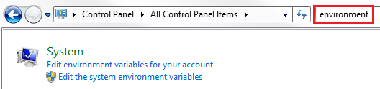
4. In the **"System Properties"** window that pops up, click on **"Environment Variables"** button   
   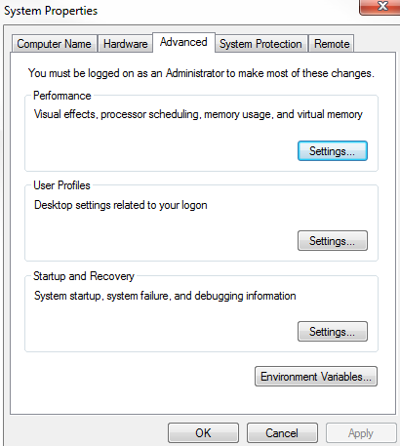
5. On the **"Environment Variables"** window that pops up, click on **"New"** button under **"System variables"** section
6. In the **"New System Variable"** window that pops up, type
   * ASPNETCORE_ENVIRONMENT in "Variable name" text box
   * Development in "Variable value" text box   
     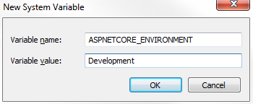
7. Click **"OK"** to close all the pop up windows

On a **staging** or **production** environment we typically set this environment variable in the operating system.   
  
We usually set this variable to one of the following values depending on the environment in which our application is hosted and running.

* Development
* Staging
* Production

**Accessing ASPNETCORE_ENVIRONMENT variable value**   
  
Out of the box, ASP.NET core provides IHostingEnvironment service which we can use to access ASPNETCORE_ENVIRONMENT variable value. Take a look at the sample application we have been working with, notice the Configure() method in Startup.cs file. IHostingEnvironment service is already injected into this method.  
  
Now modify the code in Configure() method as shown below. Notice, we are using EnvironmentName property of IHostingEnvironment service instance to access the environment name.

public void Configure(IApplicationBuilder app, IHostingEnvironment env)  
{  
    if (env.IsDevelopment())  
    {  
        app.UseDeveloperExceptionPage();  
    }  
  
    app.UseStaticFiles();  
  
    app.Run(async (context) =>  
    {  
        await context.Response.WriteAsync("Hosting Environment: " + env.EnvironmentName);  
    });  
}

If you have the environment variable set in both the places i.e launchsettings.json file and in the operating system, then the values in launchsettings.json file overrides the value specified at the operating system level.   
  
**Please note :** Please restart Visual Studio, if you do not see the Environment Variable value set at the operating system level   
  
If we have not explicitly set ASPNETCORE_ENVIRONMENT variable, it defaults to **Production**. This is done on purpose for better security and performance.    
  
Imagine, on a production server, we have forgot to set the ASPNETCORE_ENVIRONMENT variable to Production.If the default value is Development, the application may display Developer Exception Page and it could be exploited by a malicious user to hack into your application.    
  
Also, instead of loading minified JavaScript and CSS files, the non-minified files may be loaded. So for better performance and security it defaults to a value of Production if we have not explicitly set the ASPNETCORE_ENVIRONMENT variable.   
  
**Useful methods of IHostingEnvironment service**   
  
Use the following methods of IHostingEnvironment service to identify the environment in which our application is running.

* IsDevelopment()
* IsStaging()
* IsProduction()

What if you have a custom environment like UAT (User Acceptance Testing) or QA (Quality Assurance) environment. Well, custom environments like these are also supported in ASP.NET core. For example, to check if the environment is UAT, use **IsEnvironment()** method as shown below.   
  
env.IsEnvironment("UAT")

// If the environment is Development serve Developer Exception Page  
if (env.IsDevelopment())  
{  
    app.UseDeveloperExceptionPage();  
}  
// else serve User Friendly Error Page with Application Support Contact Info  
else if (env.IsStaging() || env.IsProduction() || env.IsEnvironment("UAT"))  
{  
    app.UseExceptionHandler("/Error");  
}

**Tag Helpers are new in ASP.NET Core.** In a razor view ie. in a .CSHTML page we can use, something called an Environment Tag Helper. This environment tag helper supports rendering different content depending on the value of the ASPNETCORE_ENVIRONMENT variable. We will discuss Tag Helpers including the environment tag helper in detail as we progress through this course and create **Models**, **Views** and **Controllers** for our application.

### ASP.NET Core MVC tutorial

**In this video we will discuss**

* What is MVC
* How MVC works

**What is MVC**   
  
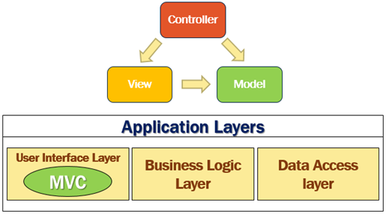  
  
MVC consists of three fundamental parts - **Model**, **View** and **Controller**. It's an architectural design pattern for implementing User Interface Layer of an application. A typical real world application usually has the following layers.

* User Interface Layer
* Business Logic Layer or Domain Layer
* Data Access layer

MVC design pattern is usually used for implementing the User Interface Layer of the application.   
  
**How MVC Works**   
  
Let us understand how the MVC design pattern works with an example. Let's say we want to retrieve a specific employee details (i.e an employee whose ID is 1) and display those details on a web page in an HTML table as shown below.   
  
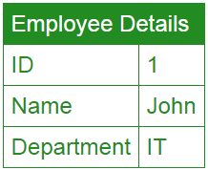  
  
So from the web browser we issue a request and the URL may look something like the following  
**http://pragimtech.com/employee/details/1**   
  
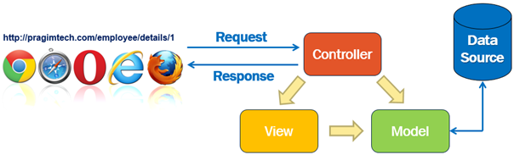

1. When this request arrives at our server, it is the Controller in the MVC design pattern that receives the request and handles it.
2. The controller creates the model. The model has the classes that describe the data.
3. In addition to the data itself, Model also contains the logic to retrieve data from the underlying data source such as a database.
4. In addition to creating the Model, the controller also selects a View and passes the Model object to that View.
5. The view is only responsible for presenting the model data.
6. It is the view, that generates the required HTML to present the model data i.e the employee data provided to it by the Controller.
7. This HTML is then sent over the network to the user who made the request.

**Model**   
  
So model in this case consists of the Employee class + the EmployeeRepository class that manages the employee data as shown below.

public class Employee  
{  
    public int Id { get; set; }  
    public string Name { get; set; }  
    public string Department { get; set; }  
}  
  
public interface IEmployeeRepository  
{  
    Employee GetEmployee(int id);  
    void Save(Employee employee);  
}  
  
public class EmployeeRepository : IEmployeeRepository  
{  
    public Employee GetEmployee(int id)  
    {  
        // Logic to retrieve employee details  
    }  
  
    public void Save(Employee employee)  
    {  
        // Logic to save employee details  
    }  
}

We use the Employee class to hold the employee data and It is the EmployeeRepository class that retrieves and saves data in the underlying data source.    
  
So to generalise this, **a Model in MVC contains a set of classes that represent data and the logic to manage that data.** The class that represent the data is the Employee class and the class that manages the data is the EmployeeRepository class.  
  
If you are wondering why are we using the interface IEmployeeRepository. Can't we use just the EmployeeRepository class without the interface.  
  
Well, we can, but using the interface abstraction allows us to use dependency injection which in turn allows us to create systems that are loosely coupled  and easily testable. We will discuss dependency injection in detail in our upcoming videos.  
  
**View**  
  
A View in MVC should only contain the logic to display the Model data provided to it by the Controller. You can think of a view as an HTML Template. Let's say in our example, we want to display Employee data in an HTML table.   
  
The view in this case will be provided with the Employee object. The Employee object is the model that carries the employee data to the view. The only responsibility of the view is to present the employee data in an HTML table. Here is the code in the view.

@model EmployeeManagement.Employee  
  
<html>  
<head>  
    <title>Employee Details</title>  
</head>  
<body>  
    <table>  
        <tr>  
            <td>ID</td>  
            <td>@Model.Id</td>  
        </tr>  
        <tr>  
            <td>Name</td>  
            <td>@Model.Name</td>  
        </tr>  
        <tr>  
            <td>Department</td>  
            <td>@Model.Department </td>  
        </tr>  
    </table>  
</body>  
</html>

In MVC, a View in only responsible for presenting the model data. There should be no complex logic in a view. To maintain a clear separation of concerns, the logic in a view must be very minimal and that too it must only be there for presenting data. If you get to a point where the presentation logic is getting too complicated, consider using a **ViewModel** or **View Component**. **View Components** are new in this version of MVC. We will discuss View Components in detail in our upcoming videos.   
  
**Controller**  
  
When a request from the browser arrives at our application, it is the controller in the MVC design pattern, that handles the incoming http request and responds to the user action.    
  
In this case the user has issued a request to the URL (/employee/details/1), so this request is mapped to the Details action method in the EmployeeController, passing it the EMPLOYEE ID which in this case is 1. This mapping is done by the **Routing rules** defined in our application. We will discuss Routing in ASP.NET Core MVC in detail in our upcoming videos.

public class EmployeeController : Controller  
{  
    private IEmployeeRepository _employeeRepository;  
  
    public EmployeeController(IEmployeeRepository employeeRepository)  
    {  
        _employeeRepository = employeeRepository;  
    }  
  
    public IActionResult Details(int id)  
    {  
        Employee model = _employeeRepository.GetEmployee(id);  
        return View(model);  
    }  
}

As you can see, from the code in the **Details** action method, the controller builds the model, in this case the Model is the **Employee** object. To retrieve the Employee data from the underlying data source, the controller is making use of the **EmployeeRepository** class.   
  
Once the controller has constructed the Employee model object with the required data, it then passes that Employee model object to the view. The view then generates the required HTML to present the Employee data provided to it by the Controller. This HTML is then sent over the network to the user who made the request.  
  
If this is confusing at the moment, please do not worry, we will bring this to life, by implementing Models, Views and Controllers for our application as we progress through this course and it will be much clear at that point.  
  
**Summary**

* MVC is an architectural design pattern for implementing User Interface Layer of an application
* **Model :** Set of classes that represent data + the logic to manage that data. Example - Employee class that represents the Employee data + EmployeeRepository class that saves and retrieves employee data from the underlying data source such as a Database.
* **View :** Contains the display logic to present the Model data provided to it by the Controller
* **Controller :** Handles the http request, work with the model, and selects a view to render that model.

As you can see, in the MVC design pattern we have a clear separation of concerns i. each component has a very specific task to do. In our next video we will discuss setting up the MVC middleware in our asp.net core application.

### Setup mvc in asp.net core

In this video we will discuss, **setting up MVC in ASP.NET Core application**.   
  
  
The ASP.NET Core Project we have been working with so far in this video series is generated using the **"Empty"** project template. At the moment this project does not have MVC setup.   
  
  
**Two steps to setup MVC in ASP.NET Core Application**   
  
**Step 1 :** In ConfigureServices() method of the Startup class in Startup.cs file, include the following line. This line of code adds the required MVC services to the dependency injection container in asp.net core.

services.AddMvc();

**Step 2 :** In the Configure() method, add UseMvcWithDefaultRoute() midddleware to our application's request processing pipeline. Modify the code as shown below.

public void Configure(IApplicationBuilder app, IHostingEnvironment env)  
{  
    if (env.IsDevelopment())  
    {  
        app.UseDeveloperExceptionPage();  
    }  
  
    app.UseStaticFiles();  
  
    app.UseMvcWithDefaultRoute();  
  
    app.Run(async (context) =>  
    {  
        await context.Response.WriteAsync("Hello World!");  
    });  
}

Notice, we placed UseStaticFiles() middleware before UseMvcWithDefaultRoute() middleware. This order is important, because if the request is for a static file like an image, css or JavaScript file, then UseStaticFiles() middleware will handle the request and short-circuit the rest of the pipeline.    
  
So if the request is for a static file, UseMvcWithDefaultRoute() middleware is not executed, there by avoiding the unnecessary processing.    
  
On the other hand, if the request is an MVC request, UseStaticFiles() middleware will pass that request to UseMvcWithDefaultRoute() middleware which will handle the request and produces the response.   
  
Notice, in addition to UseMvcWithDefaultRoute() middleware, we also have UseMvc() middleware. For now, let's use, UseMvcWithDefaultRoute() middleware. In our upcoming videos, when we discuss routing, we will discuss the difference between these 2 middlewares.   
  
At this point, if we run the application and navigate to the root URL -http://localhost:49119, we see "Hello World!" message displayed in the browser.

* With UseMvcWithDefaultRoute() middleware configured in the pipeline, when we issue a request to the root URL - http://localhost:49119
* As the request is not for a static file, UseStaticFiles() middleware will pass the request to UseMvcWithDefaultRoute() middleware
* Since we have not specified the controller and action method segments in the URL, UseMvcWithDefaultRoute() middleware looks for Index() action method in the HomeController.
* Since, at the moment, we do not have a HomeController in our application, UseMvcWithDefaultRoute() middleware passes the request to the middleware registered using the Run() method and hence we see the "Hello World!" message produced by this middleware.

Now let's see, what happens if we remove the Run() middleware. At this point the code in your Configure() method must be as shown below.

public void Configure(IApplicationBuilder app, IHostingEnvironment env)  
{  
    if (env.IsDevelopment())  
    {  
        app.UseDeveloperExceptionPage();  
    }  
  
    app.UseStaticFiles();  
  
    app.UseMvcWithDefaultRoute();  
}

With the above code in place, if we again issue a request to the root URL - http://localhost:49119, we now see the 404 error. This is because UseMvcWithDefaultRoute() middleware did not find the HomeController with the Index() action and there is no other middleware in the pipeline, so we see 404 error.  
  
**Add HomeController**  
  
Add Controllers folder, in the root project folder. In the "Controllers" add a new Controller. Copy and paste the following code.

public class HomeController  
{  
    public string Index()  
    {  
        return "Hello from MVC";  
    }  
}

Build the solution and issue a request to the application root URL - http://localhost:49119. You will now see the string - "Hello from MVC" displayed in the browser.

### ASP.NET Core AddMvc vs AddMvcCore

In this video we will discuss the **difference between AddMvc() and AddMvcCore()** methods.    
  
  
To setup MVC in an ASP.NET Core application we call AddMvc() method of the IServiceCollection interface in ConfigureServices() method of the Startup class.

services.AddMvc();

In addition to AddMvc() method we also have AddMvcCore() method on the IServiceCollection interface. So, the obvious question that comes to our mind is, what's the difference between these 2 methods.    
  
**AddMvc() v/s AddMvcCore()**   
  
Before we discuss the difference between AddMvc() and AddMvcCore() methods, let's modify the following HomeController to return JSON formatted data, instead of a simple string.    
  
At the moment, there is no base class specified for the the HomeController class. It works for us now because we are returning a simple string from the Index() action method.

public class HomeController  
{  
    public string Index()  
    {  
            return "Hello from MVC";  
    }  
}

However, if we want to return an **HTML View** or **JSON data** from the **Index()** action method, our **HomeController** class has to derive from the **Controller** class provided by the framework. The **Controller** base class provides support to return different results like **JsonResult**, **ViewResult**, **PartialViewResult** etc. Modify the **HomeController** class to derive from the **Controller** class and return **JsonResult** from the **Index()** action method as shown below.

public class HomeController : Controller  
{  
    public JsonResult Index()  
    {  
        return Json(new { id=1, name="pragim" });  
    }  
}

**Please note :** Controller class is present in Microsoft.AspNetCore.Mvc namespace.   
  
At this point, run the application and we should see JSON data in the browser as expected.   
  
Now, in the ConfigureServices() method call AddMvcCore() method instead of AddMvc() and run the application.

public void ConfigureServices(IServiceCollection services)  
{  
    services.AddMvcCore();  
}

**We get the following error**  
No service for type 'Microsoft.AspNetCore.Mvc.Formatters.Json.Internal.JsonResultExecutor' has been registered.  
  
To be able to return JSON data, JsonFormatterServices need to be registered with the dependency injection container. AddMvc() method does this but not the AddMvcCore() method. You can confirm this by looking at the source code on ASP.NET Core MVC Github page.   
  
As the name implies, AddMvcCore() method only adds the core MVC services. On the other hand, AddMvc() method adds all the required MVC services. AddMvc() method calls AddMvcCore() method internally, to add all the core MVC services. So if we are calling AddMvc() method there is no need to explicitly call AddMvcCore() method again.  
  
I hope this clarifies the difference between AddMvc() and AddMvcCore() methods.

### Model in ASP.NET Core MVC

In this video we will discuss **Model in ASP.NET Core MVC** with an example.    
  
  
We want to ultimately, retrieve a specific employee details from the **Employees** database table and display on the web page as shown below.   
  
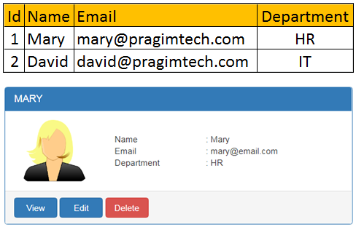  
  
  
**Model in MVC** contains a set of classes that represent data and the logic to manage that data. So, to represent the employee data that we want to display, we use the following Employee class.

public class Employee  
{  
    public int Id { get; set; }  
    public string Name { get; set; }  
    public string Email { get; set; }  
    public string Department { get; set; }  
}

Model classes in ASP.NET Core does not have to be in the **Models** folder, but keeping them in a folder named **Models** is a good practice as it is easier to find them later.   
  
In addition to the Employee class that represent the data, model also contains the class that manages the model data. To manage the data i.e to retrieve and save employee data we are going to use the following IEmployeeRepository service. At the moment, we only have one method GetEmployee() that retrieves employee by ID. As we progress through the course we will add methods to **Create**, **Update** and **Delete** as well.

public interface IEmployeeRepository  
{  
    Employee GetEmployee(int Id);  
}

The following MockEmployeeRepository class provides the implementation for IEmployeeRepository interface. At the moment, we are hard coding the Employee data in the MockEmployeeRepository class. In our upcoming videos, we will provide another implementation for IEmployeeRepository interface, and that implementation will retrieve data from a SQL Server database.

public class MockEmployeeRepository : IEmployeeRepository  
{  
    private List<Employee> _employeeList;  
  
    public MockEmployeeRepository()  
    {  
        _employeeList = new List<Employee>()  
        {  
            new Employee() { Id = 1, Name = "Mary", Department = "HR", Email = "mary@pragimtech.com" },  
            new Employee() { Id = 2, Name = "John", Department = "IT", Email = "john@pragimtech.com" },  
            new Employee() { Id = 3, Name = "Sam", Department = "IT", Email = "sam@pragimtech.com" },  
        };  
    }  
  
    public Employee GetEmployee(int Id)  
    {  
        return this._employeeList.FirstOrDefault(e => e.Id == Id);  
    }  
}

Throughout our application we will be programming against the interface IEmployeeRepository and not the concrete implementation MockEmployeeRepository. This interface abstraction allows us to use dependency injection which in turn makes our application flexible and easily unit testable. We will discuss Dependency Injection in detail in our next video.

**ASP.NET Core dependency injection tutorial**   
  
In this video we will discuss **dependency injection** in detail with an example.   
  
  
**HomeController**

public class HomeController : Controller  
{    // Retrieve employee name and return  
    public string Index()  
    {  
        return _employeeRepository.GetEmployee(1).Name;  
    }  
}

**Please note :**

* HomeController is dependant on IEmployeeRepository for retrieving Employee data.
* Instead of the HomeController creating a new instance of an implement ion of IEmployeeRepository, we are injecting IEmployeeRepository instance into the HomeController using the constructor.
* This is called **constructor injection**, as we are using the constructor to inject the dependency.
* Notice, we are assigning the injected dependency to a **read-only field**. This is a good practice as it prevents accidentally assigning another value to it inside a method.
* At this point, if we run the project we get the following error  
  InvalidOperationException: Unable to resolve service for type 'EmployeeManagement.Models.IEmployeeRepository' while attempting to activate 'EmployeeManagement.Controllers.HomeController'.
* This is because the ASP .NET dependency injection container does not know which object instance to provide if someone requests an object that implements IEmployeeRepository
* IEmployeeRepository may have several implementations. At the moment in our project we only have one implementation and that is MockEmployeeRepository
* As the name implies, MockEmployeeRepository works with the in-memory employee mock data.
* In our upcoming videos, we will discuss providing another implementation for IEmployeeRepository which retrieves employee data from SQL Server database.
* For now, let's work with MockEmployeeRepository.
* To fix the InvalidOperationException error, we need to register MockEmployeeRepository class with the dependency injection container in ASP.NET core.
* We do this in ConfigureServices() method in Startup class

**Registering Services with the ASP.NET Core Dependency Injection Container :**   
  
ASP.NET core provides the following 3 methods to register services with the dependency injection container. The method that we use determines the **lifetime of the registered service**.  
  
**AddSingleton()** - As the name implies, AddSingleton() method creates a **Singleton service**. A Singleton service is created when it is first requested. This same instance is then used by all the subsequent requests. So in general, a Singleton service is created only one time per application and that single instance is used throughout the application life time.  
  
**AddTransient()** - This method creates a **Transient service**. A new instance of a Transient service is created each time it is requested.   
  
**AddScoped()** - This method creates a **Scoped service**. A new instance of a Scoped service is created once per request within the scope. For example, in a web application it creates 1 instance per each http request but uses the same instance in the other calls within that same web request.  
  
Please do not worry, if this is a bit confusing at the moment. We will be revisiting these 3 methods several times in our upcoming videos in this series.  
  
For now, to fix the InvalidOperationException error, let's register MockEmployeeRepository class with the ASP.NET Core Dependency Injection container using AddSingleton() method as shown below. So, with this code in-place, if someone asks for IEmployeeRepository, an instance of MockEmployeeRepository will be provided.

public void ConfigureServices(IServiceCollection services)  
{  
    services.AddMvc();  
    services.AddSingleton<IEmployeeRepository, MockEmployeeRepository>();  
}

At this point, you might be thinking, why do we have to do all this. Why can't we simply create an instance of MockEmployeeRepository class in the HomeController using the **new** keyword as shown below.

public class HomeController : Controller  
{  
    private readonly IEmployeeRepository _employeeRepository;  
  
    // Inject IEmployeeRepository using Constructor Injection  
    public HomeController(IEmployeeRepository employeeRepository)  
    {  
        _employeeRepository = new MockEmployeeRepository();  
    }  
  
    // Retrieve employee name and return  
    public string Index()  
    {  
        return _employeeRepository.GetEmployee(1).Name;  
    }  
}

Well, this makes HomeController tightly coupled to MockEmployeeRepository. Later if we provide a new implementation for IEmployeeRepository and if we want to use that new implementation instead of MockEmployeeRepository, we have to change the code in HomeController. You might be thinking, this is just one line of code change, so it is not that difficult to do.  
  
Well, what if we have used this MockEmployeeRepository in 50 other controllers in our application?  
The code in all the 50 controllers has to change. This is not only tedious but also error prone.  
  
So in-short, using **the** new keyword to create instances of dependencies creates tight coupling and as a result your application will be difficult to change. With dependency injection we will not have this tight coupling.   
  
With dependency injection, even, if we have used MockEmployeeRepository in 50 other controllers in our application, if we want to swap it out with a different implementation, we just need to change the following one line of code in Startup.cs file. Notice, we are now using DatabaseEmployeeRepository instead of MockEmployeeRepository.

public void ConfigureServices(IServiceCollection services)  
{  
    services.AddMvc();  
    services.AddSingleton<IEmployeeRepository, DatabaseEmployeeRepository>();  
}

Unit testing also becomes much easier, as we can easily swap out dependencies with dependency injection.  
  
Don't worry, if this is slightly confusing. We will provide a different implementation for IEmployeeRepository in our upcoming videos. This new implementation will retrieve data from a SQL Server database. We will then replace the MockEmployeeRepository implementation with the DatabaseEmployeeRepository implementation. At that point, you will understand the power and flexibility dependency injection provides.

### Controller in MVC Controller in ASP.NET Core MVC

* Controller in MVC is a class and it inherits from Microsoft.AspNetCore.Mvc.Controller
* The controller class name is suffixed with word **"Controller"**. For example HomeController, EmployeeController.
* When a request from the browser arrives at our application, it is the controller in the MVC design pattern, that handles the incoming http request and responds to the user action.
* Controller class contains a set of public methods. These public methods in the Controller class are called **action methods**. It is these controller action methods that handle and process the incoming http request.
* Let's say the user has typed the following URL in the browser address bar and hit the ENTER keyhttp://localhost:12345/home/details
* The URL "/home/details" is mapped to the "Details" public action method in the HomeController. This mapping is done by the **routing rules** defined in our application.
* We will discuss Routing in ASP.NET Core MVC in detail in our upcoming videos.
* The request arrives at a controller action method. As part of processing that request, the controller creates the **Model**.
* To retrieve model data, the controller depends on a service.
* For example, in our case to retrieve Employee data, HomeController depends on IEmployeeReporsitory service.
* IEmployeeReporsitory service is injected into the HomeController using the constructor. This is called Dependency Injection.
* We discussed [Dependency Injection](https://youtu.be/BPGtVpu81ek) in our previous video of this [ASP.NET Core tutorial](https://www.youtube.com/playlist?list=PL6n9fhu94yhVkdrusLaQsfERmL_Jh4XmU).
* Notice, we are assigning the injected dependency to a read-only field. This is a good practice as it prevents accidentally assigning another value to it inside a method.
* Once the controller has the required model data, it can simply return that model data if we are building a RESTful service or an API.

**Controller returns JSON data**   
  
The following example returns JSON data. Notice, the return type of the Details() method is set to JsonResult as we are explicitly returning JSON data. In this case, Details() method always returns JSON data. It does not respect content negotiation and ignores the **Accept Header**.

public class HomeController : Controller  
{  
    private readonly IEmployeeRepository _employeeRepository;  
  
    public HomeController(IEmployeeRepository employeeRepository)  
    {  
        _employeeRepository = employeeRepository;  
    }  
  
    public JsonResult Details()  
    {  
        Employee model = _employeeRepository.GetEmployee(1);  
        return Json(model);  
    }  
}

**Controller returns ObjectResult**   
  
The following example respects content negotiation. It looks at the **Request Accept Header** and if it is set to **application/xml**, then XML data is returned. If the Accept header is set to **application/json**, then JSON data is returned.

public class HomeController : Controller  
{  
    private IEmployeeRepository _employeeRepository;  
  
    public HomeController(IEmployeeRepository employeeRepository)  
    {  
        _employeeRepository = employeeRepository;  
    }  
  
    public ObjectResult Details()  
    {  
        Employee model = _employeeRepository.GetEmployee(1);  
        return new ObjectResult(model);  
    }  
}

**Please note :** To be able to return data in XML format, we have to add Xml Serializer Formatter by calling AddXmlSerializerFormatters() method in ConfigureServices() method in Startup.cs file.

public void ConfigureServices(IServiceCollection services)  
{  
    services.AddMvc().AddXmlSerializerFormatters();  
}

**Controller returns View**   
  
The following example returns a **View**. Notice we have set ViewResult as the return type for the Details method as we are returning a view.

public class HomeController : Controller  
{  
    private IEmployeeRepository _employeeRepository;  
  
    public HomeController(IEmployeeRepository employeeRepository)  
    {  
        _employeeRepository = employeeRepository;  
    }  
  
    public ViewResult Details()  
    {  
        Employee model = _employeeRepository.GetEmployee(1);  
        return View(model);  
    }  
}

At this point if we run the application and navigate to http://localhost:49119/home/details, we get the following error. This  is because we do not have the required View file created yet. We will discuss Views in MVC in our next video.

InvalidOperationException: The view 'Details' was not found. The following locations were searched: /Views/Home/Details.cshtml /Views/Shared/Details.cshtml /Pages/Shared/Details.cshtml

**Summary**

* When a request from the browser arrives at our application, it is the controller in the MVC design pattern, that handles the incoming http request and responds to the user action.
* The controller builds the model AND
* Returns the Model data to the caller if we are building an API  OR
* Select a View and pass the model data to the view
* The View then generates the required HTML to present the data

### Views in MVC

In this video we will discus, **what is a View** and it's role in the MVC design pattern.   
  
  
**View in MVC**

* Contains the logic to display the Model data provided to it by the Controller.
* A view is an HTML template with embedded Razor markup.
* A view file has .cshtml extension if the programming language is C#.

**Where are View files stored**

* By default, MVC looks for view files in the **Views** folder
* View files that belong to a specific controller are stored in a sub-folder in the **Views** folder and that sub-folder has the **same name as the controller.**
* The view file has the **same name as that of the controller action method** with a **.cshtml** extension

**Example**   
  
For exammple, let's say, in our MVC project we have 2 controllers - HomeController and EmployeesController   
  
HomeController has the following 3 action methods.

* Index()
* Details()
* Edit()

EmployeesController has the following 3 action methods.

* List()
* Details()
* Edit()

**Views Folder Structure**   
  
The following diagram demonstrates **views folder structure**   
  
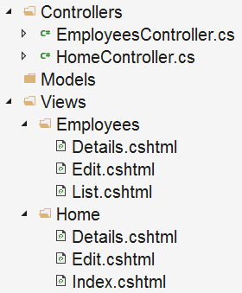

* For each **Controller** we have a separate folder in the **"Views"** folder.
* All the **HomeController** views are in **Home** folder in the **"Views"** folder.
* All the **EmployeesController** views are in **Employees** folder in the **"Views"** folder.
* Each view file has the **same name** as the **controller action method**.

**Views Discovery**   
  
Consider the following HomeController. We have only one action method - Details(). The Details() action returns a View using the View() method. This View() method is provided by the Controller base class.

public class HomeController : Controller  
{  
    public ViewResult Details()  
    {  
        return View();  
    }  
}

Since we are returning a **View** from the action method that is named **Details()**, by default MVC looks for a view file with same name that has .cshtml extension. So in this case, it looks for **Details.cshtml**. It looks for this file in the following 3 locations in the order specified

* First in "/Views/Home/" folder beacause the Controller name is HomeController
* Then in "/Views/Shared/" folder
* Finally in "/Pages/Shared/" folder

If a view file is found, the HTML generated by the view is sent back to the client who made the request. If the view file is not found we get the following error.   
  
InvalidOperationException: The view 'Details' was not found. The following locations were searched:  
/Views/Home/Details.cshtml  
/Views/Shared/Details.cshtml  
/Pages/Shared/Details.cshtml

**Customize view discovery in asp.net core mvc**   
  
In this video we will discuss, **How to customize view discovery in ASP.NET Core MVC**   
  
  
**Default View Discovery in ASP.NET Core MVC**   
  
There are several overloaded versions of View() method in ASP.NET Core MVC. If we use one of the following overloaded versions of View() method, it looks for a view file with the same name as the action method.

* View()
* View(object model)

**For example,** we are returning a View() from the Details action method of the HomeController. So, by default, MVC looks for a view file with name Details.cshtml in "Views/Home" folder.

public class HomeController : Controller  
{  
    public ViewResult Details()  
    {  
        return View();  
    }  
}

**View(string viewName) method**   
  
If you do not like this default convention, you can use the overloaded version of the View(string viewName) method, that takes **viewName** as a parameter, to look for a view file with your own custom name.   
  
In the following example, MVC looks for a view file with name "Test.cshtml" instead of "Details.cshtml". Had we not specified the view name, it would have looked for "Details.cshtml".

public class HomeController : Controller  
{  
    public ViewResult Details()  
    {  
        return View("Test");  
    }  
}

**Specifying view file path**   
  
With this overloaded version, we can either specify a **view name** or a **view file path**. In the following example, we specified the absolute view file path. So in this case, MVC looks for a view file with name "Test.cshtml" in "MyViews" folder. Had we not specified the path to the view file, by default, MVC would look for "Details.cshtml" file in "Views/Home" folder. With the absolute path, the **.cshtml** extension must be specified.

public class HomeController : Controller  
{  
    public ViewResult Details()  
    {  
        return View("MyViews/Test.cshtml");  
    }  
}

**Please note :** With the absolute path, to get to the root project directory, we can use **/** or **~/**. So the following 3 lines of code does the same thing

return View("MyViews/Test.cshtml");  
return View("/MyViews/Test.cshtml");  
return View("~/MyViews/Test.cshtml");

**Relative View File Path**   
  
When specifying a view file path, we can also use a relative path. With relative path we do not specify the file extension **.cshtml**. In the following example, MVC looks for **Update.cshtml** file in **"Views/Test"** folder.

public class HomeController : Controller  
{  
    public ViewResult Details()  
    {  
        return View("../Test/Update");  
    }  
}

If you want to go back up 2 levels in the folder hierarchy, use **../** twice as shown below. In the following example, MVC looks for **"Details.cshtml"** in **"MyViews"** folder in the root project directory

public class HomeController : Controller  
{  
    public ViewResult Details()  
    {  
        return View("../../MyViews/Details");  
    }  
}

**Other view() overloaded versions**

|  |  |
| --- | --- |
| **Overloaded Method** | **Description** |
| View(object model) | Use this overloaded version to pass model data from the controller to the view. We will discuss passing data to the view from the controller in our next video |
| View(string viewName, object model) | Pass both the view name and model data. |
|  |  |

### Viewdata & Viewbag

In this video we will discuss different ways of **passing data to a View from a Controller** in ASP.NET Core MVC.   
  
  
**Three ways to pass data from a controller to a view**   
  
In ASP.NET Core MVC, there are 3 ways to pass data from a controller to a view

1. Using ViewData
2. Using ViewBag
3. Using a strongly typed model object. This is also called **Strongly typed view.**

By using **ViewData** or **ViewBag** to pass data, we are creating a loosely typed view. We will discuss what a loosely typed view means in just a bit.   
  
Using ViewData to pass Data from a Controller to a View  
  
We want to pass **Employee** model data and a Title for the view page from the Details() action method of the HomeController to the Details.cshtml view. So modify the Details() action method in the HomeController as shown below.

public ViewResult Details()  
{  
    Employee model = _employeeRepository.GetEmployee(1);  
  
    // Pass PageTitle and Employee model to the View using ViewData  
    ViewData["PageTitle"] = "Employee Details";  
    ViewData["Employee"] = model;  
  
    return View();  
}

**Accessing ViewData in a View**   
  
To access the ViewData passed by the Details() action method of the HomeController, modify the code in Details.cshtml view file as shown below.

<html>  
<head>  
    <title></title>  
</head>  
<body>  
    <h3>@ViewData["PageTitle"]</h3>  
  
    @{  
        var employee = ViewData["Employee"] as EmployeeManagement.Models.Employee;  
    }  
  
    <div>  
        Name : @employee.Name  
    </div>  
    <div>  
        Email : @employee.Email  
    </div>  
    <div>  
        Department : @employee.Department  
    </div>  
</body>  
</html>

**ViewData**

* ViewData is a dictionary of weakly typed objects.
* To store and retrieve data from the ViewData dictionary we use string keys.
* String data can be accessed from ViewData dictionary without the need to cast the data to string type.
* If we are accessing any other type of data, we need to explicitly cast it to the type we are expecting.
* In our example, we are casting the Employee object to Employee Type before accessing **Name**, **Email** and **Department** properties of the Employee object.
* ViewData is dynamically resolved at runtime, so it does not provide compile-time type checking and as a result we do not get intellisense.
* Since we do not have intellisense, the speed at which we write code is reduced and the chances of mis-spelling and making typographical errors are also high.
* We will only come to know about these errors at run time.
* For this reason we usually do not use ViewData.
* When we use ViewData, we end up creating a loosely typed view.

ViewBag   
  
In this video, we will discuss using **ViewBag** to pass data from the Controller to the view. Along the way, we will also discuss the difference between **ViewData** and **ViewBag**.   
  
  
We discussed using **ViewData** to do the same in our [previous video](https://youtu.be/tz4q6q0_JwQ). In fact, ViewBag is a wrapper around ViewData. With ViewData we use string keys to store and retrieve data. With **ViewBag** we use dynamic properties instead of string keys.   
  
  
**Using ViewBag to pass Data from a Controller to a View**   
  
We want to pass Employee model data and a Title for the view page from the Details() action method of the HomeController to the Details.cshtml view. So modify the Details() action method in the HomeController as shown below.   
  
Notice, we are using dynamic properties (Title and Properties) on the **ViewBag** instead of string keys.

public ViewResult Details()  
{  
    Employee model = _employeeRepository.GetEmployee(1);  
  
    // To store the page title and empoyee model object in the   
    // ViewBag we are using dynamic properties PageTitle and Employee  
    ViewBag.PageTitle = "Employee Details";  
    ViewBag.Employee = model;  
  
    return View();  
}

**Accessing ViewBag in a View**   
  
To access the **ViewBag** data passed by the Details() action method of the HomeController, modify the code in Details.cshtml view file as shown below. Notice, we are using the same dynamic properties PageTitle and Employee to access the **ViewBag** data.

<html>  
<head>  
    <title></title>  
</head>  
<body>  
    <h3>@ViewBag.PageTitle</h3>  
  
    <div>  
        Name : @ViewBag.Employee.Name  
    </div>  
    <div>  
        Email : @ViewBag.Employee.Email  
    </div>  
    <div>  
        Department : @ViewBag.Employee.Department  
    </div>  
</body>  
</html>

**ViewData v/s ViewBag**

* Both **ViewData** and **ViewBag** can be used to pass data from a Controller to a View
* **ViewBag** is a wrapper around **ViewData**
* Both of them create a loosely typed view
* With **ViewData** we use string keys to store and retrieve data from the **ViewData** dictionary
* With **ViewBag** we use dynamic properties to store and retrieve data
* Both **ViewData** keys and **ViewBag** dynamic properties are resolved dynamically at runtime.
* Both **ViewData** and **ViewBag** does not provide compile-time type checking and as a result we do not get intellisense.
* Since we do not have intellisense, the speed at which we write code is reduced and the chances of mis-spelling and making typographical errors are also high.
* We will only come to know about these errors at run time.
* For this reason we usually do not use **ViewData** or **ViewBag**.
* The preferred approach to pass data from a controller to a view is by using a strongly typed model object.
* Using a strongly typed model object creates a **strongly typed view**.

### Strongly Typed View in ASP.NET Core MVC

In this video we will discuss creating a **Strongly Typed View in ASP.NET Core MVC**   
  
  
In ASP.NET Core MVC, there are 3 ways to pass data from a controller to a view

1. Using a strongly typed model object. This is also called Strongly typed view.
2. Using ViewData
3. Using ViewBag

**Strongly Typed View - Controller Code**   
  
The preferred approach to pass data from a controller to a view is by using a **strongly typed view.** To create a strongly typed view, in the controller action method, pass the model object to the View() helper method. Notice, in the example below, we are passing the Employee model object to the View() method.

public ViewResult Details()  
{  
    Employee model = _employeeRepository.GetEmployee(1);  
  
    ViewBag.PageTitle = "Employee Details";  
  
    return View(model);  
}

**Strongly Typed View - View Code**   
  
To create a **strongly typed view** specify the model type in the view using @model directive. In the example below, we told the view that it will using the EmployeeManagement.Models.Employee object as the model by using @model directive. Please note that in the directive(@model), **m** is in lowercase.   
  
To access the model object properties we use @Model. In @Model, M is in uppercase. In the example, below to access the Employee object properties like Name, Email and Department we are using @Model.Name, @Model.Email and @Model.Department respectively.

@model EmployeeManagement.Models.Employee

<html>

<head>

<title></title>

</head>

<body>

<h3>@ViewBag.PageTitle</h3>

<div>

Name : @Model.Name

</div>

<div>

Email : @Model.Email

</div>

<div>

Department : @Model.Department

</div>

</body>

</html>

**Strongly Typed View Benefits**   
  
Unlike **ViewData** and **ViewBag**, a **strongly typed view** provides **compile-time type checking** and **intellisense**. With intellisense support we can be more productive and the chances of mis-spelling and making typographical errors are almost nill. If we do make any errors we will come to know about them at compile time rather than at runtime. So always use a **strongly typed view** to pass data from a controller to a view.   
  
**What about PageTitle**   
  
In our example, we are still using **ViewBag** to pass PageTitle from the Controller to the View. How can we use a strongly typed view to pass PageTitile. Well, this is one example, where we can use a view specific model called **ViewModel**.

### **ViewModel** in ASP.NET Core MVC

**In this video, we will discuss**

* Why we need a ViewModel in ASP.NET Core MVC
* ViewModel example in ASP.NET Core MVC

**Why do we need a ViewModel in ASP.NET Core MVC**  
  
In some cases, a model object may not contain all the data a view needs. This is when we create a **ViewModel**. It contains all the data a view needs.  
  
  
Consider the following Details() action method. Notice, we are passing Employee details and PageTitle to the View. We are using Employee model object to pass Employee details and ViewBag to pass PageTitle.

public class HomeController : Controller  
{  
    // Other Code  
  
    public ViewResult Details()  
    {  
        Employee model = _employeeRepository.GetEmployee(1);  
        ViewBag.PageTitle = "Employee Details";  
  
        return View(model);  
    }  
}

Using ViewBag to pass data from a controller to a view creates a loosely typed view and as a result we will not have intellisense and compile-time type and error checking. It does not make any sense, to include PageTitle property in the Employee class, because an Employee class should only contain Employee related properties.   
  
This is when we create a class, that contains all the data a view needs. This class is called a ViewModel.   
  
**ViewModel Example**   
  
**ViewModel** classes can live anywhere in your ASP.NET Core MVC project, but to keep things better organised, we usually place them in a folder that is named **ViewModels**   
  
We named the **ViewModel** class HomeDetailsViewModel. We have the word "Home" in the name, because, the name of the Controller is HomeController. The word "Details" because, the name of the action method is Details()   
  
This ViewModel class contains all the data the view needs. In general, we use **ViewModels** to shuttle data between a View and a Controller. For this reason ViewModels are also called as **Data Transfer Objects** or **DTO** in short.   
  
We can now use this ViewModel to pass both Employee details and PageTitle from the Controller to the View

namespace EmployeeManagement.ViewModels  
{  
    public class HomeDetailsViewModel  
    {  
        public Employee Employee { get; set; }  
        public string PageTitle { get; set; }  
    }  
}

Employee class is in **EmployeeManagement.Models** namespace, so please don't forget to include the following **using** statement.

using EmployeeManagement.Models;

**Using ViewModel - Controller Code**

public ViewResult Details()  
{  
    // Instantiate HomeDetailsViewModel and store Employee details and PageTitle  
    HomeDetailsViewModel homeDetailsViewModel = new HomeDetailsViewModel()  
    {  
        Employee = _employeeRepository.GetEmployee(1),  
        PageTitle = "Employee Details"  
    };  
  
    // Pass the ViewModel object to the View() helper method  
    return View(homeDetailsViewModel);  
}

**Using ViewModel - View Code**

* The view has access to the **ViewModel** object that the controller has passed using the View() helper method
* Using the @model directive, set HomeDetailsViewModel as the Model for the view
* We can then access Employee details and PageTitle uisng @Model property
* Please note, @model directive has a lowercase **"m"** and @Model property has a capital letter **"M"**

@model EmployeeManagement.ViewModels.HomeDetailsViewModel

<html>

<head>

<title></title>

</head>

<body>

<h3>@Model.PageTitle</h3>

<div>

Name : @Model.Employee.Name

</div>

<div>

Email : @Model.Employee.Email

</div>

<div>

Department : @Model.Employee.Department

</div>

</body>

</html>

### List view in asp.net core mvc

In this video, we will discuss **implementing List view in asp.net core mvc**.    
  
  
**Example**   
  
Let's understand this with an example. We want to retrieve all the employees and display them on a web page as shown below. At the moment, from styling perspective the page does not look that good. In our upcoming videos in this series we will install Bootstrap and style the page to make it look good.   
  
  
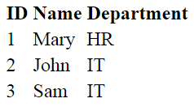  
  
**IEmployeeRepository - Code Change**   
  
Modify IEmployeeRepository interface to include GetAllEmployees() method. As you can see this method returns the list of all employees.

public interface IEmployeeRepository  
{  
    Employee GetEmployee(int Id);  
    IEnumerable<Employee> GetAllEmployees();  
}

**MockEmployeeRepository - Code Change**   
  
At the moment, in our application we have only one class (MockEmployeeRepository) that implements IEmployeeRepository interface. So modify, MockEmployeeRepository class to provide implementation for GetAllEmployees() method as shown below. Notice, GetAllEmployees() returns the hard-coded list of employees we have in the private field _employeeList.    
  
In our upcoming videos, we will provide another implementation for IEmployeeRepository interface. This new implementation will retrieve employees from a SQL server database.

public class MockEmployeeRepository : IEmployeeRepository

{

private List<Employee> _employeeList;

public MockEmployeeRepository()

{

_employeeList = new List<Employee>()

{

new Employee() { Id = 1, Name = "Mary", Department = "HR", Email = "mary@pragimtech.com" },

new Employee() { Id = 2, Name = "John", Department = "IT", Email = "john@pragimtech.com" },

new Employee() { Id = 3, Name = "Sam", Department = "IT", Email = "sam@pragimtech.com" },

};

}

public IEnumerable<Employee> GetAllEmployees()

{

return _employeeList;

}

public Employee GetEmployee(int Id)

{

return this._employeeList.FirstOrDefault(e => e.Id == Id);

}

}

**HomeController - Code Change**   
  
Modify, Index() action method in the HomeController as shown below. Notice, we retrieve the list of employees by calling GetAllEmployees() method and pass that list to the View.

public class HomeController : Controller

{

private IEmployeeRepository _employeeRepository;

public HomeController(IEmployeeRepository employeeRepository)

{

_employeeRepository = employeeRepository;

}

public ViewResult Index()

{

// retrieve all the employees

var model = _employeeRepository.GetAllEmployees();

// Pass the list of employees to the view

return View(model);

}

public ViewResult Details()

{

HomeDetailsViewModel homeDetailsViewModel = new HomeDetailsViewModel()

{

Employee = _employeeRepository.GetEmployee(1),

PageTitle = "Employee Details"

};

return View(homeDetailsViewModel);

}

}

**Index.cshtml - Code Change**

* Set IEnumerable<EmployeeManagement.Models.Employee> as the model for the view using @model directive
* Use the foreach loop to loop over each employee in the list of employees and dynamically generate a table row and table cells to display ID, Name and Department property values.

@model IEnumerable<EmployeeManagement.Models.Employee>

<html>

<head>

<title></title>

</head>

<body>

<table>

<thead>

<tr>

<th>ID</th>

<th>Name</th>

<th>Department</th>

</tr>

</thead>

<tbody>

@foreach (var employee in Model)

{

<tr>

<td>

@employee.Id

</td>

<td>

@employee.Name

</td>

<td>

@employee.Department

</td>

</tr>

}

</tbody>

</table>

</body>

</html>

### Layout view

Most of the web apps have the following sections

Header

* Footer
* Navigation menu
* View specific content

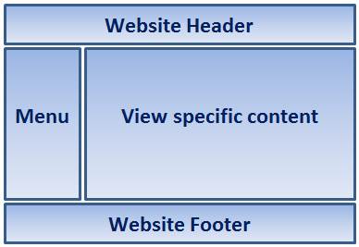  
  
Without a Layout View, we would repeat all the HTML for these different sections in every view in our application. With this duplicated HTML in every view, maintaining our application would be a night mare, if for example, we have to add or remove a menu item from the navigation menu or change header or footer. We would have to do this change, in every view, which is obviously tedious, monotonous, time consuming and error prone.   
  
Rather than having all of these sections, in each and every view, we can define them in a layout view and then inherit that look and feel in all the views. With layout views, maintaining the consistent look and feel across all the views becomes much easier, as we have only one layout file to modify, should there be any change. The change will then be immediately reflected across all the views in our entire application.   
  
**Layout View in ASP.NET Core MVC**

* Just like a regular view a layout view is also a file on the file system with a **.cshtml** extension
* You can think of a layout view as a master page in asp.net web forms.
* Since a layout view is not specific to a controller, we usually place the layout view in a sub folder called **"Shared"** in the **"Views"** folder
* By default, in ASP.NET Core MVC, the layout file is named **_Layout.cshtml**.
* In ASP.NET Core MVC, the file names of other .cshtml files like **_ViewStart.cshtml** and **_ViewImports.cshtml** start with an underscore.
* The leading underscore in the file name indicates that these files are not intended to be served directly by the browser.
* It is also possible to have multiple layout files in a single application. Perhaps one layout file for all admin users and a different layout file for all non admin users.

**Creating a Layout View**

1. Right click on **"Views"** folder and add **"Shared"** folder.
2. Right click on **"Shared"** folder and select **"Add"** - **"New Item"**
3. In the **"Add New Item"** window search for Layout
4. Select **"Razor Layout"** and click the **"Add"** button
5. A file with name **_Layout.cshtml** will be added to the **"Shared"** folder

**Auto-generated HTML in _Layout.cshtml file**   
  
The following is the default generated HTML in **_Layout.cshtml**.

<!DOCTYPE html>

<html>

<head>

<meta name="viewport" content="width=device-width" />

<title>@ViewBag.Title</title>

</head>

<body>

<div>

@RenderBody()

</div>

</body>

</html>

Notice, the standard html, head, title and body elements are in this layout file. Since we now have them in the layout file, we do not have to repeat all this HTML in every view. At the moment, we do not have a navigation menu. We will include it in the layout view in our upcoming videos.   
  
View specific title is retrieved using @ViewBag.Title expression. For example, when "index.cshtml" view is rendered using this layout view, index.cshtml will set Title property on the ViewBag. This is then retrieved by the Layout view using the expression @ViewBag.Title and set as the value for the <title> tag.   
  
ViewBag does not provide intellisense and compile-time error checking. So using it to pass large amount of data from a regular razor view to a Layout view is not great, but for passing something very small like PageTitle, ViewBag is OK.   
  
@RenderBody() is the location where view specific content is injected. For example, if index.chtml view is rendered using this layout view, index.cshtml view content is injected at the location where we have @RenderBody() method call.

**Using the Layout View**   
  
To render a view using the layout view (_Layout.cshtml) set the Layout property. For example, to use the Layout view with details.cshtml, modify the code in details.cshtml to include the Layout property as shown below.

@model EmployeeManagement.ViewModels.HomeDetailsViewModel

@{

Layout = "~/Views/Shared/_Layout.cshtml";

ViewBag.Title = "Employee Details";

}

<h3>@Model.PageTitle</h3>

<div>

Name : @Model.Employee.Name

</div>

<div>

Email : @Model.Employee.Email

</div>

<div>

Department : @Model.Employee.Department

</div>

We have a better way of setting the Layout property, instead of setting it in every view. We will discuss this in our upcoming videos.

### Sections in layout page

Section in a Layout View   
  
A layout page in ASP.NET Core MVC can also include a section. A section can be optional or mandatory. It provides a way to organize where certain page elements should be placed.   
  
Example    
  
You have a custom JavaScript files that is only needed by a few views in your application. It's a good practice to place the script files at the bottom of the page before the closing </body> tag.   
  
If the custom script file is required by all the views then we could place it in the Layout page as shown below.

<html>

<head>

<meta name="viewport" content="width=device-width" />

<title>@ViewBag.Title</title>

</head>

<body>

<div>

@RenderBody()

</div>

<script src="~/js/CustomScript.js"></script>

</body>

</html>

In our case, we do not need the custom JavaScript file in every view. Let's assume we only need it in the Details view but not in the other views. This is one example where we could make use of a **section.**   
  
**Rendering the Section**  
  
In the layout page, call RenderSection() method at the location where you want the section content to be rendered. In our case, we want the script file to be included just before the closing </body> tag. This is the reason we have placed the call to @RenderSection() method just before the closing </body> tag.    
  
RenderSection() method has 2 parameters. The first parameter specifies the name of the section. The second parameter parameter specifies if the section is required or optional.

<html>

<head>

<meta name="viewport" content="width=device-width" />

<title>@ViewBag.Title</title>

</head>

<body>

<div>

@RenderBody()

</div>

@RenderSection("Scripts", required: false)

</body>

</html>

If required is set to true and if a content view does not include the section, we get the following error.   
  
InvalidOperationException: The layout page '/Views/Shared/_Layout.cshtml' cannot find the section 'Scripts' in the content page '/Views/Home/Index.cshtml'.   
  
**Making the layout section optional**   
  
There are 2 options to mark a layout section as optional   
  
**Option 1 :** Set required parameter of RenderSection() method to false

@RenderSection("Scripts", required: false)

**Option 2 :** Use IsSectionDefined() method

@if (IsSectionDefined("Scripts"))  
{  
    @RenderSection("Scripts", required: false)  
}

**Providing Section Content**   
  
Every view that intends to provide content for the section, must include a section with the same name. We use @section directive to include the section and provide the content as shown below.   
  
In our case, we want the details view to include <script> tag in the "Scripts" section in the layout page. To achieve this we include "Scripts" section in Details.cshtml as shown below.

@model EmployeeManagement.ViewModels.HomeDetailsViewModel

@{

Layout = "~/Views/Shared/_Layout.cshtml";

}

<h3>@Model.PageTitle</h3>

<div>

Name : @Model.Employee.Name

</div>

<div>

Email : @Model.Employee.Email

</div>

<div>

Department : @Model.Employee.Department

</div>

@section Scripts {

<script src="~/js/CustomScript.js"></script>

}

**Testing**   
  
With these changes in place, if we navigate to /Home/Details we see the <script> tag included just before the closing </body> tag. If we navigate to /Home/Index we do not see the <script> tag.

### _Viestart.cshtml

**Setting the Layout property**   
  
We use the Layout property to associate a view with a layout view. Without the _ViewStart.cshtml file, we set the Layout property in each and every view. This violates DRY (Don't Repeat Yourself) principle, and has the following disadvantages

1. Redundant code.
2. Maintenance overhead.

To use a different layout file, all the individual views need to be updated. This is not only tedious and time-consuming process, but also error prone.   
  
**What is _ViewStart.cshtml file in ASP.NET Core MVC**   
  
It's a special file in ASP.NET Core MVC. The code in this file is executed before the code in an individual view is executed. So this means, instead of setting the Layout property in each individual view, we can move that code into the _ViewStart.cshtml file.

@{  
    Layout = "_Layout";  
}

By setting the Layout property in _ViewStart.cshtml file maintaining our application becomes much easier. In the future, if we want to use a different layout file we just need to change the code in one place in _ViewStart.cshtml.   
  
**_ViewStart.cshtml file is hierarchical**   
  
We usually place the **ViewStart** file in the **Views** folder. Since this file is hierarchical we can also place it in any sub-folder in the Views folder.   
  
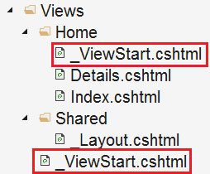  
  
In the folder hierarchy above, we have placed one **ViewStart** file in the **Views** folder and another **ViewStart** file in the **Home** sub-folder. The layout page specified in the ViewStart file in the Home sub-folder overwrites the layout page specified in the ViewStart file in the Views folder.   
  
This means, all the views in the **Views** folder will use the the layout page specified in the ViewStart file in the Views, but then the views in the Home folder will use the layout page specified in the ViewStart file in the Home folder.

**Please note :** If you want to use a layout file that is different from what is specified in _ViewStart.cshtml, you can do so by setting the Layout property in an individual view. You can also set the Layout property to null, if you want your view to be rendered without a layout view.   
  
**Logic to select layout view**   
  
In an ASP.NET Core MVC application, we can have multiple layout views. Let's say for example, we have the following 2 layout views in our application.

1. _AdminLayout.cshtml
2. _NonAdminLayout.cshtml

The following logic in _ViewStart.cshtml will select the layout view spending on the logged-in user role.

@{  
    if (User.IsInRole("Admin"))  
    {  
        Layout = "_AdminLayout";  
    }  
    else  
    {  
        Layout = "_NonAdminLayout";  
    }  
}

### _ViewImports.cshtml in ASP.NET Core MVC

In this short video, we will discuss **_ViewImports.cshtml file in ASP.NET Core MVC**   
  
**_ViewImports.cshtml** file is usually placed in the **Views** folder. It is used to include the common namespaces so we do not have to include them in every view that needs those namespaces.    
  
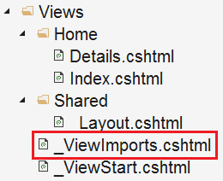  
  
For example, if we include the following 2 namespaces in the **ViewImports** file, then all the types in these 2 namespaces are available to every view in the **"Home"** folder without having to type the fully qualified name of the Type.    
  
@using EmployeeManagement.Models;  
@using EmployeeManagement.ViewModels;   
  
Notice, @using directive is used to include the common namespaces. In addition to @using directive, _ViewImports file also supports the following directives.

@addTagHelper  
@removeTagHelper  
@tagHelperPrefix  
@model  
@inherits  
@inject

**TagHelpers** are new in this version of MVC. We will discuss them in detail in our upcoming videos.   
  
**_ViewImports file is hierarchical**   
  
Just like, _ViewStart file, _ViewImports file is also hierarchical. In addition to placing it in the Views folder, we can also place another _ViewImports in the "Home" sub-folder in the Views folder.    
  
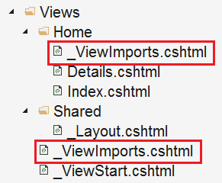  
  
The settings specified in the _ViewImports file in the **Home** sub-folder overwrites the settings specified in the _ViewImports file in the Views folder.    
  
**Please note :** If a setting is specified in the view itself, then that setting overrides the matching settings in the parent _ViewImports files in the folder hierarchy.

### Routing (Conventional)

In this video, we will discuss **Routing in ASP.NET Core MVC.**   
  
There are 2 routing techniques in ASP.NET Core MVC. **Conventional Routing** and **Attribute Routing**. In this video, we will discuss Conventional Routing and in our next video we will discuss Attribute Routing.   
  
When a request from the browser arrives at our application, it is the controller in the MVC design pattern, that handles the incoming http request and responds to the user action. The incoming request URL is mapped to a controller action method. This mapping is done by the routing rules defined in our application.   
  
For example, when a request is issued to /Home/Index, this URL is mapped to the Index() action method in the HomeController class.   
  
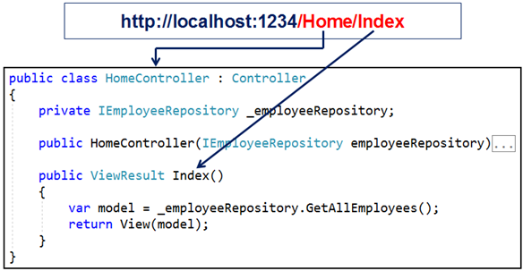  
  
Similarly, when a request is issued to /Home/Details/1, this URL is mapped to the Details() action method in the HomeController class. The value 1 in the URL is automatically mapped to the "id" parameter of the Details(int id) action method.

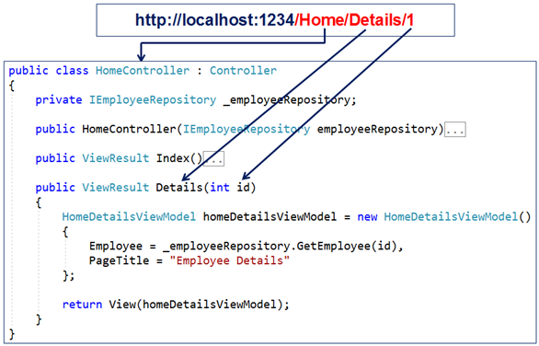  
  
At the moment, we have not explicitly defined any routing rules in our ASP.NET Core MVC application. So the question that comes to our mind is, how is this URL (/Home/Index) mapped to the Index() action method in the HomeController.   
  
**Default Route in ASP.NET Core MVC**   
  
The following is the code in the Configure() method in Startup.cs file. The code in this method sets up the HTTP request processing pipeline. We discussed this method in our previous videos of this ASP.NET Core tutorial.

public void Configure(IApplicationBuilder app, IHostingEnvironment env)  
{  
    if (env.IsDevelopment())  
    {  
        app.UseDeveloperExceptionPage();  
    }  
  
    app.UseStaticFiles();  
  
    app.UseMvcWithDefaultRoute();  
}

In this method we have a call to UseMvcWithDefaultRoute() extension method. It is this method, that adds MVC with the following default route to our application's request processing pipeline.

{controller=Home}/{action=Index}/{id?}

You can see the default route from the intellisense, just by hovering the mouse over UseMvcWithDefaultRoute() in visual studio. Also, ASP.NET Core is opensource. So you can also see the code of UseMvcWithDefaultRoute() method on their GITHUB page at the following link.   
  
<https://github.com/aspnet/Mvc/blob/release/2.2/src/Microsoft.AspNetCore.Mvc.Core/Builder/MvcApplicationBuilderExtensions.cs>   
  
**Code in UseMvcWithDefaultRoute()**   
  
For your quick reference, the following is the code from the above GITHUB page. Notice, UseMvcWithDefaultRoute() method internally calls UseMvc() method and it sets up the default route.

public static IApplicationBuilder UseMvcWithDefaultRoute(this IApplicationBuilder app)  
{  
    if (app == null)  
    {  
        throw new ArgumentNullException(nameof(app));  
    }  
  
    return app.UseMvc(routes =>  
    {  
        routes.MapRoute(  
            name: "default",  
            template: "{controller=Home}/{action=Index}/{id?}");  
    });  
}

**Understanding the default route**   
  
The default route template "{controller=Home}/{action=Index}/{id?}" maps most URL's that have the following pattern   
  
http://localhost:1234/Employees/Details/1   
  
In the above example

|  |  |
| --- | --- |
| **Path Segment** | **Maps to** |
| /Employees | EmployeesController class |
| /Details | Details(int id) action method |
| /1 | id parameter of the Details(int id) action method |

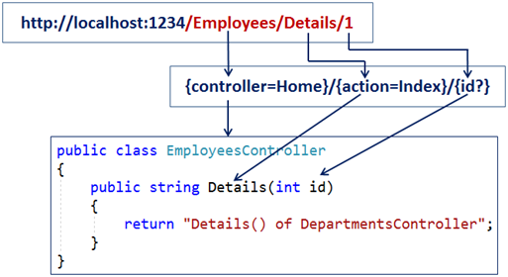  
  
The first URL path segment "/Employees" is mapped to the "EmployeesController". In the URL we do not have to have the word Controller. When MVC finds the word /Employee in the first URL path segment, it appends the word Controller and looks for a class with name EmployeesController.   
  
The second URL path segment "/Details" is mapped to the Details(int id) action method in the EmployeesController.

The third path segment **"1"** is mapped to the id parameter of the Details(int id) action method. This is done by a process called **model binding**. We will discuss model binding in detail in our upcoming videos.   
  
Notice in the following default route template, we have a question mark after the id parameter.   
The default route template **"{controller=Home}/{action=Index}/{id?}"**   
  
The question mark, makes the id parameter in the URL optional. This means both the following URLs will be mapped to the Details() action method of the EmployeesController class.   
  
/Employees/Details/1  
/Employees/Details   
 **The value "Home" in {controller=Home} is the default value for the Controller. Similarly the value "Index" in {action=Index} is the default value for the action method.**  
So with these default values in place, if we navigate to the application root URL like the following. Notice in the URL we do not have the Controller and Action method path segments. So the default values will be used and the request will be mapped to the Index() action method of the HomeController class.  
http://localhost:1234   
  
Along the same lines both the following request URL's will also be mapped to the Index() action method of the HomeController class.  
http://localhost:1234/Home  
http://localhost:1234/Home/Index   
  
For most applications the default route works just fine. For example, if you have the following DepartmentsController.

public class DepartmentsController : Controller  
{  
    public string List()  
    {  
        return "List() of DepartmentsController";  
    }  
  
    public string Details()  
    {  
        return "Details() of DepartmentsController";  
    }  
}

The URL "/departments/list" is mapped to the List() action method of the DepartmentsController and the URL "/departments/details" is mapped to the Details() action method of the DepartmentsController.   
  
**UseMvc or UseMvcWithDefaultRoute**   
  
If you want to define your own route templates and want to have more control over the routes, use UseMvc() method, instead of UseMvcWithDefaultRoute() method.

app.UseMvc(routes =>  
{  
    routes.MapRoute("default", "{controller=Home}/{action=Index}/{id?}");  
});

### Attribute Routing in ASP.NET Core MVC

Consider the following code in Configure() method of Startup.cs file. Notice we are using UseMvc() method without passing the default route template as a parameter.

public void Configure(IApplicationBuilder app, IHostingEnvironment env)  
{  
    if (env.IsDevelopment())  
    {  
        app.UseDeveloperExceptionPage();  
    }  
  
    app.UseStaticFiles();  
  
    app.UseMvc();  
  
    //app.UseMvc(routes =>  
    //{  
    //    routes.MapRoute("default", "{controller=Home}/{action=Index}/{id?}");  
    //});  
}

This means, at the moment our application does not have any routes configured and when we navigate to any of the following URLs we see 404 errors.   
  
http://localhost:1234  
http://localhost:1234/home  
http://localhost:1234/home/index   
  
**Attribute Routing Example**   
  
With attribute routing, we use the Route attribute to define our routes. We could apply the Route attribute on the Controller or on the Controller Action Methods.   
  
**Consider the example below.**

public class HomeController : Controller  
{  
  
    [Route("")]  
    [Route("Home")]  
    [Route("Home/Index")]  
    public ViewResult Index()  
    {  
        return View();  
    }  
}

The Route() attribute is specified 3 times on the Index() action method. With each instance of the Route() attribute we specified a different route template. With these 3 route templates in place, the Index() action method of the HomeController will be executed for any of the following 3 URL paths.   
  
/  
/Home  
/Home/Index  
  
**Attribute Routing Parameters**   
  
With conventional routing we can specify route parameter as part of the route template. We can do the same with attribute routing as well. Consider the example below.

public class HomeController : Controller

{

private IEmployeeRepository _employeeRepository;

public HomeController(IEmployeeRepository employeeRepository)

{

_employeeRepository = employeeRepository;

}

[Route("Home/Details/{id}")]

public ViewResult Details(int id)

{

HomeDetailsViewModel homeDetailsViewModel = new HomeDetailsViewModel()

{

Employee = _employeeRepository.GetEmployee(id),

PageTitle = "Employee Details"

};

return View(homeDetailsViewModel);

}

}

Details() action method has id parameter. This parameter specifies the id of the employee whose details we want to view. Notice in the route template we specified id parameter. So the URL (/Home/Details/1) will execute the Details(int id) action method and maps the value "1" to the "id" parameter of the Details(int id). This is done by a process called **Model binding**. We will discuss model binding in our upcoming videos.   
  
**Attribute Route Optional Parameters**  
  
At the moment, the Details(int id) action method of the HomeController is executed, only if we have a value for the "id" route parameter in the URL(/Home/Details/1). If the id value is not in the URL, we get 404. For example, URl /Home/Details will not execute the Details(int id) action method. Instead 404 error is displayed.  
  
To make the route parameter **"id"** optional, simply include a **"?"** at the end.

public class HomeController : Controller

{

private IEmployeeRepository _employeeRepository;

public HomeController(IEmployeeRepository employeeRepository)

{

_employeeRepository = employeeRepository;

}

// The ? makes id route parameter optional. To make it required remove ?

[Route("Home/Details/{id?}")]

// ? makes id method parameter nullable

public ViewResult Details(int? id)

{

HomeDetailsViewModel homeDetailsViewModel = new HomeDetailsViewModel()

{

// If "id" is null use 1, else use the value passed from the route

Employee = _employeeRepository.GetEmployee(id ?? 1),

PageTitle = "Employee Details"

};

return View(homeDetailsViewModel);

}

}

**Controller and Action Method Names**   
  
With attribute routing the controller name and action method names play no role in which action is selected. Consider the example below.

public class WelcomeController : Controller

{

[Route("")]

[Route("Home")]

[Route("Home/Index")]

public ViewResult Welcome()

{

return View();

}

}

Since we have specified the route template directly on the action method, Welcome() action in the WelcomeController is executed for all the following 3 URL paths.    
  
**/**  
**/Home**  
**/Home/Index**  
  
**Attribute Routes are Hierarchical**  
  
The Route() attribute can be applied on the Controller class as well on the individual actions. To make attribute routing less repetitive, route attributes on the controller are combined with route attributes on the individual action methods.   
  
Consider the example below

public class HomeController : Controller

{

private IEmployeeRepository _employeeRepository;

public HomeController(IEmployeeRepository employeeRepository)

{

_employeeRepository = employeeRepository;

}

[Route("")]

[Route("Home")]

[Route("Home/Index")]

public ViewResult Index()

{

var model = _employeeRepository.GetAllEmployees();

return View(model);

}

[Route("Home/Details/{id?}")]

public ViewResult Details(int? id)

{

HomeDetailsViewModel homeDetailsViewModel = new HomeDetailsViewModel()

{

Employee = _employeeRepository.GetEmployee(id ?? 1),

PageTitle = "Employee Details"

};

return View(homeDetailsViewModel);

}

}

Index() action method of the HomeController is executed for the following 3 URL paths  
  
**/Home**  
**/Home/Index**   
  
Details(int? id) action method of the HomeController is executed for the following 2 URL paths   
  
**/Home/Details**  
**/Home/Details/2**   
  
As you can see there is lot of repetition. To make these routes less repetitive, apply the Route() attribute on the HomeController class as shown below.

[Route("Home")]

public class HomeController : Controller

{

private IEmployeeRepository _employeeRepository;

public HomeController(IEmployeeRepository employeeRepository)

{

_employeeRepository = employeeRepository;

}

[Route("")]

[Route("Index")]

public ViewResult Index()

{

var model = _employeeRepository.GetAllEmployees();

return View(model);

}

[Route("Details/{id?}")]

public ViewResult Details(int? id)

{

HomeDetailsViewModel homeDetailsViewModel = new HomeDetailsViewModel()

{

Employee = _employeeRepository.GetEmployee(id ?? 1),

PageTitle = "Employee Details"

};

return View(homeDetailsViewModel);

}

}

The Route template applied on the controller is prepended to the route template applied on the action. However, when we navigate to the root URL (http://localhost:1234), the Index() action method of the HomeController will not be executed. We instead see 404. To address this, include route template that begins with **"/"** on the Index() action method as shown below.

[Route("/")]

[Route("")]

[Route("Index")]

public ViewResult Index()

{

var model = _employeeRepository.GetAllEmployees();

return View(model);

}

One very important point to keep in mind is, the controller route template is not combined with action method route template if the route template on the action method begins with **/** or **~/**   
  
**Tokens in Attribute Routing**  
  
Attribute routes support token replacement by enclosing a token in square-braces ([ ]). The tokens [controller] and [action] are replaced with the values of the controller name and action name where the route is defined.   
  
Consider this example.

[Route("[controller]")]

public class DepartmentsController : Controller

{

[Route("[action]")]

public string List()

{

return "List() of DepartmentsController";

}

[Route("[action]")]

public string Details()

{

return "Details() of DepartmentsController";

}

}

With the controller and action tokens in place, the URL /Departments/List executes the List() action in the DepartmentsController. Similarly the URL /Departments/Details executes Details() action in the DepartmentsController.   
  
This is a very powerful technique because, later if we rename the controller or action name we do not have to change our route templates. The application just works with the new controller and action names.   
  
To make the List() action the default action for the DepartmentsController, you can still include the Route("") attribute with an empty string as shown below.

[Route("[controller]")]

public class DepartmentsController : Controller

{

[Route("[action]")]

[Route("")] // Makes List(), the default action

public string List()

{

return "List() of DepartmentsController";

}

[Route("[action]")]

public string Details()

{

return "Details() of DepartmentsController";

}

}

Instead of including the [action] token on every action method in a controller, we can apply it just once on the controller as shown below.

[Route("[controller]/[action]")]

public class DepartmentsController : Controller

{

public string List()

{

return "List() of DepartmentsController";

}

public string Details()

{

return "Details() of DepartmentsController";

}

}

**Conventional Routing vs Attribute Routing**   
  
With attribute routing, routes are placed next to the action methods that will actually use them. Attribute routes offer a bit more flexibility than conventional routes. However, in general, conventional routes are used for controllers that serve HTML pages, and attribute routes for controllers that serve REST APIs. However, there is nothing stopping us from mixing conventional routing with attribute routing in a single application to get a bit more flexibility with routes.

### Instalacija Bootstrap Libman

Install and use Bootstrap in ASP.NET Core   
**Tools to install client-side packages**   
  
There are many tools that we can use with Visual Studio to install client-side packages like Bootstrap and jQuery. For example we could use tools like Bower, NPM, WebPack etc.   
  
  
However, we are not going to use any of these tools. We will instead use **Library Manager** (LibMan for short). Library Manager is a light-weight, client-side library acquisition tool. It downloads client-side libraries and frameworks from the file system or from a CDN (Content Delivery Network).   
  
To be able to use LibMan you should have Visual Studio 2017 version 15.8 or later  
  
**Check and Upgrade Visual Studio Version**   
  
**To check the version of Visual Studio you have**

* Click on the "Help" menu item and
* Select "About Microsoft Visual Studio" from the context menu
* The window that appears, displays the version of Visual Studio you have
* On my machine I have 15.9.4

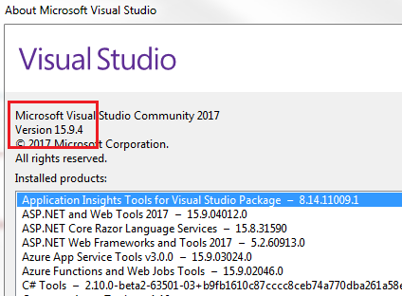  
  
If you have an older version of Visual Studio 2017, you can easily update it.    
  
**To update visual studio version**

* Click on the "Help" menu item and
* Select "Check for Updates" from the context menu
* The subsequent window that appears display your current version and the latest available version.
* Simply click the "Update" button

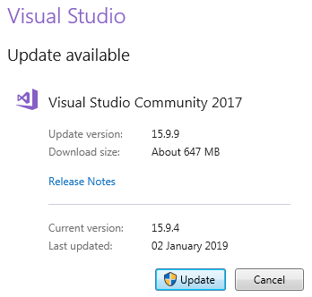  
  
**Install Bootstrap Using LibMan**

* Right click on the "Project Name" in Solution Explorer and Select Add > Client-Side Library. In the "Add Client-Side Library" window that opens
* Leave the default provider which is cdnjs
* In the "Library" text box, type "twitter-bootstrap". Upon selecting the matching entry, it tries to install the latest version. However, you can manually type the version you want. You also have intellisense support. We will install the lates Bootstrap version 4.
* You can either include "All the library file" or "Just the files you need"
* In the "Target Location" text box specify the folder where you want the library files to be copied. Recollect, by default static files are only served from WWWRoot folder.
* Click the "Install" Button

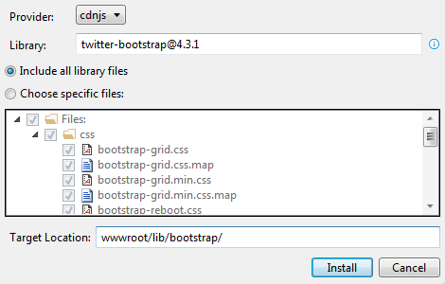  
  
**libman.json file**   
  
**libman.json** is the Library Manager manifest file. Notice in the manifest file we have an entry for the Bootstrap client-side library that we just installed. We can also directly edit the manifest file to install client-side packages, instead of using the user interface provided by LibMan.   
  
**Clean and Restore Client-Side Libraries**   
  
To clean library files, right click on libman.json file and select "Clean Client-Side Libraries" from the context menu. The clean operation deletes the library files from the destination folder. However, the entries in libman.json will not be deleted.   
  
To restore the deleted files, right click on libman.json file and select "Restore Client-Side Libraries" from the context menu. The restore operation will download and copy the library files into the specified destination folder.   
  
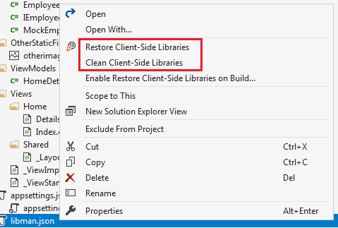  
  
**Uninstall or Update a Client-Side Library**

* Open libman.json file
* Click on the client-side library you want to uninstall
* A light bulb icon appears
* Click on the light bulb icon and you will have options to either update or uninstall that specific client-side library

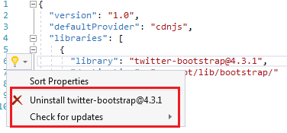  
  
Alternatively, you can also just delete the client-side library entry in libman.json file and upon saving the file, the respective client-side library will be uninstalled.   
  
Similarly, to upgrade or downgrade a client-side library, you can directly change the version number in libman.json file. Upon saving the file, the respective client-side library is updated to the version specified. You will also have intellisense when editing the version number in visual studio.   
  
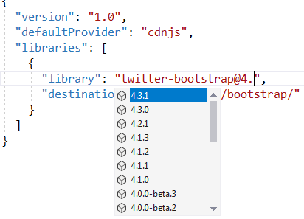  
  
**Site Specific CSS**   
  
We will be placing all our site specific CSS in a separate stylesheet. Add a stylesheet with name site.css to the "css" folder. We already created this "css" in "wwwroot" folder.   
  
**Copy and paste the following .btn class in site.css**   
  
.btn {  
    width: 75px;  
}   
  
**Using Bootstrap in ASP.NET Core Application**   
  
To start using Bootstrap in your asp.net core application, include a reference to the Boostrap.css file in the layout file _Layout.cshtml. Also include a reference to our custom stylesheet site.css.   
  
**The following is the code in _Layout.cshtml**

<html>

<head>

<meta name="viewport" content="width=device-width" />

<link href="~/lib/bootstrap/css/bootstrap.css" rel="stylesheet" />

<link href="~/css/site.css" rel="stylesheet" />

<title>@ViewBag.Title</title>

</head>

<body>

<div class="container">

@RenderBody()

</div>

@if (IsSectionDefined("Scripts"))

{

@RenderSection("Scripts", required: false)

}

</body>

</html>

**Please note :** We are using the Bootstrap "container" class for positioning elements on the page.   
  
**Styling Details.cshtml View**   
  
We are using Bootstrap 4 styling class to position and style elements on the page.

@model HomeDetailsViewModel

@{

ViewBag.Title = "Employee Details";

}

<div class="row justify-content-center m-3">

<div class="col-sm-8">

<div class="card">

<div class="card-header">

<h1>@Model.Employee.Name</h1>

</div>

<div class="card-body text-center">

<img class="card-img-top" src="~/images/noimage.jpg" />

<h4>Employee ID : @Model.Employee.Id</h4>

<h4>Email : @Model.Employee.Email</h4>

<h4>Department : @Model.Employee.Department</h4>

</div>

<div class="card-footer text-center">

<a href="#" class="btn btn-primary">Back</a>

<a href="#" class="btn btn-primary">Edit</a>

<a href="#" class="btn btn-danger">Delete</a>

</div>

</div>

</div>

</div>

@section Scripts {

<script src="~/js/CustomScript.js"></script>

}

**Styling Index.cshtml View**   
  
We are using Bootstrap 4 styling class to position and style elements on the page.

@model IEnumerable<Employee>

@{

ViewBag.Title = "Employee List";

}

<div class="card-deck">

@foreach (var employee in Model)

{

<div class="card m-3">

<div class="card-header">

<h3>@employee.Name</h3>

</div>

<img class="card-img-top" src="~/images/noimage.jpg" />

<div class="card-footer text-center">

<a href="#" class="btn btn-primary">View</a>

<a href="#" class="btn btn-primary">Edit</a>

<a href="#" class="btn btn-danger">Delete</a>

</div>

</div>

}

</div>

### Tag helpers in asp.net core

**Suggested Videos**  
  
**Tag helpers are new in ASP.NET Core.** Let's understand what are Tag Helpers and their use with an example.   
  
  
**What are Tag Helpers**   
  
Tag Helpers are server side components. They are processed on the server to create and render HTML elements in Razor files. If you have any experience with previous version of ASP.NET MVC, then you may be familiar with HTML helpers. Tag Helpers are similar to HTML helpers. There are many built-in Tag Helpers for common tasks such as generating links, creating forms, loading assets etc.  
  
  
**Importing built-in Tag Helpers**  
  
To make the built-in tag helpers available for all the views in our entire application, import the tag helpers using _ViewImports.cshtml file. To import tag helpers we use @addTagHelper directive.

@addTagHelper *, Microsoft.AspNetCore.Mvc.TagHelpers

The wildcard **\*** indicates that we want to import all the tag helpers  
Microsoft.AspNetCore.Mvc.TagHelpers is the assemly that contains the built-in tag helpers  
  
**Generating Links using Tag Helpers**  
  
Let's say we want to view a specific employee details. So we want to generate the following hyperlink. The number 5 is the ID of the employee whose details we want to view.  
  
/home/details/5  
  
There are several ways we could do this in a razor view  
  
**Option 1 :** Manually generating the links

@foreach (var employee in Model)

{

<a href="/home/details/@employee.Id">View</a>

}

**Option 2 :** Using HTML helpers

@Html.ActionLink("View", "details", new { id = employee.Id })

generates an anchor element

<a href="/hom/details/5">View</a>

@Url.Action("details", "home", new { id = employee.Id })

generates a string   
  
/hom/details/5   
  
**Option 3 :** Using Tag Helpers

<**a** **asp-controller**="home" **asp-action**="details"

**asp-route-id**="@employee.Id">View</**a**>

generates

<a href="/Home/details/5">View</a>

**Anchor Tag Helper**   
  
The Anchor Tag Helper enhances the standard HTML anchor (<a ... ></a>) tag by adding new attributes such as   
**asp-controller**  
**asp-action**  
**asp-route-{value}**   
  
The rendered anchor element's href attribute value is determined by the values of these **asp-** attributes.    
  
As the names imply **asp-controller** specifies the controller name and **asp-action** specifies the action name to include in the generated href attribute value. **asp-route-{value}** attribute is used to include route data in the generated href attribute value. {value} can be replaced with the route parameters such as id for example.

<**a** **asp-controller**="home" **asp-action**="details"

**asp-route-id**="@employee.Id">View</**a**>

generates

<a href="/Home/details/5">View</a>

As you can see from the code below, manually generating links is much easier than using HTML Helpers or Tag Helpers.

<a href="/home/details/@employee.Id">View</a>

The obvious question that comes to our mind is, why should we use **HTML helpers** or **Tag Helpers** over manually generating these links. We will answer this question in our next video.

n this video we will discuss **why should we use tag helpers** instead of writing the same HTML by hand. Let's understand the advantage of using tag helpers with an example.   
  
  
Let's say we want to view a specific employee details. So we want to generate the following hyperlink. The number 5 is the ID of the employee whose details we want to view.   
  
/home/details/5   
  
  
We could manually generate this as shown below

<a href="/home/details/@employee.Id">View</a>

**OR**   
  
Use the anchor <a> tag helper as shown below

<**a** **asp-controller**="home" **asp-action**="details" **asp-route-id**="@employee.Id">View</**a**>

### Why use tag helpers

Advantage of using Tag helpers   
  
Tag helpers generate links based on the application routing templates. This means if we later change routing templates, the links generated by tag helpers will automatically reflect those changes made to the routing templates. The generated links just work.    
  
Where as if we have hard-coded the URL paths manually, we would have to change the code in lot of places when the application routing templates change.   
  
Let's understand this with an example   
  
The following is the route template our application is using

app.UseMvc(routes =>  
{  
    routes.MapRoute("default", "{controller=Home}/{action=Index}/{id?}");  
});

The following code is **not using tag helpers**. We are manually generating the link by hard-coding the URL paths.

<a href="/home/details/@employee.Id">View</a>

The following code is using **<a>** anchor tag helper.

<**a** **asp-controller**="home" **asp-action**="details"

**asp-route-id**="@employee.Id">View</**a**>

Notice here, we are not hard coding the URL paths. We are only specifying the **controller and action names** and the route parameters along with their values. When tag helpers are executed on the server they look at the route templates and generate the correct URLs automatically.   
  
Both the above techniques generate the correct URL path (/home/details/5) and it works with the current route template ({controller=Home}/{action=Index}/{id?})   
  
Now let's say we have changed the routing template to the following. Notice in the URL we have the string literal "pragim"

app.UseMvc(routes =>

{

routes.MapRoute("default", "pragim/{controller=Home}/{action=Index}/{id?}");

});

The code that's using the anchor tag helper generates the following correct link

<a href="/pragim/home/details/1">View</a>

Where as the code that's not using the **anchor tag helper** continues to generate the following link. Notice the URL path "/pragim" is missing.

<a href="/home/details/1">View</a>

We also have tag helpers that generate forms. When this form is posted back to the server, the posted values are automatically handled and the associated validation messages are displayed. Without these tag helpers we would have to write a lot of custom code to achieve the same.    
  
If this does not make much sense at the moment, please do not worry. We will discuss form tag helpers when we create "Create Employee" form in our upcoming videos.

### ASP.NET Core Image tag helper

In this video we will discuss **Image Tag Helper in ASP.NET Core with an example.**   
  
**Browser Cache**   
  
When we visit a web page, most modern browsers cache the images of that web page. When we visit the page again, instead of downloading the same image again from the web server, the browser serves the image from the cache. In most cases, this is not a problem as images do not change that frequently.   
  
  
**Disable Browser Cache**   
  
For some reason, if you do not want a browser to use it's cache you can disable it. For example, to disable cache in Google chrome

* Using **F12** key, launch Browser Developer Tools
* Click on the **"Network"** tab
* Check **"Disable Cache"** checkbox

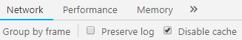  
  
The obvious problem with disabling the browser cache is that, the images have to be downloaded from the server, every time you visit the page.   
  
**ASP.NET Core Image tag helper**   
  
From a performance standpoint, wouldn't it be great to download the image only if it has changed on the server. If the image has not changed, use the image from the browser cache. This means we will have the best of both the worlds.   
  
**Image Tag Helper** can help us achieve this. To use the Image tag helper, include ***asp-append-version*** attribute and set it to true.

<**img** **src**="~/images/noimage.jpg" **asp-append-version**="true" />

**Image Tag Helper** enhances the <img> tag to provide **cache-busting behavior** for static image files. Based on the content of the image, a unique hash value is calculated and is appended to image URL. This unique string prompts the browser to reload the image from the server and not from the browser cache.

<img class="card-img-top" src="/images/noimage.jpg?v=IqNLbsazJ7ijEbbyzWPke-xWxkOFaVcgzpQ4SsQKBqY" />

Each time the image on the server changes a new hash value is calculated and cached. If the image has not changed the hash isn't recalculated. Using this unique hash value, the browser keeps track of whether the image content on the server has changed

### ASP.NET Core Environment Tag Helper

In this video, we will discuss **Environment tag helper in ASP.NET Core** with an example.   
  
  
**Requirement**

* We are using **Bootstrap** in our ASP.NET Core Application
* For ease of debugging, on our local development machine (i.e on the **Development Environment**) we want the application to load non-minified bootstrap css file (bootstrap.css)
* On **Staging**, **Production** or any other environment **except Development environment** we want the application to load minified bootstrap css file (bootstrap.min.css) from a **CDN** (Content Delivery Network) for better performance.
* However, if the **CDN is down** or for some reason, our application is not able to reach the CDN, we want our application to fallback and load the minified bootstrap file (bootstrap.min.css) from our own application web server.

We can achieve this very easily using ASP.NET Core <environment> tag helper. Before we understand the <environment> tag helper, first let's understand how we set the name of the application environment.   
  
**How to set Application Environment**   
  
Use the ***ASPNETCORE_ENVIRONMENT*** variable to set the application environment. On our local development machine we usually set this environment variable in ***launchsettings.json*** file. On a staging or production environment it is set in the operating system.    
  
We discussed environment variables in [Part 14](https://youtu.be/x8jNX1nb_og) of [ASP.NET Core tutorial](https://www.youtube.com/playlist?list=PL6n9fhu94yhVkdrusLaQsfERmL_Jh4XmU).   
  
**ASP.NET Core Environment Tag Helper**   
  
***Environment tag helper*** supports rendering different content depending on the application environment. The application environment name is set using using ***ASPNETCORE_ENVIRONMENT*** variable.   
  
This example loads the non-minified bootstrap css file, if the application environment is "Development"

<**environment** **include**="Development">

<link href="~/lib/bootstrap/css/bootstrap.css" rel="stylesheet" />

</**environment**>

This example loads the minified bootstrap css file from the CDN (Content Delivery Network), if the application environment is "Staging" or "Production".

<**environment** **include**="Staging,Production">

<link rel="stylesheet"

href="https://stackpath.bootstrapcdn.com/bootstrap/4.3.1/css/bootstrap.min.css"

integrity="sha384-ggOyR0iXCbMQv3Xipma34MD+dH/1fQ784/j6cY/iJTQUOhcWr7x9JvoRxT2MZw1T"

crossorigin="anonymous">

</**environment**>

***"include"*** attribute accepts a single hosting environment name or a comma-separated list of hosting environment names. On the ***<environment>*** tag helper, we also have ***"exclude"*** attribute. The content of the ***<environment>*** tag is rendered when the hosting environment doesn't match an environment listed in the ***exclude*** attribute value.   
  
This example loads the minified bootstrap css file from the CDN (Content Delivery Network), if the application environment IS NOT "Development".

<**environment** **exclude**="Development">

<link rel="stylesheet"

href="https://stackpath.bootstrapcdn.com/bootstrap/4.3.1/css/bootstrap.min.css"

integrity="sha384-ggOyR0iXCbMQv3Xipma34MD+dH/1fQ784/j6cY/iJTQUOhcWr7x9JvoRxT2MZw1T"

crossorigin="anonymous">

</**environment**>

The ***"integrity"*** attribute on the <link> element is used for **Subresource Integrity check**. Subresource Integrity (SRI for short), is a security feature that allows a browser to check if the file being retrieved has been maliciously altered. When the browser downloads the file, it recalculates the hash and compares it against the "integrity" attribute hash value. If the hash values match, the browser allows the file to be downloaded otherwise it is blocked.   
  
**What if the CDN is down**   
  
If the CDN is down or for some reason, our application is not able to reach the CDN, we want our application to fallback and load the minified bootstrap file (bootstrap.min.css) from our own application web server. Consider the following example

<**environment** **include**="Development">

<link href="~/lib/bootstrap/css/bootstrap.css" rel="stylesheet" />

</**environment**>

<**environment** **exclude**="Development">

<**link** rel="stylesheet"

integrity="sha384-ggOyR0iXCbMQv3Xipma34MD+dH/1fQ784/j6cY/iJTQUOhcWr7x9JvoRxT2MZw1T"

crossorigin="anonymous"

**href**="https://sstackpath.bootstrapcdn.com/bootstrap/4.3.1/css/bootstrap.min.css"

**asp-fallback-href**="~/lib/bootstrap/css/bootstrap.min.css"

**asp-fallback-test-class**="sr-only" **asp-fallback-test-property**="position"

**asp-fallback-test-value**="absolute"

**asp-suppress-fallback-integrity**="true" />

</**environment**>

If the application environment is "Development", non-minified bootstrap css file (bootstrap.css) is loaded from our application web server   
  
If the application environment IS NOT "Development", minified bootstrap css file (bootstrap.min.css) is loaded from the CDN   
  
A fallback source is specified using asp-fallback-href attribute. This means, if the CDN is down, our application fallsback and load the minified bootstrap file (bootstrap.min.css) from our own application web server.   
  
The following 3 attributes and their associated values are used to check if the CDN is down  
***asp-fallback-test-class="sr-only"***  
***asp-fallback-test-property="position"***  
***asp-fallback-test-value="absolute"***   
  
Obviously, there is some processing involved to calculate hash and compare it with the integrity attribute hash value. For most applications, fallback source is their own server. You have the option to turn off integrity check for the files downloaded from the fallback source by setting ***asp-suppress-fallback-integrity*** attribute to ***true***.

### Bootstrap navigation menu in asp.net core application

In this video we will discuss **creating a responsive navigation menu in asp.net core application using Bootstrap 4**.   
  
  
On a large screen device the navigation menu should look as shown below.   
  
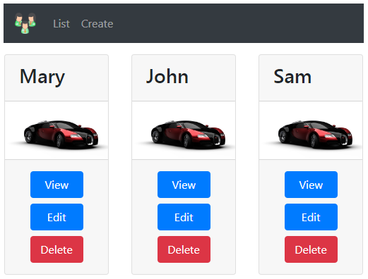  
  
  
On a small screen device the navigation menu should look as shown below.   
  
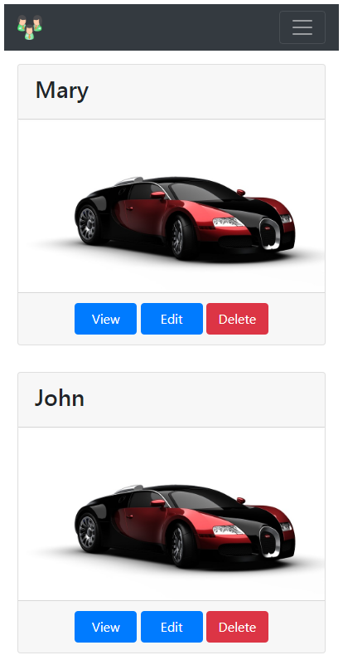  
  
**Bootstarp 4 has a dependency on jQuery.** So please download and install jQuery in your asp.net core application. You can use the Library Manager tool to do this. We discussed Library Manager in [Part 34](https://youtu.be/5qzzjvZ4w0c) of [ASP.NET Core tutorial](https://www.youtube.com/playlist?list=PL6n9fhu94yhVkdrusLaQsfERmL_Jh4XmU).   
  
**_Layout.cshtml Code**

<html>

<head>

<meta name="viewport" content="width=device-width" />

<**environment** **include**="Development">

<link href="~/lib/bootstrap/css/bootstrap.css" rel="stylesheet" />

<script src="~/lib/jquery/jquery.js"></script>

<script src="~/lib/bootstrap/js/bootstrap.js"></script>

</**environment**>

<**environment** **exclude**="Development">

<**link** rel="stylesheet" **href**="https://stackpath.bootstrapcdn.com/bootstrap/4.3.1/css/bootstrap.min.css"

integrity="sha384-ggOyR0iXCbMQv3Xipma34MD+dH/1fQ784/j6cY/iJTQUOhcWr7x9JvoRxT2MZw1T" crossorigin="anonymous"

**asp-fallback-href**="~/lib/bootstrap/css/bootstrap.min.css"

**asp-fallback-test-class**="sr-only" **asp-fallback-test-property**="position" **asp-fallback-test-value**="absolute"

**asp-suppress-fallback-integrity**="true" />

</**environment**>

<link href="~/css/site.css" rel="stylesheet" />

<title>@ViewBag.Title</title>

</head>

<body>

<div class="container">

<nav class="navbar navbar-expand-sm bg-dark navbar-dark">

<**a** class="navbar-brand" **asp-controller**="home" **asp-action**="index">

<img src="~/images/employees.png" width="30" height="30">

</**a**>

<button class="navbar-toggler" type="button" data-toggle="collapse" data-target="#collapsibleNavbar">

<span class="navbar-toggler-icon"></span>

</button>

<div class="collapse navbar-collapse" id="collapsibleNavbar">

<ul class="navbar-nav">

<li class="nav-item">

<**a** class="nav-link" **asp-controller**="home" **asp-action**="index">List</**a**>

</li>

<li class="nav-item">

<**a** class="nav-link" **asp-controller**="home" **asp-action**="create">Create</**a**>

</li>

</ul>

</div>

</nav>

<div>

@RenderBody()

</div>

@if (IsSectionDefined("Scripts"))

{

@RenderSection("Scripts", required: false)

}

</div>

</body>

</html>

On a small screen device, for the ***navbar*** toggle button to work, jQuery must be loaded before Bootstrap JavaScript file. If you flip the order, the ***navbar toggle button*** does not work.

<**environment** **include**="Development">

<link href="~/lib/bootstrap/css/bootstrap.css" rel="stylesheet" />

<script src="~/lib/jquery/jquery.js"></script>

<script src="~/lib/bootstrap/js/bootstrap.js"></script>

</**environment**>

**Please note :** For a ***non-development environment*** (i.e Staging, Production etc), I have not included the required <link> tags to load jQuery and Bootstrap JavaScript from a CDN. I am leaving that as an exercise for you to do.   
  
Notice how the buttons ***(View, Edit & Delete)*** are attached to each other. To include margin between these button use the Bootstrap margin classes ***(m-1, m-2 etc)***. In the class name, ***"m"*** stands for ***margin*** and the number ***1,2 etc*** is the size of the space you want.   
  
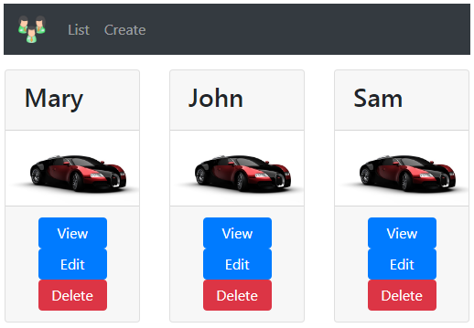  
  
In ***index.chtml*** modify the ***<a>*** tags to include ***"m-1"*** bootstrap class

<div class="card-footer text-center">

<**a** **asp-controller**="home" **asp-action**="details"

**asp-route-id**="@employee.Id" class="btn btn-primary m-1">View</**a**>

<a href="#" class="btn btn-primary m-1">Edit</a>

<a href="#" class="btn btn-danger m-1">Delete</a>

</div>

Ceo kod za navigaciju: layout.cshtml, pogledaj I video, korisan

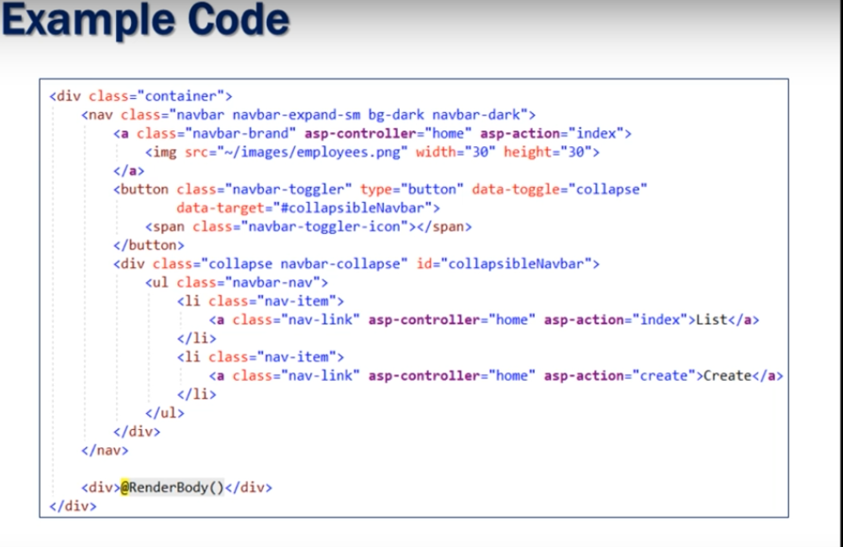

### Form tag helpers in asp.net core

**Suggested Videos**  
[Part 37 - ASP.NET Core Image tag helper](https://youtu.be/4jW9T-TLPTM) | [Text](https://csharp-video-tutorials.blogspot.com/2019/03/aspnet-core-image-tag-helper.html) | [Slides](https://csharp-video-tutorials.blogspot.com/2019/04/aspnet-core-image-tag-helper-slides.html)  
[Part 38 - ASP.NET Core Environment Tag Helper](https://youtu.be/-E4zP2L-R_U) | [Text](https://csharp-video-tutorials.blogspot.com/2019/04/aspnet-core-environment-tag-helper.html) | [Slides](https://csharp-video-tutorials.blogspot.com/2019/03/aspnet-core-environment-tag-helper_28.html)  
[Part 39 - Bootstrap navigation menu in asp.net core application](https://youtu.be/l2dzzuxvmxk) | [Text](https://csharp-video-tutorials.blogspot.com/2019/04/bootstrap-navigation-menu-in-aspnet.html) | [Slides](https://csharp-video-tutorials.blogspot.com/2019/04/bootstrap-navigation-menu-in-aspnet_2.html)  
  
In our previous videos in this series we discussed ***anchor***, ***image*** and ***environment*** tag helpers. In this video we will discuss ***Form Tag Helpers*** in ASP.NET Core that help us create forms.   
  
  
**Tag Helpers to create forms**   
  
We use the following common tag helpers to create a form in ASP.NET Core

* Form Tag Helper
* Label Tag Helper
* Input Tag Helper
* Select Tag Helper
* Textarea Tag Helper

We also have Validation tag helpers. We will discuss form validation and model binding in our upcoming videos.   
  
By the end of this video, we want to create a form using the form tag helpers and style it using Bootstrap 4. The ***"Create Employee Form"*** should be as shown below.   
  
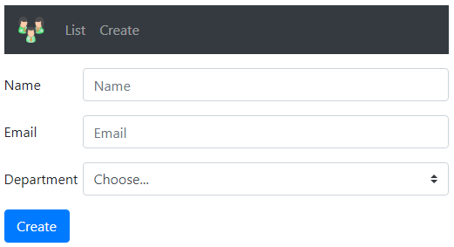  
  
**Form Tag Helper**  
  
To create a form we use the ***<form>*** tag helper   
  
Notice, we are using ***asp-controller*** and ***asp-action*** tag helpers. These 2 tag helpers specify the controller and the action method to which the form data must be posted when the form is submitted. We want to issue a POST request when the form is submitted, so we have set the ***method*** attribute to ***post***

<**form** **asp-controller**="home" **asp-action**="create" method="post">

</**form**>

The above code produces the following HTML when the form is rendered on the client browser. As you can see from the generated HTML when the form is submitted it will be posted to the ***index()*** action of the ***HomeController.***

<**form** method="post" action="/home/create"></**form**>

**Please note :** By default, when a form is submitted, it will be posted to the same action of the controller that rendered the form. So this means, even if we did not specify the controller and action using the ***asp-controller*** and ***asp-action*** tag helpers, the form will still be posted to the ***index()*** action of the ***HomeController.***   
  
**Input Tag Helper**  
  
The Input Tag Helper binds an HTML **<input>** element to a model expression in your razor view.  
  
In our case, we want a form to create a new employee. So the model for our ***Create.cshtml*** view is **Employee** class. We specify that using the ***model*** directive.

**@model Employee**

To be able to capture the ***employee name*** we want a text box. We want the text box to bind to the ***Name*** property of the ***Employee*** model class. We do this by using ***asp-for*** tag helper and setting it's value to the ***Name*** property of the ***Employee*** model class. Notice we also have intellisense. Later if we change the property name form ***Name*** to ***FullName*** on the ***Employee*** class, and if we do not change the value assigned to the tag helper, we get a compiler error.

<**input** **asp-for**="Name">

The above code generates an ***input*** element with ***id*** and ***name*** attributes. Notice both of them are set to a value of ***Name***.

<input type="text" id="Name" name="Name" value="">

The ***name*** attribute is required and it is used to map the value of the input element to the corresponding property of the model class when the form is submitted. This is done by a process called model binding in ASP.NET Core. We will discuss model binding in our next video.

**Label Tag Helper**  
  
The Label Tag Helper generates a label with ***for*** attribute. The ***for*** attribute links the label with it's associated input element. Consider the following example.

<**label** **asp-for**="Name"></**label**>

<**input** **asp-for**="Name">

The above code generates the following HTML.

<label for="Name">Name</label>

<input type="text" id="Name" name="Name" value="">

The label is linked to the input element, because both the label ***for*** attribute and the input element ***id*** attribute have the same value ***(Name)***. So this means when we click on the label, the corresponding input element receives the focus.   
  
Similarly, the following code generates a label and an input element to capture employee email.

<**label** **asp-for**="Email"></**label**>

<**input** **asp-for**="Email">

**Select Tag Helper**   
  
Generates ***select*** element and it's associated option elements. In our case we want a select element to display the list of departments.   
  
Ultimately we want a label and a select element with list of department options as shown below.

<label for="Department">Department</label>

<select id="Department" name="Department">

<**option** **value**="0">None</**option**>

<**option** **value**="1">HR</**option**>

<**option** **value**="2">Payroll</**option**>

<**option** **value**="3">IT</**option**>

</select>

The options for the ***department*** select element can be hard-coded like in the example above, or they can come from an ***enum*** or a database table. We do not have a database hooked up yet. So for our example, let's get the options from an ***enum***.   
  
Place the following ***enum*** in ***Dept.cs*** file in the ***Models*** folder

namespace EmployeeManagement.Models

{

public enum Dept

{

None,

HR,

Payroll,

IT

}

}

Update the Employee class in *Employee.cs* file in the *Models* folder   
  
*Department* property data type is ***Dept*** enum.

namespace EmployeeManagement.Models

{

public class Employee

{

public int Id { get; set; }

public string Name { get; set; }

public string Email { get; set; }

public Dept Department { get; set; }

}

}

In ***Create.cshtml*** view, include the following code

<**label** **asp-for**="Department"></**label**>

<**select** **asp-for**="Department"

**asp-items**="Html.GetEnumSelectList<Dept>()"></**select**>

Notice, we are using ***asp-items*** tag helper and ***Html.GetEnumSelectList<Dept>()*** to get the options for the ***select*** element.   
  
The above code produces the following HTML

<label for="Department">Department</label>

<select id="Department" name="Department">

<**option** **value**="0">None</**option**>

<**option** **value**="1">HR</**option**>

<**option** **value**="2">Payroll</**option**>

<**option** **value**="3">IT</**option**>

</select>

**Create.cshtml - Complete Code without Bootstrap**

@model Employee

@{

ViewBag.Title = "Create Employee";

}

<**form** **asp-controller**="home" **asp-action**="create" method="post">

<div>

<**label** **asp-for**="Name"></**label**>

<**input** **asp-for**="Name" />

</div>

<div>

<**label** **asp-for**="Email"></**label**>

<**input** **asp-for**="Email">

</div>

<div>

<**label** **asp-for**="Department"></**label**>

<**select** **asp-for**="Department"

**asp-items**="Html.GetEnumSelectList<Dept>()"></**select**>

</div>

<button type="submit">Create</button>

</**form**>

The above code generates the following HTML

<form method="post" action="/home/create">

<div>

<label for="Name">Name</label>

<input type="text" id="Name" name="Name" value="" />

</div>

<div>

<label for="Email">Email</label>

<input type="text" id="Email" name="Email" value="">

</div>

<div>

<label for="Department">Department</label>

<select id="Department" name="Department">

<option value="0">None</option>

<option value="1">HR</option>

<option value="2">Payroll</option>

<option value="3">IT</option>

</select>

</div>

<button type="submit">Create</button>

</form>

**Create.cshtml - Complete Code with Bootstrap**

@model Employee

@{

ViewBag.Title = "Create Employee";

}

<**form** **asp-controller**="home" **asp-action**="create" method="post" class="mt-3">

<div class="form-group row">

<**label** **asp-for**="Name" class="col-sm-2 col-form-label"></**label**>

<div class="col-sm-10">

<**input** **asp-for**="Name" class="form-control" placeholder="Name">

</div>

</div>

<div class="form-group row">

<**label** **asp-for**="Email" class="col-sm-2 col-form-label"></**label**>

<div class="col-sm-10">

<**input** **asp-for**="Email" class="form-control" placeholder="Email">

</div>

</div>

<div class="form-group row">

<**label** **asp-for**="Department" class="col-sm-2 col-form-label"></**label**>

<div class="col-sm-10">

<**select** **asp-for**="Department" class="custom-select mr-sm-2"

**asp-items**="Html.GetEnumSelectList<Dept>()"></**select**>

</div>

</div>

<div class="form-group row">

<div class="col-sm-10">

<button type="submit" class="btn btn-primary">Create</button>

</div>

</div>

</**form**>

**Next Video :** Model Binding in ASP.NET Core

### ASP.NET Core Model Binding

In this video we will discuss **Model Binding in ASP.NET Core with examples.**   
  
**What is Model Binding**

* Model binding maps data in an HTTP request to controller action method parameters
* The action parameters may be simple types such as integers, strings, etc or complex types like Customer, Employee, Order etc.
* Model binding is great, because without it we have to write lot of custom code to map request data to action method parameters which is not only tedious but also error prone.

**ASP.NET Core Model Binding Example**   
  
When an HTTP request arrives at our MVC application it is the Controller action method that handles the incoming request. Let's say we want to view employee details whose ID is 2. For this we issue a GET request to the following URL   
  
http://localhost:48118/home/details/2   
  
Our application default route template ({controller=Home}/{action=Index}/{id?}) routes this request to *Details(int? id)* action method of the *HomeController*.

public ViewResult Details(int? id)

{

HomeDetailsViewModel homeDetailsViewModel = new HomeDetailsViewModel()

{

Employee = _employeeRepository.GetEmployee(id ?? 1),

PageTitle = "Employee Details"

};

return View(homeDetailsViewModel);

}

The *id value 2* in the request URL is mapped to the *id* parameter of the *details(int? id)* action method. MVC will bind the data in the request to the action parameters by name. Notice, in the above example, the parameter name in the default route template is *"id"* and the parameter name on the *Details(int? id)* action method is also *id*. So the value *2* in the URL (http://localhost:48118/home/details/2) is mapped to the *id* parameter on the *Details(int? id)* action method.   
  
**Another Example**   
  
**Request URL**  
http://localhost:48118/home/details/2?name=pragim   
  
The following *Details()* action method handles the above request URL and maps the value *2* to the *id* parameter and the value *pragim* to the *name* parameter

public string Details(int? id, string name)

{

return "id = " + id.Value.ToString() + " and name = " + name;

}

**HTTP Request Data**   
  
To bind the request data to the controller action method parameters, model binding looks for data in the HTTP request in the following places in the order specified below.

* Form values
* Route values
* Query strings

UKOLIKO SE PROSLEDI I ROUTA I QUERY STRING TIPA:

/HOME/DETAILS/2/?ID=5  
  
2 KAO DEO ROUTE TEMPLATE A 5 KAO QUERY STRING

ZBOG OVOG REDOSLEDA GORE, UZIMA VREDNOST RUTE, DA IMA VREDNOSTI U FORMI, NJU BI UZELO

**Model Binding Complex Types**   
  
Model Binding also works with complex types such as Customer, Order, Employee etc. Consider the following *"Create Employee Form"*   
  
  
  
When the above form is posted to the server, the values in the form are mapped to the Employee object parameter of the following *Create()* action method.

public RedirectToActionResult Create(Employee employee)

{

Employee newEmployee = _employeeRepository.Add(employee);

return RedirectToAction("details", new { id = newEmployee.Id });

}

* Model binder in asp.net core binds the posted form values to the properties of the Employee object that is passed as a parameter to the *Create()* action method.
* The value in the input element that has the *name* attribute set to *"Name"* is mapped to the *Name* property of the Employee object
* Similarly value in the input element with name *"Email"*is mapped to *Email* property of the Employee object
* The same is true for *Department*

**Add() method - IEmployeeRepository interface**

public interface IEmployeeRepository

{

Employee GetEmployee(int Id);

IEnumerable<Employee> GetAllEmployees();

Employee Add(Employee employee);

}

**Add() method - MockEmployeeRepository class**

public class MockEmployeeRepository : IEmployeeRepository

{

private List<Employee> _employeeList;

public MockEmployeeRepository()

{

_employeeList = new List<Employee>()

{

new Employee() { Id = 1, Name = "Mary", Department = Dept.HR, Email = "mary@pragimtech.com" },

new Employee() { Id = 2, Name = "John", Department = Dept.IT, Email = "john@pragimtech.com" },

new Employee() { Id = 3, Name = "Sam", Department = Dept.IT, Email = "sam@pragimtech.com" },

};

}

public Employee Add(Employee employee)

{

employee.Id = _employeeList.Max(e => e.Id) + 1;

_employeeList.Add(employee);

return employee;

}

public IEnumerable<Employee> GetAllEmployees()

{

return _employeeList;

}

public Employee GetEmployee(int Id)

{

return this._employeeList.FirstOrDefault(e => e.Id == Id);

}

}

**HttpGet vs HttpPost**   
  
At the moment in the HomeController we have the following 2 *Create()* action methods.

public ViewResult Create()

{

return View();

}

public RedirectToActionResult Create(Employee employee)

{

Employee newEmployee = _employeeRepository.Add(employee);

return RedirectToAction("details", new { id = newEmployee.Id });

}

If we now navigate to the URL (http://localhost:1234/home/create) we get the following error  
AmbiguousActionException: Multiple actions matched.

This is because asp.net core does not know which action method to execute. We want the first *Create()* action method to respond to GET request and the second *Create()* action method to respond to the POST request. To tell this to asp.net core decorate the *Create()* action methods with *HttpGet* and *HttpPost* attributes as shown below.

[HttpGet]

public ViewResult Create()

{

return View();

}

[HttpPost]

public RedirectToActionResult Create(Employee employee)

{

Employee newEmployee = _employeeRepository.Add(employee);

return RedirectToAction("details", new { id = newEmployee.Id });

}

The *Create()* action method that responds to the POST action adds the new employee to the EmployeeRepository and redirects the user to the *Details()* action method passing it the *ID* of the newly created employee.    
  
Upon redirection if you get a NullReferenceException, make sure to use *AddSingleton()* method instead of *AddTransient()* method to register IEmployeeRepository service in *ConfigureServices()* method of *Startup.cs* file.

public class Startup

{

public void ConfigureServices(IServiceCollection services)

{

services.AddMvc();

services.AddSingleton<IEmployeeRepository, MockEmployeeRepository>();

}

// Other code here....

}

We will discuss what's causing this error and the difference between AddSingleton(), AddTransient() and AddScoped() methods in our upcoming videos.   
  
At the moment *Create Employee Form* does not have any validation in place. If we submit the form without filling any of the form fields, we will end up creating a new employee whose *name* and *email* fields are null. We will discuss form validation in our next video.

### ASP.NET Core model validation

In this video we will discuss **model validation in ASP.NET Core with examples**.   
  
  
**Model Validation Example**   
  
Consider the following *Create Employee Form*   
  
  
  
  
We want to make both *Name* and *Office Email* fields required. If the required values are not provided and the form is submitted we want to display required validation errors as shown below.   
  
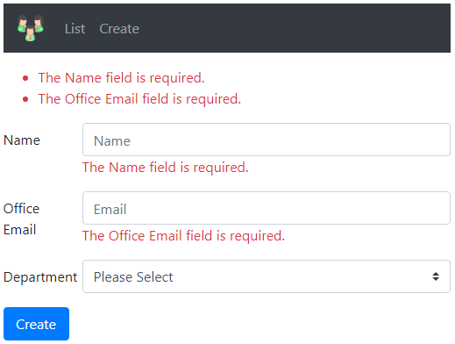  
  
If invalid *email* is provided we want to display *Invalid Email Format* validation error as shown below.   
  
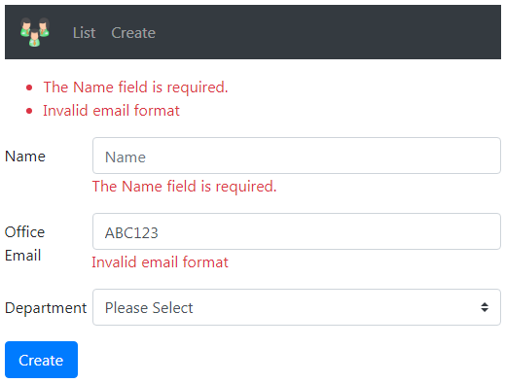  
  
To make *Name* field a required field, apply *Required* attribute on the *Name* property of the Employee model class. *Required* attribute is in *System.ComponentModel.DataAnnotations* namespace.

public class Employee

{

public int Id { get; set; }

[Required]

public string Name { get; set; }

public string Email { get; set; }

public Dept Department { get; set; }

}

**ModelState.IsValid Property**

* When the form is submitted, the following *Create()* action method is executed
* The model for *Create Employee Form* is Employee class
* When the form is submitted, model binding maps the posted form values to the respective properties of the Employee class
* With the *Required* attribute on the *Name* property of the Employee class, if a value for the *Name* property is not present, the validation fails
* Use *ModelState.IsValid* property to check if validation has failed or succeeded
* If validation has failed we return the same view so the user can provide the required data and resubmit the form.

[HttpPost]

public IActionResult Create(Employee employee)

{

if (ModelState.IsValid)

{

        Employee newEmployee = _employeeRepository.Add(employee);

return RedirectToAction("details", new { id = newEmployee.Id });

}

return View();

}

**Displaying Model Validation Errors**   
  
To display validation errors use *asp-validation-for* and *asp-validation-summary* tag helpers. *asp-validation-for* tag helper displays a validation message for a single property of our model class. *asp-validation-summary* tag helper displays a summary of validation errors.   
  
To display the validation error associated with the *Name* property of the *Employee* class use *asp-validation-for* tag helper on a <span> element as shown below.

<div class="form-group row">

<**label** **asp-for**="Name" class="col-sm-2 col-form-label"></**label**>

<div class="col-sm-10">

<**input** **asp-for**="Name" class="form-control" placeholder="Name">

<**span** **asp-validation-for**="Name"></**span**>

</div>

</div>

To display a summary of all validation errors use *asp-validation-summary* tag helper on a <div> element as shown below.

<**div** **asp-validation-summary**="All">

</**div**>

The value for *asp-validation-summary* tag helper can be any of the following

* All
* ModelOnly
* None

We will discuss the difference between these values and what they do in our upcoming videos. For now set it to a value of *All*.   
  
**Customising Model Validation Error Message**

public class Employee

{

public int Id { get; set; }

[Required]

public string Name { get; set; }

public string Email { get; set; }

public Dept Department { get; set; }

}

By default the *Required* attribute on the *Name* property displays the following validation error message.  
The Name field is required.   
  
If you want to change the validation error message to "Please provide a value for the Name field" you can do so using the *ErrorMessage* property of the *Required* attribute as shown below.

public class Employee

{

public int Id { get; set; }

[Required(ErrorMessage = "Please provide a value for Name field")]

public string Name { get; set; }

public string Email { get; set; }

public Dept Department { get; set; }

}

**ASP.NET Core Built-in Model Validation Attributes**   
  
The following are some of the common built-in validation attributes in ASP.NET Core

|  |  |
| --- | --- |
| **Attribute** | **Purpose** |
| Required | Specifies the field is required |
| Range | Specifies the minimum and maximum value allowed |
| MinLength | Specifies the minimum length of a string |
| MaxLength | Specifies the maximum length of a string |
| Compare | Compares 2 properties of a model. For example compare Email and ConfirmEmail properties |
| RegularExpression | Validates if the provided value matches the pattern specified by the regular expression |

**Display Attribute**   
  
This is not a validation attribute. It is commonly used for display purpose in the UI.    
  
For example, in the UI by default, the label for *Email* field displays the text *Email*, because the property name is *Email*.

public class Employee

{

public int Id { get; set; }

public string Name { get; set; }

public string Email { get; set; }

public Dept Department { get; set; }

}

If you want the label to display *Office Email* instead, use the *Display* attribute

public class Employee

{

public int Id { get; set; }

public string Name { get; set; }

[Display(Name = "Office Email")]

public string Email { get; set; }

public Dept Department { get; set; }

}

**Using Multiple Model Validation Attributes**   
  
Multiple validation attributes can be applied on a property by separating them with a comma as shown on the *Name* property or we stack them on top of each other as shown on the *Email* property.

public class Employee

{

public int Id { get; set; }

[Required, MaxLength(50, ErrorMessage = "Name cannot exceed 50 characters")]

public string Name { get; set; }

[Display(Name = "Office Email")]

[RegularExpression(@"^[a-zA-Z0-9_.+-]+@[a-zA-Z0-9-]+\.[a-zA-Z0-9-.]+$",

ErrorMessage = "Invalid email format")]

[Required]

public string Email { get; set; }

public Dept Department { get; set; }

}

**Model Validation Errors Colour**   
  
To change the colour of the model validation errors on the UI, use Bootstrap *text-danger* class on the <span> and <div> elements that have *asp-validation-for* and *asp-validation-summary* tag helpers

<**div** **asp-validation-summary**="All" class="text-danger"></**div**>

<**span** **asp-validation-for**="Name" class="text-danger"></**span**>

### Select list validation in asp.net core

In this video we will discuss implementing **required validation on a select list in ASP.NET Core**. Let's understand this with an example.   
  
Consider the following *Create Employee Form*   
  
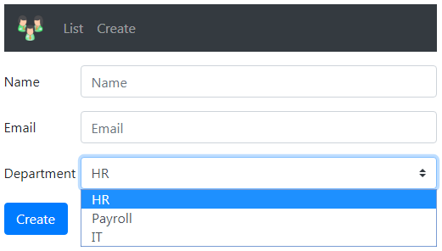  
  
  
We want to make the *"Department"* field required. Among the options, we want *Please Select* as the first option. *Please Select* is not a valid selection, it is just an option to prompt the user to select a valid department.   
  
The *Department* select list is bound to the following Dept enum.

public enum Dept

{

None,

HR,

Payroll,

IT

}

**Department Select List HTML**   
  
Notice, we are using *asp-items* tag helper to bind *Department* select list to Dept enum

<div>

<**label** **asp-for**="Department"></**label**>

<div>

<**select** **asp-for**="Department" **asp-items**="Html.GetEnumSelectList<Dept>()">

</**select**>

</div>

</div>

**Select List First Option**   
  
We want the first option in the Select List to be *Please Select*. The easiest way to achieve this is by including an <option> element in the select list HTML as shown below.

<div>

<**label** **asp-for**="Department"></**label**>

<div>

<**select** **asp-for**="Department" **asp-items**="Html.GetEnumSelectList<Dept>()">

<**option** **value**="">Please Select</**option**>

</**select**>

<**span** **asp-validation-for**="Department" class="text-danger"></**span**>

</div>

</div>

*value* attribute of the *Please Select* option element is set to an empty string. We are also using *asp-validation-for* tag helper to display the validation error. To apply red font-clolor to the validation error, we are using *text-danger* Bootstrap class.   
  
**Making Select List Required**   
  
The Select List is bound to *Department* property of the Employee model class. To make the *Department* Select List required, apply [Required] attribute on the *Department* property of the Employee class.

public class Employee

{

public int Id { get; set; }

public string Name { get; set; }

public string Email { get; set; }

    [Required]

public Dept Department { get; set; }

}

At this point if we run the project and submit the form without selecting a valid department from the select list we get the error - The value '' is invalid.   
  
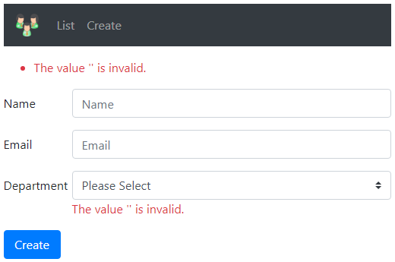  
  
The error that we are getting here is not the required validation error. To prove this, remove the [Required] attribute from the *Department* property of the Employee class and you will still get the same error.   
  
Let's first understand why we are getting this error - The value '' is invalid.

* The datatype of the *Department* property is Dept enum.
* By default an enum underlying data type is int.
* An empty string is set as the value for *Please Select* option of the select list in the HTML.
* So when this option *Please Select* is selected from the select list, the value empty string is used as the value for *Department* property whose underlying data type is int.
* Obviously an empty string is not a valid value for int.
* This is the reason we get - The value '' is invalid.
* Value types (such as int, float, decimal, DateTime) are inherently required and don't need the Required attribute.

**Select List Required Validation**   
  
However, if you make the *Department* property, a nullable property by including a question mark then the [Required] attribute is needed to make the field a required field.

public class Employee

{

public int Id { get; set; }

public string Name { get; set; }

public string Email { get; set; }

    [Required]

public Dept? Department { get; set; }

}

If we now submit the form with *Please Select* option selected we get Required validation error as expected.   
  
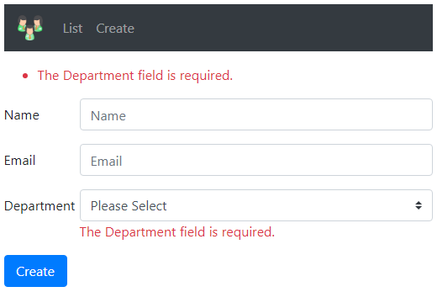

### AddSingleton vs AddScoped vs AddTransient

**Suggested Videos**

In this video we will discuss the **differences between AddSingleton(), AddScoped() and AddTransient()** methods in ASP.NET Core with an example.   
  
  
**IEmployeeRepository interface**  
  
Consider the following IEmployeeRepository interface. *Add()* method adds a new employee to the repository. *GetAllEmployees()* method returns all the Employees in the repository.

public interface IEmployeeRepository

{

    IEnumerable<Employee> GetAllEmployees();

    Employee Add(Employee employee);

}

**Employee Class**

public class Employee

{

public int Id { get; set; }

public string Name { get; set; }

}

**MockEmployeeRepository**   
  
MockEmployeeRepository implements IEmployeeRepository. To keep the example simple we are storing the list of employees in-memory in a private field _employeeList.

public class MockEmployeeRepository : IEmployeeRepository

{

private List<Employee> _employeeList;

public MockEmployeeRepository()

{

_employeeList = new List<Employee>()

{

new Employee() { Id = 1, Name = "Mary" },

new Employee() { Id = 2, Name = "John" },

new Employee() { Id = 3, Name = "Sam" },

};

}

public Employee Add(Employee employee)

{

employee.Id = _employeeList.Max(e => e.Id) + 1;

_employeeList.Add(employee);

return employee;

}

public IEnumerable<Employee> GetAllEmployees()

{

return _employeeList;

}

}

**HomeController**   
  
IEmployeeRepository is injected in to the HomeController. The *Create()* action method that responds to the *POST* request, uses the injected instance to add the employee object to the repository.

public class HomeController : Controller

{

private IEmployeeRepository _employeeRepository;

public HomeController(IEmployeeRepository employeeRepository)

{

_employeeRepository = employeeRepository;

}

[HttpGet]

public ViewResult Create()

{

return View();

}

[HttpPost]

public IActionResult Create(Employee employee)

{

if (ModelState.IsValid)

{

Employee newEmployee = _employeeRepository.Add(employee);

}

return View();

}

}

**Create View**   
  
We are injecting IEmployeeRepository service in to the *Create* view using @inject directive. We are using the injected service to display the total number of employees in the repository.

@model Employee

@inject IEmployeeRepository empRepository

<**form** **asp-controller**="home" **asp-action**="create" method="post">

<div>

<**label** **asp-for**="Name"></**label**>

<div>

<**input** **asp-for**="Name">

</div>

</div>

<div>

<button type="submit">Create</button>

</div>

<div>

Total Employees Count = @empRepository.GetAllEmployees().Count().ToString()

</div>

</**form**>

**Registering Services**   
  
ASP.NET core provides the following 3 methods to register services with the dependency injection container. The method that we use determines the lifetime of the registered service.   
  
**AddSingleton()** - As the name implies, **AddSingleton()** method creates a Singleton service. A Singleton service is created when it is first requested. This same instance is then used by all the subsequent requests. So in general, a Singleton service is created only one time per application and that single instance is used throughout the application life time.   
  
**AddTransient()** - This method creates a Transient service. A new instance of a Transient service is created each time it is requested.    
  
**AddScoped()** - This method creates a Scoped service. A new instance of a Scoped service is created once per request within the scope. For example, in a web application it creates 1 instance per each http request but uses the same instance in the other calls within that same web request.   
  
In ASP.NET Core, services are registered in **ConfigureServices()** method of the **Startup.cs** file.

public void ConfigureServices(IServiceCollection services)

{

services.AddMvc();

    services.AddSingleton<IEmployeeRepository, MockEmployeeRepository>();

}

1. At the moment we are using **AddSingleton()** method to register MockEmployeeRepository service.
2. **AddSingleton()** creates a single instance of the service when it is first requested and reuses that same instance in all the places where that service is needed.
3. This means all the requests throughout the life time of the application use that same instance.
4. At the moment, in our example we need MockEmployeeRepository service instance in 2 places - *Create* action method in the HomeController and in the *Create* view.
5. At this point when we navigate to http://localhost:/home/create we see the Total Employees Count is 3
6. To serve this request an instance of the HomeController is created first. HomeController has a dependency on IEmployeeRepository.
7. This is the first time, the instance of the service is requested. So asp.net core creates an instance of the service and injects it into the HomeController.
8. *Create* view also needs an instance of the service to calculate the total number of employees. With singleton, the same service instance is used. So the instance of the service that is already created is provided to the *Create* view also.
9. Now if you provide a Name in the Name textbox and click *Create* button you will see the count goes up every time you click the button.
10. This is because with Singleton, the same object is used, so changes made to the object can be viewed in all the places across all the HTTP requests.

**AddScoped**   
  
Now, use **AddScoped()** method to register the service.

public void ConfigureServices(IServiceCollection services)

{

services.AddMvc();

    services.AddScoped<IEmployeeRepository, MockEmployeeRepository>();

}

1. Issue a request to http://localhost:/home/create.
2. We see the Total Employees Count is 3.
3. Provide a Name and click the *Create* button.
4. The Total Employees Count increases to 4.
5. When we click the *Create* button again, the Total Employees Count is still 4.

This is because for a scoped service with every http request we get a new instance. However, with in the same http request if the service is required in multiple places like in the view and in the controller then the same instance is provided for the entire scope of that http request.   
  
If we relate this to our example, both the HomeController and the *Create* view will use the same instance of the service for a given http request. This is the reason *Create* view is also able to see the new employee added by the *Create* action method of the HomeController. Hence we see the Total Employees Count as 4.   
  
But every new http request will get a new instance of the service. This is the reason an employee added by one http request cannot be seen in another http request. So this means every time we click the *Create* button we are issuing a new http request and hence the Total Employees Count does not go beyond 4.   
  
**AddTransient**   
  
Finally let’s use **AddTransient()** method to register our service

public void ConfigureServices(IServiceCollection services)

{

services.AddMvc();

    services.AddTransient<IEmployeeRepository, MockEmployeeRepository>();

}

1. Issue a request to http://localhost:/home/create
2. We see the Total Employees Count is 3
3. Provide a Name and click the *Create* button.
4. Notice, on the *Create* view, we still see the Total Employees Count as 3

This because with a transient service a new instance is provided every time a service instance is requested whether it is in the scope of the same http request or across different http requests.   
  
Since a new instance is provided even within the same scope of a given http request, the *Create* view is not able to see the new employee added by the *Create* action of the HomeController. This is the reason the count of employees is 3 even after adding a new employee.   
  
**Scoped Service vs Transient Service vs Singleton Service**  
  
The following is the main difference between a scoped service and a transient service.    
  
With a scoped service we get the same instance within the scope of a given http request but a new instance across different http requests   
  
With a transient service a new instance is provided every time an instance is requested whether it is in the scope of the same http request or across different http requests   
  
With a singleton service, there is only a single instance. An instance is created, when the service is first requested and that single instance is used by all http requests throughout the application.

### Introduction to entity framework core

**Suggested Videos**  
[Part 42 - ASP.NET Core model validation](https://youtu.be/aDRC_IgwmH8) | [Text](https://csharp-video-tutorials.blogspot.com/2019/04/aspnet-core-model-validation.html) | [Slides](https://csharp-video-tutorials.blogspot.com/2019/04/aspnet-core-model-validation-slides.html)  
[Part 43 - Select list validation in asp.net core](https://youtu.be/woFHR3iNEEI) | [Text](https://csharp-video-tutorials.blogspot.com/2019/04/select-list-validation-in-aspnet-core.html) | [Slides](https://csharp-video-tutorials.blogspot.com/2019/04/select-list-validation-in-aspnet-core_9.html)  
[Part 44 - AddSingleton vs AddScoped vs AddTransient](https://youtu.be/v6Nr7Zman_Y) | [Text](https://csharp-video-tutorials.blogspot.com/2019/04/addsingleton-vs-addscoped-vs.html) | [Slides](https://csharp-video-tutorials.blogspot.com/2019/04/addsingleton-vs-addscoped-vs_10.html)  
  
This is an introduction to Entity Framework Core. Entity Framework Core, also called EF Core is a complete rewrite from the ground up. If you have any experience with previous versions of Entity Framework, you will find lot of familiar features.    
  
  
**What is EF Core**   
  
EF Core is an ORM (Object-Relational Mapper).   
  
  
EF core is lightweight, extensible, and open source software. Like .NET Core, EF Core is also cross platform. It works on windows, Mac OS, and Linux. EF core is Microsoft’s official data access platform.   
  
**What is ORM**   
  
ORM stands for Object-Relational Mapper and it enables developers to work with a database using business objects. As a developer we work with the application business objects and the ORM generates the SQL that the underlying database understands. In-short, an ORM, eliminates the need for most of the data-access code that developers usually need to write.    
  
**Why use an ORM**   
  
Let's understand, the use of an ORM with an example. If we are developing an application to manage employees we would have classes like Employee, Department etc in our application code. These classes are called the Domain classes.   
  
Without an ORM like EF Core, we have to write a lot of custom data access code to store and retrieve employee and department data from the underlying database.   
  
For example to read, insert, update or delete data from the underlying database table we have to write code in the application to generate the required sql statements that the underlying database understands. Also when the data is read from the database into our application, we again have to write custom code to map the database data to our model classes like Employee, Department etc. This is a very common task that we do almost in every application.   
  
An ORM like EF Core can do all of this for us and saves a lot of time. It sits between our application code and the Database. It eliminates the need for most of the custom data-access code that we usually have to write without an ORM.   
  
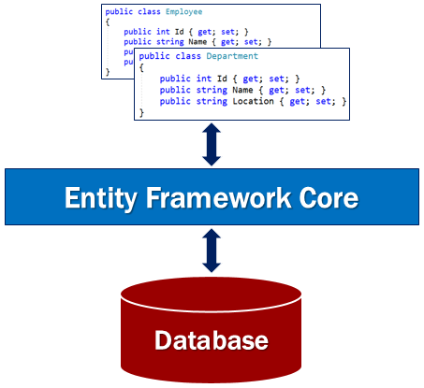  
  
**EF Core Code First Approach**   
  
EF Core supports both **Code First approach** and **Database First approach**. However, with the Database First approach there is very limited support in EF core at the moment.   
  
  
  
With the Code First Approach, we first create our application domain classes like Employee, Customer etc and a special class that derives from Entity Framework DbContext class. Based on these domain and DBContext classes, EF Core creates the database and relevant tables. Out of the box, EF Core uses it's default conventions to create the database and database tables. You can change these default conventions if you want to.   
  
**EF Core Database First Approach**   
  
  
  
Sometimes we may have an existing database. When we have a database and the database tables already, we use the database first approach. With the database first approach, EF Core creates the DBContext and Domain classes based on the existing database schema.   
  
**EF Core Database Providers**   
  
EF Core supports many relational and even non relational databases. EF Core is able to do this by using plug-in libraries called the database providers. These database providers are available as NuGet packages.    
  
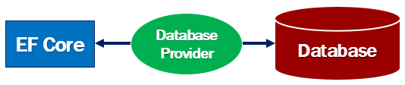  
  
List of EF Core Database Providers  
<https://docs.microsoft.com/en-us/ef/core/providers/>   
  
A database provider, usually sits between EF Core and the database it supports. The database provider contains the functionality specific to the database it supports. Functionality that is common to all the databases is in the EF Core component. Functionality that is specific to a database, for example, Microsoft SQL Server specific functionality is with-in the SQL Server provider for EF Core.

We will discuss more about this provider model when we include support for SQL server in our asp.net core application in our upcoming videos.

### Install entity framework core in visual studio

**Suggested Videos**  
[Part 43 - Select list validation in asp.net core](https://youtu.be/woFHR3iNEEI) | [Text](https://csharp-video-tutorials.blogspot.com/2019/04/select-list-validation-in-aspnet-core.html) | [Slides](https://csharp-video-tutorials.blogspot.com/2019/04/select-list-validation-in-aspnet-core_9.html)  
[Part 44 - AddSingleton vs AddScoped vs AddTransient](https://youtu.be/v6Nr7Zman_Y) | [Text](https://csharp-video-tutorials.blogspot.com/2019/04/addsingleton-vs-addscoped-vs.html) | [Slides](https://csharp-video-tutorials.blogspot.com/2019/04/addsingleton-vs-addscoped-vs_10.html)   
[Part 45 - Introduction to entity framework core](https://youtu.be/OE0_9c-K-Ow) | [Text](https://csharp-video-tutorials.blogspot.com/2019/04/introduction-to-entity-framework-core.html) | [Slides](https://csharp-video-tutorials.blogspot.com/2019/04/introduction-to-entity-framework-core_20.html)  
  
In this video we will discuss **how to install Entity Framework Core in Visual Studio.**   
  
  
Depending on how you have your project set up, you may have Entity Framework Core already installed.   
  
  
**Single Layer Web Application**   
  
If it's a small project, you may have your presentation layer, business layer and data access layer all in one project. So if you have created a web application project using ASP.NET Core 2.1 or higher, then in that web application project, you already have Entity Framework Core installed.   
  
**Entity Framework Core in ASP.NET Core Web Application Project**   
  
An ASP.NET Core Web application project that is created using ASP.NET Core 2.1 or higher has the following NuGet package installed.

Microsoft.AspNetCore.App

This package is called - **metapackage**. A metapackage has no content of its own but is a list of dependencies (other packages). You can find this metapackage, in the Solution Explorer. When you expand the metapackage, you can find all the dependencies. In the dependencies you will find the Entity Framework Core nuget packages already installed.   
  
So the point that I am trying to make is, an asp.net core web application project that is created using ASP.NET Core Version 2.1 or later will have Entity Framework Core already installed as part of the meta package.   
  
**Multi Layer Web Application**   
  
In a large application we will usually have at least the following 3 layers

* Presentation Layer
* Business Logic Layer
* Data Access Layer

These layers are implemented as separate projects. Entity Framework Core is usually required in the Data Access Layer project. The Data Access Layer project is a class library project and does not usually have the meta package referenced. So this means, Entity Framework Core is not installed for the Data Access Layer project.   
  
To install Entity Framework Core and to be able to use SQL server as the database for your application, you need to install the following nuget packages.

|  |  |
| --- | --- |
| **Package** | **Purpose** |
| Microsoft.EntityFrameworkCore.SqlServer | This nuget package contains SQL Server specific functionality |
| Microsoft.EntityFrameworkCore.Relational | This nuget package contains functionality that is common to all relational databases |
| Microsoft.EntityFrameworkCore | This nuget package contains common entity frameowrk core functionality |

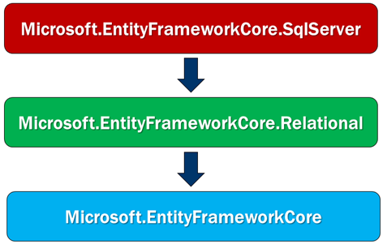

* Microsoft.EntityFrameworkCore.SqlServer has a dependency on Microsoft.EntityFrameworkCore.Relational package.
* Microsoft.EntityFrameworkCore.Relational package has a dependency on Microsoft.EntityFrameworkCore package.
* Microsoft.EntityFrameworkCore package has a dependency on several other packages.

When we install Microsoft.EntityFrameworkCore.SqlServer package, it also installs all the other dependant nuget packages automatically.    
  
**In a class library project, to install a nuget package**

Right click on the *"Dependencies"* node in *"Solution Explorer"* and Select *"Manage NuGet Packages"* from the context menu.   
  
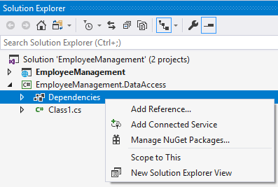  
  
On the screen that pops up, search for the package that you want to install and follow the onscreen instructions.   
  
We want to use SQL Server as the database for our application, so we used the nuget package Microsoft.EntityFrameworkCore.SqlServer. This package is usually called Database provider package.   
  
If you want to use a different database with your application, then you will have to install that database provider specific nuget package instead of Microsoft.EntityFrameworkCore.SqlServer database provider package.   
  
For example, if you want to use mysql as your database, then install Pomelo.EntityFrameworkCore.MySql database provider package. Along the same lines, if you want to use PostgreSQL as your database, use Npgsql.EntityFrameworkCore.PostgreSQL database provider package.   
  
You can find all the provider specific NuGet packages on the following MSDN page  
<https://docs.microsoft.com/en-us/ef/core/providers/>

### DbContext in entity framework core

In this video we will discuss the **significance of the DbContext class in Entity Framework Core**   
  
  
One of the very important classes in Entity Framework Core is the *DbContext* class. This is the class that we use in our application code to interact with the underlying database. It is this class that manages the database connection and is used to retrieve and save data in the database.   
  
  
**To use the DbContext class in our application**

* We create a class that derives from the DbContext class.
* DbContext class is in Microsoft.EntityFrameworkCore namespace.

public class AppDbContext : DbContext  
{ }

**DbContextOptions in Entity Framework Core**

* For the *DbContext* class to be able to do any useful work, it needs an instance of the *DbContextOptions* class.
* The *DbContextOptions* instance carries configuration information such as the connection string, database provider to use etc.
* To pass the *DbContextOptions* instance we use the constructor as shown in the example below.
* We will discuss more about the *DbContextOptions* class in our next video when we discuss database connection string in ASP.NET Core.

public class AppDbContext : DbContext

{

public AppDbContext(DbContextOptions<AppDbContext> options)

: base(options)

{

}

}

**Entity Framework Core DbSet**

* The *DbContext* class includes a *DbSet<TEntity>* property for each entity in the model.
* At the moment in our application we have, only one entity class - Employee.
* So in our *AppDbContext* class we only have one *DbSet<Employee>* property.
* We will use this *DbSet* property Employees to query and save instances of the Employee class.
* The LINQ queries against the *DbSet<TEntity>* will be translated into queries against the underlying database.
* We will see this in action in our upcoming videos.

public class AppDbContext : DbContext

{

public AppDbContext(DbContextOptions<AppDbContext> options)

: base(options)

{

}

public DbSet<Employee> Employees { get; set; }

}

To be able to connect to a database we need the database connection string. In our next video, we will discuss, where to define the connection string and using it in Entity Framework Core.

ConnString za ovaj komp:

"Server=DESKTOP-VVCDA5V\\SQLEXPRESS;Database=BethanyDemo123;Trusted_Connection=True;MultipleActiveResultSets=true"

Jos 1 za svaki slucaj :D

"Server=DESKTOP-VVCDA5V\\SQLEXPRESS;Database=EmployeeDB;Trusted_Connection=True;MultipleActiveResultSets=true"

### Using sql server with entity framework core

In this video we will discuss how to configure and use SQL Server with entity framework core.   
  
  
When using Entity Framework Core, one of the important things that we need to configure is the database provider that we plan to use. Entity Framework Core supports a wide variety of databases including non-relational databases. The following MSDN link has the list of all supported databases.  
<https://docs.microsoft.com/en-us/ef/core/providers/>

public class Startup

{

private IConfiguration _config;

public Startup(IConfiguration config)

{

_config = config;

}

public void ConfigureServices(IServiceCollection services)

{

services.AddDbContextPool<AppDbContext>(

options => options.UseSqlServer(_config.GetConnectionString("EmployeeDBConnection")));

services.AddMvc().AddXmlSerializerFormatters();

services.AddTransient<IEmployeeRepository, MockEmployeeRepository>();

}

// Rest of the code

}

* We want to configure and use Microsoft SQL Server with entity framework core.
* We usually specify this configuration in *ConfigureServices()* method in *Startup.cs* file.

**Difference between AddDbContext() and AddDbContextPool() methods**

* We can use either *AddDbContext()* or *AddDbContextPool()* method to register our application specific DbContext class with the ASP.NET Core dependency injection system.
* The difference between *AddDbContext()* and *AddDbContextPool()* methods is, *AddDbContextPool()* method provides DbContext pooling.
* With DbContext pooling, an instance from the DbContext pool is provided if available, rather than creating a new instance.
* DbContext pooling is conceptually similar to how connection pooling works in ADO.NET.
* From a performance standpoint *AddDbContextPool()* method is better over *AddDbContext()* method.
* AddDbContextPool() method is introduced in ASP.NET Core 2.0. So if you are using ASP.NET Core 2.0 or later use *AddDbContextPool()* method over *AddDbContext()* method.

**UseSqlServer() Extension Method**

* *UseSqlServer()* extension method is used to configure our application specific *DbContext* class to use Microsoft SQL Server as the database.
* To connect to a database, we need the database connection string which is provided as a parameter to *UseSqlServer()* extension method

services.AddDbContextPool<AppDbContext>(

options => options.UseSqlServer(_config.GetConnectionString("EmployeeDBConnection")));

**Database Connection String in ASP.NET Core**   
  
Instead of hard-coding the connection string in application code, we store it appsettings.json configuration file.

{

"ConnectionStrings": {

"EmployeeDBConnection": "server=(localdb)\\MSSQLLocalDB;database=EmployeeDB;Trusted_Connection=true"

}

}

In classic asp.net we store application configuration in web.config file which is in XML format. In asp.net core, there are different configuration sources. One configuration source is *appsettings.json* file and it is in JSON format.   
  
To read connection string from *appsettings.json* file we use *IConfiguration* service *GetConnectionString()* method.   
  
We are using SQL Server localdb which is automatically installed along with Visual Studio. If you want to use a full blown SQL Server instead of localdb, simply change the connection string in *appsettings.json* configuration file to point to your instance of SQL Server.

"server=(localdb)\\MSSQLLocalDB;database=EmployeeDB;Trusted_Connection=true"

What is the difference between the following in a database connection string

* Trusted_Connection=True;
* Integrated Security=SSPI;
* Integrated Security=true;

All the above 3 settings specify the same thing, use Integrated Windows Authentication to connect to SQL Server instead of using SQL Server authentication.   
  
At the moment our application is still using MockEmployeeRepository which is an in-memory collection of employees. In our next video we will implement SQLRepository which stores and retrieves employees from sql server localdb that we have just configured.

### Repository pattern in asp.net core

**In this video, we will discuss**

* What is Repository Pattern
* Benefits of Repository Pattern
* An example that uses repository pattern to store and retrieve data from sql server database using entity framework core

**What is Repository Pattern**   
  
**Repository Pattern** is an abstraction of the Data Access Layer. It hides the details of how exactly the data is saved or retrieved from the underlying data source. The details of how the data is stored and retrieved is in the respective repository. For example, you may have a repository that stores and retrieves data from an in-memory collection. You may have another repository that stores and retrieves data from a database like SQL Server.

public class Employee

{

public int Id { get; set; }

public string Name { get; set; }

public string Email { get; set; }

public Dept? Department { get; set; }

}

**Repository Pattern Interface**   
  
**The interface in the repository pattern specifies**

* What operations (i.e methods) are supported by the repository
* The data required for each of the operations i.e the parameters that need to be passed to the method and the data the method returns
* The repository interface contains what it can do, but not, how it does, what it can do
* The implementation details are in the respective repository class that implements the repository Interface

public interface IEmployeeRepository

{

    Employee GetEmployee(int Id);

    IEnumerable<Employee> GetAllEmployee();

Employee Add(Employee employee);

Employee Update(Employee employeeChanges);

Employee Delete(int Id);

}

**IEmployeeRepository interface supports the following operations**

* Get all the employees
* Get a single employee by id
* Add a new employee
* Updat an employee
* Delete an employee

The details of how these operations are implmented are in the repository class that implments this IEmployeeRepository interface    
  
**Repository Pattern - In-memory Implementation**   
  
The following MockEmployeeRepository class provides an implementation for IEmployeeRepository. This specific implementation stores and retrieves employees from an in-memory collection.

public class MockEmployeeRepository : IEmployeeRepository

{

private List<Employee> _employeeList;

public MockEmployeeRepository()

{

_employeeList = new List<Employee>()

{

new Employee() { Id = 1, Name = "Mary", Department = Dept.HR, Email = "mary@pragimtech.com" },

new Employee() { Id = 2, Name = "John", Department = Dept.IT, Email = "john@pragimtech.com" },

new Employee() { Id = 3, Name = "Sam", Department = Dept.IT, Email = "sam@pragimtech.com" },

};

}

public Employee Add(Employee employee)

{

employee.Id = _employeeList.Max(e => e.Id) + 1;

_employeeList.Add(employee);

return employee;

}

public Employee Delete(int Id)

{

Employee employee = _employeeList.FirstOrDefault(e => e.Id == Id);

if (employee != null)

{

_employeeList.Remove(employee);

}

return employee;

}

public IEnumerable<Employee> GetAllEmployee()

{

return _employeeList;

}

public Employee GetEmployee(int Id)

{

return this._employeeList.FirstOrDefault(e => e.Id == Id);

}

public Employee Update(Employee employeeChanges)

{

Employee employee = _employeeList.FirstOrDefault(e => e.Id == employeeChanges.Id);

if (employee != null)

{

employee.Name = employeeChanges.Name;

employee.Email = employeeChanges.Email;

employee.Department = employeeChanges.Department;

}

return employee;

}

}

**Repository Pattern - SQL Server Implementation**   
  
The following SQLEmployeeRepository class provides another implementation for IEmployeeRepository. This specific implementation stores and retrieves employees from a sql server database using entity framework core.

public class SQLEmployeeRepository : IEmployeeRepository

{

private readonly AppDbContext context;

public SQLEmployeeRepository(AppDbContext context)

{

this.context = context;

}

public Employee Add(Employee employee)

{

context.Employees.Add(employee);

context.SaveChanges();

return employee;

}

public Employee Delete(int Id)

{

Employee employee = context.Employees.Find(Id);

if (employee != null)

{

context.Employees.Remove(employee);

context.SaveChanges();

}

return employee;

}

public IEnumerable<Employee> GetAllEmployee()

{

return context.Employees;

}

public Employee GetEmployee(int Id)

{

return context.Employees.Find(Id);

}

public Employee Update(Employee employeeChanges)

{

var employee = context.Employees.Attach(employeeChanges);

employee.State = Microsoft.EntityFrameworkCore.EntityState.Modified;

context.SaveChanges();

return employeeChanges;

}

}

**Which implementation to use**   
  
Take a look at the following HomeController in our application. ASP.NET Core Dependency injection system injects an instance of IEmployeeRepository.

public class HomeController : Controller

{

private IEmployeeRepository _employeeRepository;

public HomeController(IEmployeeRepository employeeRepository)

{

_employeeRepository = employeeRepository;

}

public ViewResult Index()

{

var model = _employeeRepository.GetAllEmployee();

return View(model);

}

// Rest of the code

}

There are 2 implementations for IEmployeeRepository interface. How does the application know which implementation to use. The answer to this is in Startup class in Startup.cs file. With the following line of code, ASP.NET Core provides an instance of SQLEmployeeRepository class when an instance of IEmployeeRepository is requested. We are using AddScoped() method because we want the instance to be alive and available for the entire scope of the given HTTP request. For another new HTTP request, a new instance of SQLEmployeeRepository class will be provided and it will be available throughout the entire scope of that HTTP request.   
  
We discussed the difference between AddSingleton(), AddScoped() and AddTransient() methods in detail in [Part 44](https://youtu.be/v6Nr7Zman_Y) of [ASP.NET Core Tutorial](https://www.youtube.com/playlist?list=PL6n9fhu94yhVkdrusLaQsfERmL_Jh4XmU).

public void ConfigureServices(IServiceCollection services)

{

// Rest of the code

services.AddScoped<IEmployeeRepository, SQLEmployeeRepository>();

}

Throughout our entire application, in all the places where IEmployeeRepository is injected an instance of SQLEmployeeRepository is provided. If you want your application to use a different implementation instead, all you need to change is the following one line of code.

services.AddScoped<IEmployeeRepository, MockEmployeeRepository>();

**Benefits of Repository Pattern**

* The code is cleaner, and easier to reuse and maintain.
* Enables us to create loosely coupled systems. For example, if we want our application to work with oracle instead of sql server, implement an OracleRepository that knows how to read and write to Oracle database and register OracleRepository with the dependency injection system.
* In an unit testing project, it is easy to replace a real repository with a fake implementation for testing.

### Entity framework core migrations

In this video we will discuss the concept of **Migrations in Entity Framework Core.**   
  
  
**What is a migration in entity framework core**   
  
Migration is an entity framework core feature that keeps the database schema and our application model classes (also called entity class) in sync.   
  
  
If you have not executed at-least the initial migration in your application you might get the following SqlException  
SqlException: Cannot open database "EmployeeDB" requested by the login.   
  
This is because we do not have the database created yet. One way to create the database is by

1. Creating a migration first and then
2. Executing that migration

To work with migrations, we can either use the Package Manager Console (PMC) or the .NET core command-line interface (CLI). If you are using Visual Studio like me, then use the Package Manager Console.   
  
To launch Package Manager Console in Visual Studio, click on *View - Other Windows - Package Manager Console*   
  
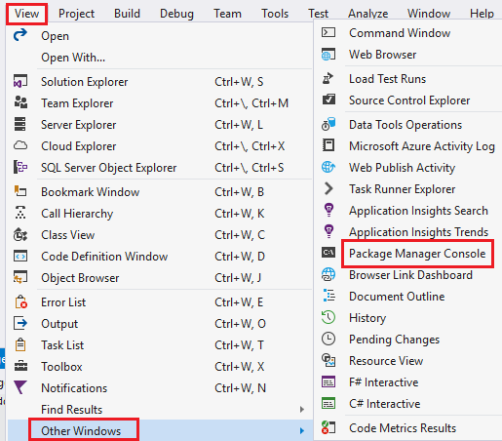  
  
**Common entity framework core migration commands**   
  
We will be using the following 3 common commands to work with migrations in entity framework core.

|  |  |
| --- | --- |
| **Command** | **Purpose** |
| get-help about_entityframeworkcore | Provides entity framework core help |
| Add-Migration | Adds a new migration |
| Update-Database | Updates the database to a specified migration |

**Please note :** You can use *get-help* command with any of the above commands. For example *get-help Add-Migration* provides help for Add-Migration command.   
  
**Creating a Migration in Entity Framework Core**  
  
The following command creates the initial migration. *InitialCreate* is the name of the migration.  
*Add-Migration InitialCreate*  
  
When the above command completes, you will see a file in the *"Migrations"* folder that contains the name *InitialCreate.cs*. This file has the code required to create the respective database tables.  
  
**Please note :** To have the command auto-completed in the Package Manager Console window, type part of the command and press the TAB key.  
  
**Update-Database in Entity Framework Core**  
  
We need to execute the migration code to create the tables. If the database does not exist already, it creates the database and then the database tables. For updating the database, we use *Update-Database* command. To the *Update-Database* command we may pass the migration name we want to execute. If no migration is specified, the command by default executes the last migration.  
  
After the migration is executed, when you navigate to the application we no longer get the following SqlException  
SqlException: Cannot open database "EmployeeDB" requested by the login.   
  
This is because the *EmployeeDB* is created when the migration is executed. We can confirm this in *SQL Server Object Explorer* window in Visual Studio.   
  
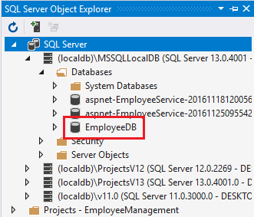  
  
At the moment we do not have any data in the Employees table. In our next video, we will discuss how to seed the database table with initial data.

### Entity framework core seed data

In this video we will discuss **how to seed database tables with initial data using Migrations in entity framework core**.   
  
  
If you are using Entity Framework Core 2.1 or later there is a new method of seeding database data. In your application DbContext class, override OnModelCreating() method. In this example, HasData() method configures Employee entity to have the specified seed data.

public class AppDbContext : DbContext

{

public AppDbContext(DbContextOptions<AppDbContext> options)

: base(options)

{

}

public DbSet<Employee> Employees { get; set; }

protected override void OnModelCreating(ModelBuilder modelBuilder)

{

modelBuilder.Entity<Employee>().HasData(

new Employee

{

Id = 1,

Name = "Mark",

Department = Dept.IT,

Email = "mark@pragimtech.com"

}

);

}

}

**Using Migrations to seed data**   
  
The following command adds a new migration. I named the migration *SeedEmployeesTable* as we are using this migration to specifically add seed data to the *Employees* database table.

Add-Migration SeedEmployeesTable

The above command generates the following code

using Microsoft.EntityFrameworkCore.Migrations;

namespace EmployeeManagement.Migrations

{

public partial class SeedEmployeesTable : Migration

{

protected override void Up(MigrationBuilder migrationBuilder)

{

migrationBuilder.InsertData(

table: "Employees",

columns: new[] { "Id", "Department", "Email", "Name" },

values: new object[] { 1, 3, "mark@pragimtech.com", "Mark" });

}

protected override void Down(MigrationBuilder migrationBuilder)

{

migrationBuilder.DeleteData(

table: "Employees",

keyColumn: "Id",

keyValue: 1);

}

}

}

Finally, execute *Update-Database* command to apply the above migration to the database.   
  
**Altering Existing Database Seed data**   
  
You can alter the existing seed data or add new seed data by adding another new migration.    
  
**Step 1 :** Modify the code in *OnModelCreating()* method.

protected override void OnModelCreating(ModelBuilder modelBuilder)

{

    modelBuilder.Entity<Employee>().HasData(

new Employee

{

Id = 1,

Name = "Mary",

            Department = Dept.IT,

Email = "mary@pragimtech.com"

},

new Employee

{

Id = 2,

Name = "John",

            Department = Dept.HR,

Email = "john@pragimtech.com"

}

);

}

**Step 2 :** Add a new migration

Add-Migration AlterEmployeesSeedData

**Step 3 :** Update the database with the latest migration

Update-Database

**Keeping DbContext Class Clean**   
  
To keep the DbContext class clean, you may move the seeding code from the DbContext class into an extension method on the ModelBuilder class.

using Microsoft.EntityFrameworkCore;

namespace EmployeeManagement.Models

{

public static class ModelBuilderExtensions

{

public static void Seed(this ModelBuilder modelBuilder)

{

            modelBuilder.Entity<Employee>().HasData(

new Employee

{

Id = 1,

Name = "Mary",

                        Department = Dept.IT,

Email = "mary@pragimtech.com"

},

new Employee

{

Id = 2,

Name = "John",

                        Department = Dept.HR,

Email = "john@pragimtech.com"

}

);

}

}

}

In OnModelCreating() method of the DbContext class, you can then call Seed() method as shown below.

protected override void OnModelCreating(ModelBuilder modelBuilder)  
{  
    modelBuilder.Seed();  
}

### Keeping domain models and database schema in sync in asp.net core

**In this video we will discuss**

* How to keep domain models and database schema in sync using migrations in asp.net core
* How to add a migration in asp.net core
* How to remove a migration in asp.net core
* How to apply the migration and update the database
* How to undo a migration that is already applied and bring the database schema to it's previous state
* What is the use of ModelSnapshot class and __EFMigrationsHistory table

As we develop our application and add new features, our application domain classes change. When the domain classes change, the corresponding changes have to be made to the underlying database schema. Otherwise the database schema goes out of sync and the application does not work as expected.    
  
However, it is important not to manually make these changes to the database schema. We use migrations to keep the database schema in sync as the application domain classes change.  
  
  
**Example**    
  
At the moment our domain Employee class does not have a property to store the Photo Path of the employee.

public class Employee

{

public int Id { get; set; }

public string Name { get; set; }

public string Email { get; set; }

public Dept? Department { get; set; }

}

To be able to store the *Photo Path* of the employee, we want to add *PhotoPath* property to the Employee class.

public class Employee

{

public int Id { get; set; }

public string Name { get; set; }

public string Email { get; set; }

public Dept? Department { get; set; }

*public string PhotoPath { get; set; }*

}

To keep the Employees database table in sync with the Employee Model class, add a new migration and execute it to update the database.    
  
**Adding a new migration**   
  
Use Add-Migration command to add a new migration. AddPhotoPathToEmployees is the name of the migration.

Add-Migration AddPhotoPathToEmployees

**Files in the Migrations folder**   
  
Executing the above command generates the following files.   
  
[TimeStap]_AddPhotoPathToEmployees.cs - The file name is made up of TimeStamp, UnderScore and the migration name. The class name in this file has the same name as the migration name. This class contains 2 methods - Up() and Down(). Up() method contains code to apply the changes made to the model class to the underlying database schema. Down() method contains code to undo the changes.   
  
[DbContextClassName]ModelSnapshot.cs - As the name implies this file contains the snapshot of your current model. This file is created when the first migration is added and updated with each subsequent migration. EF core migrations API uses this file to determine what has changed when adding the next migration.   
  
**Apply Migration and Update Database**   
  
To apply the migration and update the database use Update-Database command. This command executes the code in Up() method and applies the changes to the underlying database objects.

Update-Database

**Use of __EFMigrationsHistory table**   
  
__EFMigrationsHistory table is created in the database, when the first migration is executed. This table is used to keep track of the migrations that are applied to the database. There will be an entry for every migration that is applied.   
  
**Removing a migration**   
  
To remove a migration execute Remove-Migration command   
  
It only removes one migration at a time and that too only the latest migration that is not yet applied to the database. If all the migrations are already applied, executing Remove-Migration command throws the following exception.   
  
The migration 'Latest_Migration_Name' has already been applied to the database. Revert it and try again.   
  
**Removing a migration that is already applied to the database**   
  
Let us understand how to remove a migration that has already been applied to the database with an example. Let us say we have the following 3 migrations already applied to the database.

* Migration_One
* Migration_Two
* Migration_Three

We want to remove both migration Migration_Two and Migration_Three. Since all these 3 migrations are already applied to the database, executing Remove-Migration command will throw an error.   
  
To be able to remove a migration that is already applied to the database, we first have to undo the changes the migration made to the database. The way we do this is by executing Update-Database command with a migration name.    
  
If we relate this to our example, we want to undo the changes done by Migration_Two and Migration_Three and bring the database state to the state it was in, when Migration_One was executed. To achieve this we execute Update-Database command with Migration_One name as shown below.

Update-Database Migration_One

Executing the above command will undo the changes made by Migration_Two and Migration_Three. EF core will also remove the entries for these 2 migrations from __EFMigrationsHistory table.   
  
However, the migration code files will still be there in the **Migrations** folder. To remove the code files use Remove-Migration command. Since we want to remove both Migration_Three and Migration_Two code files, we want to execute Remove-Migration command twice.

### File upload in asp.net core mvc

**Bitan video, ovde je tekst, samo gotov kod, pokriva sve za upload slike…**  
  
  
In this video we will discuss **how to upload a file using ASP.NET Core MVC with an example**.  
  
We want to implement the following *Create Employee Form*. We want to be able upload Employee photo using the Photo field on the form.   
  
  
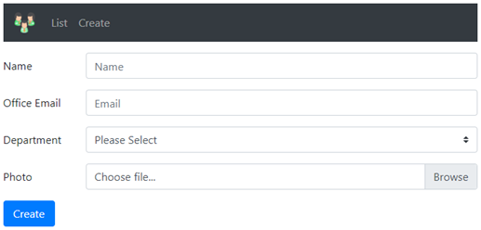  
  
  
When this *Create Employee Form* is submitted, we want to store Employee data i.e Name, Email, Department and PhotoPath in Employees database table. Here is the Employees database table. This table is created using Migrations in ASP.NET Core.   
  
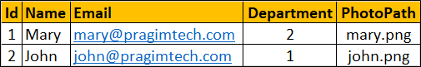  
  
Employee photo should be uploaded to wwwroot/images folder on the web server.   
  
**Employee Model Class**

public class Employee

{

public int Id { get; set; }

public string Name { get; set; }

public string Email { get; set; }

public Dept? Department { get; set; }

public string PhotoPath { get; set; }

}

**EmployeeCreateViewModel Class**

public class CreateViewModel

{

public string Name { get; set; }

public string Email { get; set; }

public Dept? Department { get; set; }

public IFormFile Photo { get; set; }

}

* IFormFile is in Microsoft.AspNetCore.Http namespace.
* The file uploaded to the server can be accessed through Model Binding using the IFormFile interface.
* The interface IFormFile has the following properties and methods

public interface IFormFile

{

string ContentType { get; }

string ContentDisposition { get; }

IHeaderDictionary Headers { get; }

long Length { get; }

string Name { get; }

string FileName { get; }

    Stream OpenReadStream();

void CopyTo(Stream target);

    Task CopyToAsync(Stream target, CancellationToken cancellationToken = null);

}

**Create View Code**   
  
The code specific to uploading the file is commented

@model EmployeeCreateViewModel

@{

ViewBag.Title = "Create Employee";

}

@*To support file upload set the form element enctype="multipart/form-data" *@

<**form** enctype="multipart/form-data" **asp-controller**="home" **asp-action**="create"

method="post" class="mt-3">

<div class="form-group row">

<**label** **asp-for**="Name" class="col-sm-2 col-form-label"></**label**>

<div class="col-sm-10">

<**input** **asp-for**="Name" class="form-control" placeholder="Name">

<**span** **asp-validation-for**="Name" class="text-danger"></**span**>

</div>

</div>

<div class="form-group row">

<**label** **asp-for**="Email" class="col-sm-2 col-form-label"></**label**>

<div class="col-sm-10">

<**input** **asp-for**="Email" class="form-control" placeholder="Email">

<**span** **asp-validation-for**="Email" class="text-danger"></**span**>

</div>

</div>

<div class="form-group row">

<**label** **asp-for**="Department" class="col-sm-2 col-form-label"></**label**>

<div class="col-sm-10">

<**select** **asp-for**="Department" class="custom-select mr-sm-2"

**asp-items**="Html.GetEnumSelectList<Dept>()">

<**option** **value**="">Please Select</**option**>

</**select**>

<**span** **asp-validation-for**="Department" class="text-danger"></**span**>

</div>

</div>

@* asp-for tag helper is set to "Photo" property. "Photo" property type is IFormFile

so at runtime asp.net core generates file upload control (input type=file)

*@

<div class="form-group row">

<**label** **asp-for**="Photo" class="col-sm-2 col-form-label"></**label**>

<div class="col-sm-10">

<div class="custom-file">

<**input** **asp-for**="Photo" class="form-control custom-file-input">

<label class="custom-file-label">Choose File...</label>

</div>

</div>

</div>

<**div** **asp-validation-summary**="All" class="text-danger"></**div**>

<div class="form-group row">

<div class="col-sm-10">

<button type="submit" class="btn btn-primary">Create</button>

</div>

</div>

@*This script is required to display the selected file in the file upload element*@

@section Scripts {

<script>

$(document).ready(function () {

$('.custom-file-input').on("change", function () {

var fileName = $(this).val().split("\\").pop();

$(this).next('.custom-file-label').html(fileName);

});

});

</script>

}

</**form**>

**Create Action Method**

using EmployeeManagement.Models;

using EmployeeManagement.ViewModels;

using Microsoft.AspNetCore.Hosting;

using Microsoft.AspNetCore.Mvc;

using System;

using System.IO;

namespace EmployeeManagement.Controllers

{

public class HomeController : Controller

{

private readonly IEmployeeRepository _employeeRepository;

private readonly IHostingEnvironment hostingEnvironment;

public HomeController(IEmployeeRepository employeeRepository,

IHostingEnvironment hostingEnvironment)

{

_employeeRepository = employeeRepository;

this.hostingEnvironment = hostingEnvironment;

}

[HttpGet]

public ViewResult Create()

{

return View();

}

[HttpPost]

public IActionResult Create(EmployeeCreateViewModel model)

{

if (ModelState.IsValid)

{

string uniqueFileName = null;

// If the Photo property on the incoming model object is not null, then the user

// has selected an image to upload.

if (model.Photo != null)

{

// The image must be uploaded to the images folder in wwwroot

// To get the path of the wwwroot folder we are using the inject

// HostingEnvironment service provided by ASP.NET Core

string uploadsFolder = Path.Combine(hostingEnvironment.WebRootPath, "images");

// To make sure the file name is unique we are appending a new

// GUID value and and an underscore to the file name

uniqueFileName = Guid.NewGuid().ToString() + "_" + model.Photo.FileName;

string filePath = Path.Combine(uploadsFolder, uniqueFileName);

// Use CopyTo() method provided by IFormFile interface to

// copy the file to wwwroot/images folder

model.Photo.CopyTo(new FileStream(filePath, FileMode.Create));

}

Employee newEmployee = new Employee

{

Name = model.Name,

Email = model.Email,

Department = model.Department,

// Store the file name in PhotoPath property of the employee object

// which gets saved to the Employees database table

PhotoPath = uniqueFileName

};

_employeeRepository.Add(newEmployee);

return RedirectToAction("details", new { id = newEmployee.Id });

}

return View();

}

}

}

The rest of the code on this page is not required to upload a file. It contains code to display a specific employee details using the details view and the list of employees using the index view.   
  
**Details View Code**

@model HomeDetailsViewModel

@{

ViewBag.Title = "Employee Details";

var photoPath = "~/images/" + (Model.Employee.PhotoPath ?? "noimage.jpg");

}

<div class="row justify-content-center m-3">

<div class="col-sm-8">

<div class="card">

<div class="card-header">

<h1>@Model.Employee.Name</h1>

</div>

<div class="card-body text-center">

<**img** class="card-img-top" **src**="@photoPath" **asp-append-version**="true" />

<h4>Employee ID : @Model.Employee.Id</h4>

<h4>Email : @Model.Employee.Email</h4>

<h4>Department : @Model.Employee.Department</h4>

</div>

<div class="card-footer text-center">

<**a** **asp-controller**="home" **asp-action**="index" class="btn btn-primary">Back</**a**>

<a href="#" class="btn btn-primary">Edit</a>

<a href="#" class="btn btn-danger">Delete</a>

</div>

</div>

</div>

</div>

**Index View Code**

@model IEnumerable<Employee>

@{

ViewBag.Title = "Employee List";

}

<div class="card-deck">

@foreach (var employee in Model)

{

var photoPath = "~/images/" + (employee.PhotoPath ?? "noimage.jpg");

<div class="card m-3" style="min-width: 18rem; max-width:30.5%;">

<div class="card-header">

<h3>@employee.Name</h3>

</div>

<**img** class="card-img-top imageThumbnail" **src**="@photoPath"

**asp-append-version**="true" />

<div class="card-footer text-center">

<**a** **asp-controller**="home" **asp-action**="details" **asp-route-id**="@employee.Id"

class="btn btn-primary m-1">View</**a**>

<a href="#" class="btn btn-primary m-1">Edit</a>

<a href="#" class="btn btn-danger m-1">Delete</a>

</div>

</div>

}

</div>

**site.css**

.imageThumbnail {

height:200px;

width:auto;

}

### Upload multiple files in asp.net core mvc

**Suggested Videos**  
  
  
In this video we will discuss **how to upload multiple files in asp.net core**. This is continuation to Part 53. Please watch Part 53 from [ASP.NET Core tutorial](https://www.youtube.com/playlist?list=PL6n9fhu94yhVkdrusLaQsfERmL_Jh4XmU) before proceeding.   
  
  
We will use the following Create Employee Form to understand uploading multiple files in ASP.NET Core. When we click on the Photo filed on the form, we should be able to select multiple files that we want to upload.   
  
  
  
  
When this Create Employee Form is submitted, we want to store Employee data i.e Name, Email, Department and PhotoPath in Employees database table. Here is the Employees database table. This table is created using Migrations in ASP.NET Core.   
  
  
  
All the selected photos should be uploaded to wwwroot/images folder on the web server.   
  
**Employee Model Class**

public class Employee

{

public int Id { get; set; }

public string Name { get; set; }

public string Email { get; set; }

public Dept? Department { get; set; }

public string PhotoPath { get; set; }

}

**EmployeeCreateViewModel Class**

public class EmployeeCreateViewModel

{

public string Name { get; set; }

public string Email { get; set; }

public Dept? Department { get; set; }

public List<IFormFile> Photos { get; set; }

}

* IFormFile is in Microsoft.AspNetCore.Http namespace.
* The file uploaded to the server can be accessed through Model Binding using the IFormFile interface.
* The Photos property receives the uploaded files through Model Binding
* To support multiple files upload we have set the data type of Photos property to List<IFormFile>
* The interface IFormFile has the following properties and methods

public interface IFormFile

{

string ContentType { get; }

string ContentDisposition { get; }

IHeaderDictionary Headers { get; }

long Length { get; }

string Name { get; }

string FileName { get; }

Stream OpenReadStream();

void CopyTo(Stream target);

    Task CopyToAsync(Stream target, CancellationToken cancellationToken = null);

}

**Create View Code**

@model EmployeeCreateViewModel

@{

ViewBag.Title = "Create Employee";

}

@*To support file upload set the form element enctype="multipart/form-data" *@

<**form** enctype="multipart/form-data" **asp-controller**="home" **asp-action**="create"

method="post" class="mt-3">

<div class="form-group row">

<**label** **asp-for**="Name" class="col-sm-2 col-form-label"></**label**>

<div class="col-sm-10">

<**input** **asp-for**="Name" class="form-control" placeholder="Name">

<**span** **asp-validation-for**="Name" class="text-danger"></**span**>

</div>

</div>

<div class="form-group row">

<**label** **asp-for**="Email" class="col-sm-2 col-form-label"></**label**>

<div class="col-sm-10">

<**input** **asp-for**="Email" class="form-control" placeholder="Email">

<**span** **asp-validation-for**="Email" class="text-danger"></**span**>

</div>

</div>

<div class="form-group row">

<**label** **asp-for**="Department" class="col-sm-2 col-form-label"></**label**>

<div class="col-sm-10">

<**select** **asp-for**="Department" class="custom-select mr-sm-2"

**asp-items**="Html.GetEnumSelectList<Dept>()">

<**option** **value**="">Please Select</**option**>

</**select**>

<**span** **asp-validation-for**="Department" class="text-danger"></**span**>

</div>

</div>

@* asp-for tag helper is set to "Photo" property. "Photo" property type is IFormFile

so at runtime asp.net core generates file upload control (input type=file). To

support multiple files upload include multiple attribute on the input element

*@

<div class="form-group row">

<**label** **asp-for**="Photos" class="col-sm-2 col-form-label"></**label**>

<div class="col-sm-10">

<div class="custom-file">

<**input** **asp-for**="Photos" multiple class="form-control custom-file-input">

<label class="custom-file-label">Choose File...</label>

</div>

</div>

</div>

<**div** **asp-validation-summary**="All" class="text-danger"></**div**>

<div class="form-group row">

<div class="col-sm-10">

<button type="submit" class="btn btn-primary">Create</button>

</div>

</div>

@*This script is required to display the selected file in the file upload element

If a sinle file is selected, the name of the file is displayed. If multiple

files are selected, then the count of files is displayed.*@

@section Scripts {

<script>

$(document).ready(function () {

$('.custom-file-input').on("change", function () {

var fileLabel = $(this).next('.custom-file-label');

var files = $(this)[0].files;

if (files.length > 1) {

fileLabel.html(files.length + ' files selected');

}

else if (files.length == 1) {

fileLabel.html(files[0].name);

}

});

});

</script>

}

</**form**>

**Create Action Method**

using EmployeeManagement.Models;

using EmployeeManagement.ViewModels;

using Microsoft.AspNetCore.Hosting;

using Microsoft.AspNetCore.Http;

using Microsoft.AspNetCore.Mvc;

using System;

using System.Collections.Generic;

using System.IO;

using System.Linq;

using System.Threading.Tasks;

namespace EmployeeManagement.Controllers

{

public class HomeController : Controller

{

private IEmployeeRepository _employeeRepository;

private readonly IHostingEnvironment hostingEnvironment;

public HomeController(IEmployeeRepository employeeRepository, IHostingEnvironment hostingEnvironment)

{

_employeeRepository = employeeRepository;

this.hostingEnvironment = hostingEnvironment;

}

[HttpGet]

public ViewResult Create()

{

return View();

}

[HttpPost]

public IActionResult Create(EmployeeCreateViewModel model)

{

if (ModelState.IsValid)

{

string uniqueFileName = null;

// If the Photos property on the incoming model object is not null and if count > 0,

// then the user has selected at least one file to upload

if (model.Photos != null && model.Photos.Count > 0)

{

// Loop thru each selected file

foreach (IFormFile photo in model.Photos)

{

// The file must be uploaded to the images folder in wwwroot

// To get the path of the wwwroot folder we are using the injected

// IHostingEnvironment service provided by ASP.NET Core

string uploadsFolder = Path.Combine(hostingEnvironment.WebRootPath, "images");

// To make sure the file name is unique we are appending a new

// GUID value and and an underscore to the file name

uniqueFileName = Guid.NewGuid().ToString() + "_" + photo.FileName;

string filePath = Path.Combine(uploadsFolder, uniqueFileName);

// Use CopyTo() method provided by IFormFile interface to

// copy the file to wwwroot/images folder

photo.CopyTo(new FileStream(filePath, FileMode.Create));

}

}

Employee newEmployee = new Employee

{

Name = model.Name,

Email = model.Email,

Department = model.Department,

PhotoPath = uniqueFileName

};

_employeeRepository.Add(newEmployee);

return RedirectToAction("details", new { id = newEmployee.Id });

}

return View();

}

}

}

### Edit view in asp.net core mvc

In this video we will discuss implementing **Edit view to edit existing data**.   
  
  
We want to display existing employee data on **edit view** as shown in the image below. The user can then change the details and click the *Update* button to update the data in the underlying database.   
  
  
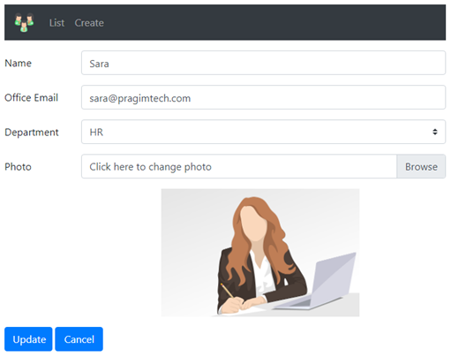  
  
In this video we will discuss implementing **edit view** and in our next video we will discuss **updating the data**. When the *Cancel* button is clicked, redirect the user to the *list view*.   
  
**Navigating to Edit View**   
  
The following is our List View.    
  
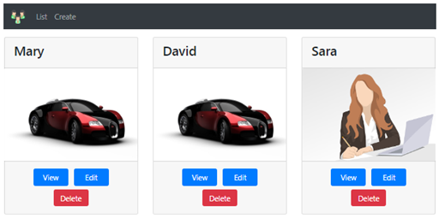  
  
When the *Edit* button is clicked we want to redirect to the *Edit view*. In *index.chtml* modify the *Edit* anchor element as shown below.

<**a** **asp-controller**="home" **asp-action**="edit" **asp-route-id**="@employee.Id"

    class="btn btn-primary m-1">Edit</**a**>

Notice, we are using the following tag helpers to get to the *Edit action* in *Home controller* passing it the *ID* of the employee.

* asp-controller
* asp-action
* asp-route-*

The above code generates an URL that looks like the following. **Edit** is the action method in the *HomeController* and the value 1 is the ID of the employee being edited.

http://localhost/home/edit/1

**Edit View Model**   
  
In the **ViewModels** folder include the following EmployeeEditViewModel class

public class EmployeeEditViewModel : EmployeeCreateViewModel

{

public int Id { get; set; }

public string ExistingPhotoPath { get; set; }

}

For your reference here is the EmployeeCreateViewModel class

public class EmployeeCreateViewModel

{

    [Required]

[MaxLength(50, ErrorMessage = "Name cannot exceed 50 characters")]

public string Name { get; set; }

    [Required]

[RegularExpression(@"^[a-zA-Z0-9_.+-]+@[a-zA-Z0-9-]+\.[a-zA-Z0-9-.]+$",

ErrorMessage = "Invalid Email Format")]

[Display(Name = "Office Email")]

public string Email { get; set; }

    [Required]

public Dept? Department { get; set; }

public IFormFile Photo { get; set; }

}

* This **view model** carries the data the **Edit view** needs
* EmployeeEditViewModel class derives from EmployeeCreateViewModel
* We used the inheritance approach in order not to duplicate code
* In addition to the properties we inherited from EmployeeCreateViewModel class, we also need employee Id and ExistingPhotoPath properties in the EmployeeEditViewModel.

**Edit Action Method in the Home Controller**   
  
Include the following Edit action method in the HomeController

[HttpGet]

public ViewResult Edit(int id)

{

    Employee employee = _employeeRepository.GetEmployee(id);

    EmployeeEditViewModel employeeEditViewModel = new EmployeeEditViewModel

{

Id = employee.Id,

Name = employee.Name,

Email = employee.Email,

Department = employee.Department,

ExistingPhotoPath = employee.PhotoPath

};

return View(employeeEditViewModel);

}

* This **Edit** action method responds to the GET request.
* It uses the injected Employee Repository instance to retrieve the employee details
* Constructs the EmployeeEditViewModel instance and passes it to the **Edit** view

**Edit View**   
  
The code is commented and self explanatory

@model EmployeeEditViewModel

@{

ViewBag.Title = "Edit Employee";

// Get the full path of the existing employee photo for display

var photoPath = "~/images/" + (Model.ExistingPhotoPath ?? "noimage.jpg");

}

<**form** **asp-controller**="home" **asp-action**="edit" enctype="multipart/form-data" method="post" class="mt-3">

<**div** **asp-validation-summary**="All" class="text-danger">

</**div**>

@*Use hidden input elements to store employee id and ExistingPhotoPath

which we need when we submit the form and update data in the database*@

<**input** hidden **asp-for**="Id" />

<**input** hidden **asp-for**="ExistingPhotoPath" />

@*Bind to the properties of the EmployeeEditViewModel. The asp-for tag helper

takes care of displaying the existing data in the respective input elements*@

<div class="form-group row">

<**label** **asp-for**="Name" class="col-sm-2 col-form-label"></**label**>

<div class="col-sm-10">

<**input** **asp-for**="Name" class="form-control" placeholder="Name">

<**span** **asp-validation-for**="Name" class="text-danger"></**span**>

</div>

</div>

<div class="form-group row">

<**label** **asp-for**="Email" class="col-sm-2 col-form-label"></**label**>

<div class="col-sm-10">

<**input** **asp-for**="Email" class="form-control" placeholder="Email">

<**span** **asp-validation-for**="Email" class="text-danger"></**span**>

</div>

</div>

<div class="form-group row">

<**label** **asp-for**="Department" class="col-sm-2 col-form-label"></**label**>

<div class="col-sm-10">

<**select** **asp-for**="Department" class="custom-select mr-sm-2"

**asp-items**="Html.GetEnumSelectList<Dept>()">

<**option** **value**="">Please Select</**option**>

</**select**>

<**span** **asp-validation-for**="Department" class="text-danger"></**span**>

</div>

</div>

<div class="form-group row">

<**label** **asp-for**="Photo" class="col-sm-2 col-form-label"></**label**>

<div class="col-sm-10">

<div class="custom-file">

<**input** **asp-for**="Photo" class="custom-file-input form-control">

<label class="custom-file-label">Click here to change photo</label>

</div>

</div>

</div>

@*Display the existing employee photo*@

<div class="form-group row col-sm-4 offset-4">

<**img** class="imageThumbnail" **src**="@photoPath" **asp-append-version**="true" />

</div>

<div class="form-group row">

<div class="col-sm-10">

<button type="submit" class="btn btn-primary">Update</button>

<**a** **asp-action**="index" **asp-controller**="home" class="btn btn-primary">Cancel</**a**>

</div>

</div>

@section Scripts {

<script>

$(document).ready(function () {

$('.custom-file-input').on("change", function () {

var fileName = $(this).val().split("\\").pop();

$(this).next('.custom-file-label').html(fileName);

});

});

</script>

}

</**form**>

### httppost edit action in asp.net core mvc

**Suggested Videos**  
[Part 53 - File upload in asp.net core mvc](https://youtu.be/aoxEJii70_I) | [Text](https://csharp-video-tutorials.blogspot.com/2019/05/file-upload-in-aspnet-core-mvc.html) | [Slides](https://csharp-video-tutorials.blogspot.com/2019/05/file-upload-in-aspnet-core-mvc-slides.html)  
[Part 54 - Upload multiple files in asp.net core mvc](https://youtu.be/14ZqBoQIW-Q) | [Text](https://csharp-video-tutorials.blogspot.com/2019/05/upload-multiple-files-in-aspnet-core-mvc.html) | [Slides](https://csharp-video-tutorials.blogspot.com/2019/05/upload-multiple-files-in-aspnet-core.html)   
[Part 55 - Edit view in asp.net core mvc](https://youtu.be/lhiIvx7jMaY) | [Text](https://csharp-video-tutorials.blogspot.com/2019/05/edit-view-in-aspnet-core-mvc.html) | [Slides](https://csharp-video-tutorials.blogspot.com/2019/05/edit-view-in-aspnet-core-mvc-slides.html)  
  
In this video we will discuss how to handle and process the **posted edit view**. So in short, we want to implement **Edit action that responds to HttpPost**.    
  
  
This is continuation to Part 55. Please watch Part 55 from [ASP.NET core tutorial](https://www.youtube.com/playlist?list=PL6n9fhu94yhVkdrusLaQsfERmL_Jh4XmU) before proceeding.   
  
When the following **Edit view** is posted to the server by clicking the *Update* button, we want to handle and process the posted form data.  
  
  
  
  
**HttpPost Edit Action**   
  
The following is the **Edit** action that handles the **posted Edit view**. The code is explained using comments where needed.

// Through model binding, the action method parameter

// EmployeeEditViewModel receives the posted edit form data

[HttpPost]

public IActionResult Edit(EmployeeEditViewModel model)

{

// Check if the provided data is valid, if not rerender the edit view

// so the user can correct and resubmit the edit form

if (ModelState.IsValid)

{

// Retrieve the employee being edited from the database

Employee employee = _employeeRepository.GetEmployee(model.Id);

// Update the employee object with the data in the model object

employee.Name = model.Name;

employee.Email = model.Email;

employee.Department = model.Department;

// If the user wants to change the photo, a new photo will be

// uploaded and the Photo property on the model object receives

// the uploaded photo. If the Photo property is null, user did

// not upload a new photo and keeps his existing photo

if (model.Photo != null)

{

// If a new photo is uploaded, the existing photo must be

// deleted. So check if there is an existing photo and delete

if (model.ExistingPhotoPath != null)

{

string filePath = Path.Combine(hostingEnvironment.WebRootPath,

"images", model.ExistingPhotoPath);

System.IO.File.Delete(filePath);

}

// Save the new photo in wwwroot/images folder and update

// PhotoPath property of the employee object which will be

// eventually saved in the database

employee.PhotoPath = ProcessUploadedFile(model);

}

// Call update method on the repository service passing it the

// employee object to update the data in the database table

Employee updatedEmployee = _employeeRepository.Update(employee);

return RedirectToAction("index");

}

return View(model);

}

The following is the private *ProcessUploadedFile()* method which saves the photo in *wwwroot/images* folder and returns the unique file name. This file name is then assigned as the value for the *PhotoPath* on the employee object which will eventually be saved in the database.

private string ProcessUploadedFile(EmployeeCreateViewModel model)

{

string uniqueFileName = null;

if (model.Photo != null)

{

string uploadsFolder = Path.Combine(hostingEnvironment.WebRootPath, "images");

uniqueFileName = Guid.NewGuid().ToString() + "_" + model.Photo.FileName;

string filePath = Path.Combine(uploadsFolder, uniqueFileName);

using (var fileStream = new FileStream(filePath, FileMode.Create))

{

model.Photo.CopyTo(fileStream);

}

}

return uniqueFileName;

}

### Handling 404 not found in asp.net core mvc

In this video we will discuss

* The 2 types of 404 errors in asp.net core mvc
* How to handle 404 Not Found errors in asp.net core mvc

**404 Errors in ASP.NET Core**   
  
There are 2 types of 404 errors.   
  
**Type 1 :** Resource with the specified ID does not exit. This type of 404 errors occur when you cannot find the employee, product, customer etc with the provided ID.   
  
  
Consider the following Details action method of HomeController

public ViewResult Details(int id)

{

    Employee employee = _employeeRepository.GetEmployee(id);

if (employee == null)

{

Response.StatusCode = 404;

return View("EmployeeNotFound", id);

}

return View(employee);

}

The following URL invokes the Details() action of the HomeController passing it the ID of 99

http://localhost/home/details/99

**404 Not Found View Code**   
  
We are using Bootstrap 4 to apply styles to the view

@model int

@{

ViewBag.Title = "404 Error";

}

<div class="alert alert-danger mt-1 mb-1">

<h4>404 Not Found Error :</h4>

<hr />

<h5>

Employee with ID = @Model cannot be found

</h5>

</div>

<**a** **asp-controller**="home" **asp-action**="index" class="btn btn-outline-success"

style="width:auto">Click here to see the list of all employees</**a**>

In this case, we know the user is trying to go to the employee details page, but the provided ID value is invalid. So we are returning a custom error page with the message, the ID cannot be found and a link that he could click to see the list of all employees.   
  
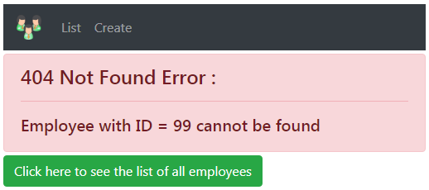  
  
**Type 2 :** The URL does not match any route   
  
Consider the following route. This also results in a **404 error**

http://localhost/foo/bar

In this case we are not sure, the page the user is trying to get to so displaying a custom error page is not possible. In this case we want to return a generic error page. We will discuss how to do handle this type of 404 error in our next video.

### Centralised 404 error handling in ASP.NET Core

In this video we will discuss how to **handle 404 errors** i.e Page Not Found errors in a centralised way in asp.net core.   
  
  
Along the way, we will discuss the following 3 middleware components that deal with status code pages in asp.net core

* UseStatusCodePages
* UseStatusCodePagesWithRedirects
* UseStatusCodePagesWithReExecute

**Types of 404 errors**   
  
In ASP.NET Core there are 2 types of 404 errors that could happen   
  
Type 1 : Resource with the specified ID does not exit. We discussed how to handle this type of 404 errors and provide a more meaningful and a more customised error view in Part 57 of ASP.NET core tutorial.   
  
Type 2 : The provided URL does not match any route in our application. In this video, we will discuss how to handle this type of 404 error in a centralised way.   
  
**404 error example in ASP.NET Core**   
  
The following is code in Configure() method of Startup class in Startup.cs file. As you might already know, this Configure() method configures the HTTP request processing pipeline for our asp.net core application.

public void Configure(IApplicationBuilder app, IHostingEnvironment env)

{

if (env.IsDevelopment())

{

app.UseDeveloperExceptionPage();

}

app.UseStaticFiles();

app.UseMvc(routes =>

{

routes.MapRoute("default", "{controller=Home}/{action=Index}/{id?}");

});

}

**Default 404 error page in ASP.NET Core**   
  
At the moment we do not have anything configured in this http request processing pipeline to handle 404 errors. So if we navigate to http://localhost/foo/bar, we see the following default 404 error page. This is because the URL /foo/bar does not match any routes in our application.   
  
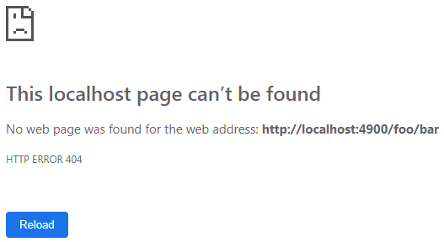  
  
**Handling non-success http status codes**   
  
To handle non-success http status codes such as 404 for example, we could use the following 3 built-in asp.net core middleware components.   
  
UseStatusCodePages  
UseStatusCodePagesWithRedirects  
UseStatusCodePagesWithReExecute   
  
**UseStatusCodePages Middleware**   
  
This is the least useful of the 3 status code middleware components. For this reason, we rarely use it in a real world production application. To use it in an application and see what it can do, plug it into the http processing pipeline as shown below.

public void Configure(IApplicationBuilder app, IHostingEnvironment env)

{

if (env.IsDevelopment())

{

app.UseDeveloperExceptionPage();

}

else

{

app.UseStatusCodePages();

}

app.UseStaticFiles();

app.UseMvc(routes =>

{

routes.MapRoute("default", "{controller=Home}/{action=Index}/{id?}");

});

}

With UseStatusCodePages Middleware configured, if we navigate to http://localhost/foo/bar, it returns the following simple text response.   
  
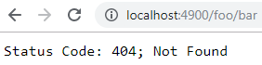  
  
**UseStatusCodePagesWithRedirects Middleware**   
  
In a production quality application we want to intercept these non-success http status codes and return a custom error view. To achieve this, we can either use UseStatusCodePagesWithRedirects middleware or UseStatusCodePagesWithReExecute middleware.

public void Configure(IApplicationBuilder app, IHostingEnvironment env)

{

if (env.IsDevelopment())

{

app.UseDeveloperExceptionPage();

}

else

{

app.UseStatusCodePagesWithRedirects("/Error/{0}");

}

app.UseStaticFiles();

app.UseMvc(routes =>

{

routes.MapRoute("default", "{controller=Home}/{action=Index}/{id?}");

});

}

With the following line in place, if there is a 404 error, the user is redirected to /Error/404. The placeholder {0}, in "/Error/{0}" will automatically receive the http status code.

app.UseStatusCodePagesWithRedirects("/Error/{0}");

**ErrorController**

public class ErrorController : Controller

{

// If there is 404 status code, the route path will become Error/404

[Route("Error/{statusCode}")]

public IActionResult HttpStatusCodeHandler(int statusCode)

{

switch (statusCode)

{

case 404:

ViewBag.ErrorMessage = "Sorry, the resource you requested could not be found";

break;

}

return View("NotFound");

}

}

**NotFound View**

@{

ViewBag.Title = "Not Found";

}

<h1>@ViewBag.ErrorMessage</h1>

<**a** **asp-action**="index" **asp-controller**="home">

Click here to navigate to the home page

</**a**>

At this point, if we navigate to http://localhost/foo/bar we see the following custom 404 error view NotFound.cshtml as expected.   
  
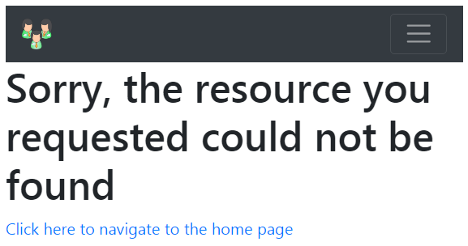  
  
To use UseStatusCodePagesWithReExecute middleware instead of UseStatusCodePagesWithRedirects middleware   
  
REPLACE app.UseStatusCodePagesWithRedirects("/Error/{0}");  
WITH app.UseStatusCodePagesWithReExecute("/Error/{0}");   
  
Re-run the application and navigate to http://localhost/foo/bar, we see the same custom 404 error view NotFound.cshtml.   
  
The obvious question that comes to our mind at this point is, what's the difference between these 2 middleware components and which one should we be using. We will answer these 2 questions in our next video.

### UseStatusCodePagesWithRedirects vs UseStatusCodePagesWithReExecute

In this video we will discuss the difference between **UseStatusCodePagesWithRedirects** and **UseStatusCodePagesWithReExecute** middleware. This is continuation to Part 58. I strongly recommend to watch Part 58 from [ASP.NET core tutorial](https://www.youtube.com/playlist?list=PL6n9fhu94yhVkdrusLaQsfERmL_Jh4XmU) before proceeding with this video.   
  
  
Irrespective of the middleware component you use, from an end user standpoint, there is no difference in the behaviour. We see the specified custom error view in both the cases.   
  
  
**UseStatusCodePagesWithRedirects**

* app.UseStatusCodePagesWithRedirects("/Error/{0}");
* When a request is issued to http://localhost/foo/bar
* Since this URL does not match with any route in our application status code 404 is raised
* UseStatusCodePagesWithRedirects middleware component intercepts the 404 status code and as the name implies, issues a redirect to the provided error path (in our case "/Error/404")

**Request processing with UseStatusCodePagesWithRedirects**

* When a request is issued to http://localhost/foo/bar
* 404 status code is raised
* StatusCodePagesWithRedirects middleware intercepts this and changes it to 302, pointing it to the error path (/Error/404)
* 302 status code means the URI of the requested resource has been changed temporarily, in our case it changed to /Error/404
* So another GET request is issued to serve the redirected request
* Because a redirect is issued, notice the URL in the address bar also changes from /foo/bar to /Error/404
* The request flows through the pipeline and handled by the MVC middleware which ultimately returns NotFound view HTML with status code 200(which means the request completed successfully)
* As far as the browser is concerned in this entire request flow there was no 404 error.
* If you closely observe this request and response flow, we are returning a success status code (200) when actually an error occurred which isn't semantically correct.

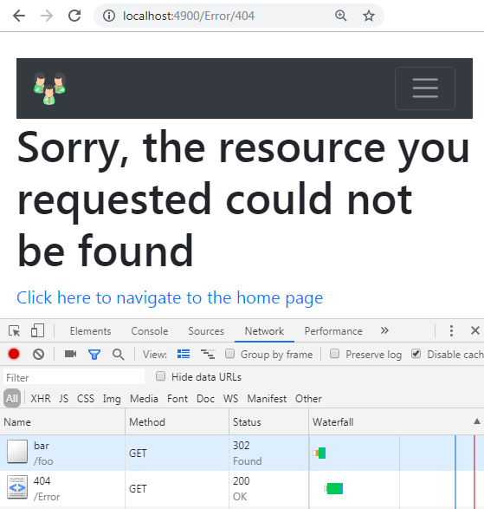  
  
**Request processing with UseStatusCodePagesWithReExecute**

* app.UseStatusCodePagesWithReExecute("/Error/{0}")
* When a request is issued to http://localhost/foo/bar
* 404 status code is raised
* UseStatusCodePagesWithReExecute middleware intercepts the 404 status code and re-executes the pipeline pointing it to the URL  (/Error/404)
* The request flows through the pipeline and handled by the MVC middleware which returns NotFound view HTML along with status code 200
* As the response flows out to the client, it passes through UseStatusCodePagesWithReExecute middleware which uses the HTML response but replaces the 200 status code with the original 404 status code.
* This is a clever piece of middleware. As the name implies it re-executes the pipeline keeping the correct (404) status code. It just returns the custom view (NotFound) HTML
* As it is just re-executing the pipeline and not issuing a redirect request, we also preserve the original URL (/foo/bar) in the address bar. It does not change from /foo/bar to /Error/404.

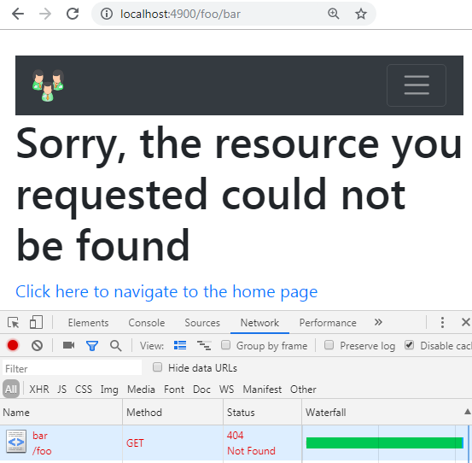  
  
If you are using UseStatusCodePagesWithReExecute middleware, it's also possible to get the original path in the ErrorController using IStatusCodeReExecuteFeature interface as shown below.

public class ErrorController : Controller

{

[Route("Error/{statusCode}")]

public IActionResult HttpStatusCodeHandler(int statusCode)

{

var statusCodeResult =

                HttpContext.Features.Get<IStatusCodeReExecuteFeature>();

switch (statusCode)

{

case 404:

ViewBag.ErrorMessage =

"Sorry, the resource you requested could not be found";

ViewBag.Path = statusCodeResult.OriginalPath;

ViewBag.QS = statusCodeResult.OriginalQueryString;

break;

}

return View("NotFound");

}

}

You can then display it in the custom error view as shown below

@{

ViewBag.Title = "Not Found";

}

<h1>@ViewBag.ErrorMessage</h1>

<h1>@ViewBag.Path</h1>

<h1>@ViewBag.QS</h1>

<**a** **asp-action**="index" **asp-controller**="home">

Click here to navigate to the home page

</**a**>

### Global exception handling in asp.net core mvc

In this video we will discuss how to implement **global exceptions handler in ASP.NET Core MVC**   
  
  
**Throwing an Exception in ASP.NET Core**   
  
Consider the following Details action method in HomeController. We are deliberately throwing an exception using the throw keyword.

public ViewResult Details(int? id)

{

    throw new Exception("Error in Details View");

    // Rest of the code

}

**UseDeveloperExceptionPage Middleware in ASP.NET Core**

public void Configure(IApplicationBuilder app, IHostingEnvironment env)

{

if (env.IsDevelopment())

{

app.UseDeveloperExceptionPage();

}

// Rest of the code

}

We have plugged in the DeveloperExceptionPage middleware into the HTTP request processing pipeline for the Development environment. So if we run the application in Development environment, then we see the following developer exception page if there is an unhandled exception.   
  
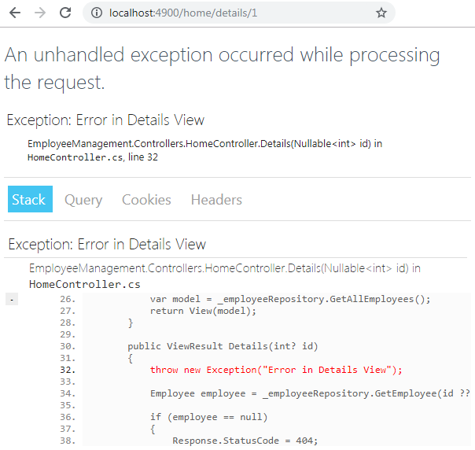  
  
We discussed the significance and the use of DeveloperExceptionPage middleware in [Part 13](https://www.youtube.com/watch?v=UGG2-oV9iQ8) of [ASP.NET Core tutorial](https://www.youtube.com/playlist?list=PL6n9fhu94yhVkdrusLaQsfERmL_Jh4XmU)   
  
As the name implies, the DeveloperExceptionPage middleware must be used only on the Development environment. Using this page on a non-development environment like Production for example is a security risk as it contains detailed exception information that could be used by an attacker. Also this exception page does not make any sense to the end user.

**Unhandled Exception on Non-Development Environment in ASP.NET Core**   
  
On your local development machine to simulate running the application on production environment set ASPNETCORE_ENVIRONMENT variable to Production.

"ASPNETCORE_ENVIRONMENT": "Production"

By default, if there is an unhandled exception in a non-development environment like production, we see the following default page.   
  
  
  
Notice, other than displaying that there was a 500 http error we do not see any other information. Error 500 means, there was an error on the server which the server did not know how to handle.   
  
This default page is not very useful for the end user. We want to handle the exception and redirect to the user to custom error view which is more useful and meaningful.   
  
**Exception Handling in ASP.NET Core**   
  
**Step 1 :** For a non-development environment, add the Exception Handling Middleware to the request processing pipeline using UseExceptionHandler() method. We do this in the Configure() method of the Startup class. Exception Handling Middleware looks for ErrorController.

public void Configure(IApplicationBuilder app, IHostingEnvironment env)

{

if (env.IsDevelopment())

{

app.UseDeveloperExceptionPage();

}

else

{

app.UseExceptionHandler("/Error");

}

// Rest of the code

}

**Step 2 :** Implement the ErrorController that retrieves the exception details and returns the custom Error view. In a production application, we do not display the exception details on the error view. We instead log them to a database table, file, event viewer etc, so a developer can review them and provide a code fix if required. We will discuss logging in a later video.

public class ErrorController : Controller

{

    [AllowAnonymous]

[Route("Error")]

public IActionResult Error()

{

// Retrieve the exception Details

var exceptionHandlerPathFeature =

                HttpContext.Features.Get<IExceptionHandlerPathFeature>();

ViewBag.ExceptionPath = exceptionHandlerPathFeature.Path;

ViewBag.ExceptionMessage = exceptionHandlerPathFeature.Error.Message;

ViewBag.StackTrace = exceptionHandlerPathFeature.Error.StackTrace;

return View("Error");

}

}

**Please note :** IExceptionHandlerPathFeature is in Microsoft.AspNetCore.Diagnostics namespace.   
  
**Step 3 :** Implement Error View

<h3>An occured while processing your request. The support

team is notified and we are working on the fix</h3>

<h5>Please contact us on pragim@pragimtech.com</h5>

<hr />

<h3>Exception Details:</h3>

<div class="alert alert-danger">

<h5>Exception Path</h5>

<hr />

<p>@ViewBag.ExceptionPath</p>

</div>

<div class="alert alert-danger">

<h5>Exception Message</h5>

<hr />

<p>@ViewBag.ExceptionMessage</p>

</div>

<div class="alert alert-danger">

<h5>Exception Stack Trace</h5>

<hr />

<p>@ViewBag.StackTrace</p>

</div>

### Logging in ASP.NET Core

**Suggested Videos**  
  
In this video we will discuss **Logging in ASP.NET Core.**   
  
**Default Logging in ASP.NET Core**   
  
We can run an asp.net core application from the Command Line or from Visual Studio.    
  
  
**To run asp.net core project from the command line**

1. Launch the command prompt as an administrator
2. Change the path to the folder that contains your project
3. Finally execute the following dot net run command
4. c:\Projects\EmployeeManagement\EmployeeManagement>dotnet run

When we run the project from the command line using the dotnet run command we see lot of information logged to the console as shown below.

info: Microsoft.AspNetCore.Hosting.Internal.WebHost[1]  
      Request starting HTTP/1.1 GET http://localhost:5000/  
info: Microsoft.AspNetCore.Mvc.Internal.ControllerActionInvoker[1]  
      Route matched with {action = "Index", controller = "Home"}. Executing acti  
on EmployeeManagement.Controllers.HomeController.Index (EmployeeManagement)  
info: Microsoft.AspNetCore.Mvc.Internal.ControllerActionInvoker[1]  
      Executing action method EmployeeManagement.Controllers.HomeController.Inde  
x (EmployeeManagement) - Validation state: Valid  
info: Microsoft.AspNetCore.Mvc.Internal.ControllerActionInvoker[2]  
      Executed action method EmployeeManagement.Controllers.HomeController.Index  
 (EmployeeManagement), returned result Microsoft.AspNetCore.Mvc.ViewResult in 0.  
8168ms.  
info: Microsoft.AspNetCore.Mvc.ViewFeatures.ViewResultExecutor[1]  
      Executing ViewResult, running view Index.  
info: Microsoft.EntityFrameworkCore.Infrastructure[10403]  
      Entity Framework Core 2.2.0-rtm-35687 initialized 'AppDbContext' using pro  
vider 'Microsoft.EntityFrameworkCore.SqlServer' with options: MaxPoolSize=128  
info: Microsoft.EntityFrameworkCore.Database.Command[20101]  
      Executed DbCommand (32ms) [Parameters=[], CommandType='Text', CommandTimeo  
ut='30']  
      SELECT [e].[Id], [e].[Department], [e].[Email], [e].[Name], [e].[PhotoPath  
]  
      FROM [Employees] AS [e]  
info: Microsoft.AspNetCore.Mvc.ViewFeatures.ViewResultExecutor[4]  
      Executed ViewResult - view Index executed in 4763.7879ms.

We see a similar output in the Debug window if we run the project from Visual Studio. To open the Debug window,

1. Click on the Debug menu in Visual Studio and select "Windows" and "Output"
2. In the Output window, select Debug from the Show output from dropdownlist

**Logging providers in ASP.NET Core**  
  
A logging provider is the component that stores or displays logs. For example, the Console log provider displays logs on the console. Similarly, the Debug log provider displays logs on the Debug window in Visual Studio.  
  
**ASP.NET Core built-in logging providers**

* Console
* Debug
* EventSource
* EventLog
* TraceSource
* AzureAppServicesFile
* AzureAppServicesBlob
* ApplicationInsights

**Third party logging providers for ASP.NET Core**

* NLog
* elmah
* Serilog
* Sentry
* Gelf
* JSNLog
* KissLog.net
* Loggr
* Stackdriver

**Default logging providers in ASP.NET Core** Main() method in the Program class in Program.cs file is the entry point for an asp.net core application. This method calls CreateDefaultBuilder() method performs several tasks like

* Setting up the web server
* Loading the host and application configuration from various configuration sources and
* Configuring logging

Since ASP.NET Core is open source we can see the complete source on their official github page. The following is the code snippet from CreateDefaultBuilder() method.

.ConfigureLogging((hostingContext, logging) =>

{

logging.AddConfiguration(hostingContext.Configuration.GetSection("Logging"));

logging.AddConsole();

logging.AddDebug();

logging.AddEventSourceLogger();

})

As part of configuring logging, CreateDefaultBuilder() method adds the following 3 logging providers by default. This is the reason when we run the asp.net core project we see the log displayed both on the console and on the debug window in Visual Studio.

1. Console
2. Debug
3. EventSource

CreateDefaultBuilder() method looks for Logging section in the application configuration file appsettings.json.  
  
**Logging section in appsettings.json**   
  
The following is the Logging section in appsettings.json file on my machine.

"Logging": {

"LogLevel": {

"Default": "Warning",

"Microsoft": "Warning"

}

}

LogLevel is used to control how much log data is logged or displayed. We will discuss Log level in detail in our upcoming videos.   
  
To turn off iisexpress.exe logs under debug tab in visual studio   
  
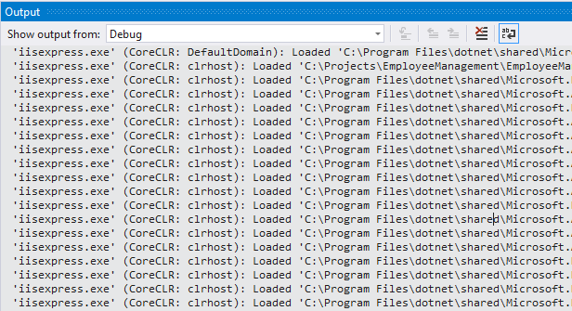  
  
In Visual Studio click on Tools - Options. On the Options window, under Debugging - Output Window turn off the messages you do not need.   
  
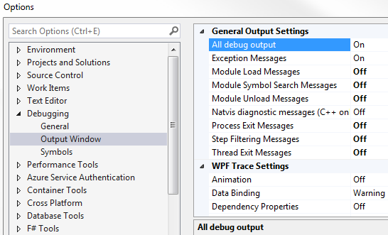

### Logging exceptions in ASP.NET Core

**Suggested Videos**  
  
In this video we will discuss how to log our own messages, warnings and exceptions using the **ILogger** interface provided by ASP.NET Core.   
  
  
If there are exceptions, while users are using our application we need to log the exceptions somewhere. A developer can then review the exception log and provide a fix if required. Logging exceptions is required to know what exceptions are occurring on production server as the application is being used.

public class ErrorController : Controller

{

private readonly ILogger<ErrorController> logger;

// Inject ASP.NET Core ILogger service. Specify the Controller

// Type as the generic parameter. This helps us identify later

// which class or controller has logged the exception

public ErrorController(ILogger<ErrorController> logger)

{

this.logger = logger;

}

[AllowAnonymous]

[Route("Error")]

public IActionResult Error()

{

// Retrieve the exception Details

var exceptionHandlerPathFeature =

HttpContext.Features.Get<IExceptionHandlerPathFeature>();

// LogError() method logs the exception under Error category in the log

logger.LogError($"The path {exceptionHandlerPathFeature.Path} " +

$"threw an exception {exceptionHandlerPathFeature.Error}");

return View("Error");

}

[Route("Error/{statusCode}")]

public IActionResult HttpStatusCodeHandler(int statusCode)

{

var statusCodeResult =

HttpContext.Features.Get<IStatusCodeReExecuteFeature>();

switch (statusCode)

{

case 404:

ViewBag.ErrorMessage = "Sorry, the resource could not be found";

// LogWarning() method logs the message under

// Warning category in the log

logger.LogWarning($"404 error occured. Path = " +

$"{statusCodeResult.OriginalPath} and QueryString = " +

$"{statusCodeResult.OriginalQueryString}");

break;

}

return View("NotFound");

}

}

**Logging Exceptions in ASP.NET Core**   
  
Two simple steps to log your own custom messages, warnings or exceptions   
  
Inject an instance of **ILogger** where you need the logging functionality

The type of the class or controller into which **ILogger** is injected can be specified as the argument for the generic parameter of **ILogger**. We do this because, the fully qualified name of the class or the controller is then included in the log output as the **log category**. Log category is used to group the log messages.   
  
Since we have specified the type of ErrorController as the generic argument for ILogger, the fully qualified name of ErrorController is also included in the log output below.

private readonly ILogger<ErrorController> logger;

public ErrorController(ILogger<ErrorController> logger)

{

this.logger = logger;

}

LogError() method logs the exception under Error category.

logger.LogError($"The path {exceptionHandlerPathFeature.Path} " +

$"threw an exception {exceptionHandlerPathFeature.Error}");

Here is the log generated by LogError() method

EmployeeManagement.Controllers.ErrorController:Error: The path /home/details/1 threw an exception System.Exception: Error in Details Controller  
   at EmployeeManagement.Controllers.HomeController.Details(Nullable`1 id) in C:\Projects\EmployeeManagement\EmployeeManagement\Controllers\HomeController.cs:line 36  
   at lambda_method(Closure , Object , Object[] )  
   at Microsoft.Extensions.Internal.ObjectMethodExecutor.Execute(Object target, Object[] parameters)  
   at Microsoft.AspNetCore.Mvc.Internal.ActionMethodExecutor.SyncActionResultExecutor.Execute(IActionResultTypeMapper mapper, ObjectMethodExecutor executor, Object controller, Object[] arguments)  
   at Microsoft.AspNetCore.Mvc.Internal.ControllerActionInvoker.InvokeActionMethodAsync()  
   at Microsoft.AspNetCore.Mvc.Internal.ControllerActionInvoker.InvokeNextActionFilterAsync()  
   at Microsoft.AspNetCore.Mvc.Internal.ControllerActionInvoker.Rethrow(ActionExecutedContext context)  
   at Microsoft.AspNetCore.Mvc.Internal.ControllerActionInvoker.Next(State& next, Scope& scope, Object& state, Boolean& isCompleted)  
   at Microsoft.AspNetCore.Mvc.Internal.ControllerActionInvoker.InvokeInnerFilterAsync()  
   at Microsoft.AspNetCore.Mvc.Internal.ResourceInvoker.InvokeNextResourceFilter()  
   at Microsoft.AspNetCore.Mvc.Internal.ResourceInvoker.Rethrow(ResourceExecutedContext context)  
   at Microsoft.AspNetCore.Mvc.Internal.ResourceInvoker.Next(State& next, Scope& scope, Object& state, Boolean& isCompleted)  
   at Microsoft.AspNetCore.Mvc.Internal.ResourceInvoker.InvokeFilterPipelineAsync()  
   at Microsoft.AspNetCore.Mvc.Internal.ResourceInvoker.InvokeAsync()  
   at Microsoft.AspNetCore.Builder.RouterMiddleware.Invoke(HttpContext httpContext)  
   at Microsoft.AspNetCore.StaticFiles.StaticFileMiddleware.Invoke(HttpContext context)  
   at Microsoft.AspNetCore.Diagnostics.StatusCodePagesMiddleware.Invoke(HttpContext context)  
   at Microsoft.AspNetCore.Diagnostics.ExceptionHandlerMiddleware.Invoke(HttpContext context)

LogWarning() method logs the message under Warning category.

EmployeeManagement.Controllers.ErrorController:Warning: 404 error occured. Path = /foo/bar and QueryString = ?email=abc@gmail.com&abc=xyz

In a real world application we usually log the exceptions and warnings to a database table, event viewer or a file. We will discuss logging to a file in our next video.

### Logging to file in asp.net core using nlog

In this video we will discuss **how to log to a file in ASP.NET Core using NLog**.   
  
ASP.NET Core supports several third-party logging providers like the following

* NLog
* Serilog
* elmah
* Sentry
* JSNLog

If we know how to work with one of the third-party logging providers, working with the other's is similar.   
  
**Using NLog in ASP.NET Core**   
  
**Step 1 :** Install NLog.Web.AspNetCore nuget package   
  
Once the NLog package is installed, you will see the PackageReference included in the .csproj file

<PackageReference Include="NLog.Web.AspNetCore" Version="4.8.2" />

**Step 2 :** Create nlog.config file   
  
Create **nlog.config** file in the root of your project. I have included the minimum configuration required.

<?xml version="1.0" encoding="utf-8" ?>

<nlog xmlns="http://www.nlog-project.org/schemas/NLog.xsd"

xmlns:xsi="http://www.w3.org/2001/XMLSchema-instance">

<!-- the targets to write to -->

<targets>

<!-- write logs to file -->

<target name="allfile" xsi:type="File"

fileName="c:\DemoLogs\nlog-all-${shortdate}.log"/>

</targets>

<!-- rules to map from logger name to target -->

<rules>

<!--All logs, including from Microsoft-->

<logger name="*" minlevel="Trace" writeTo="allfile" />

</rules>

</nlog>

To learn more about the nlog.config file please refer to the following github wiki page  
<https://github.com/NLog/NLog/wiki/Configuration-file>   
  
**Step 3 :** Enable copy to bin folder   
  
Right click on nlog.config file in the Solution Explorer and select Properties. In the Properties window set

Copy to Output Directory = Copy if newer

**Step 4 :** Enable NLog as one of the Logging Provider   
  
In addition to using the default logging providers (i.e Console, Debug & EventSource), we also added **NLog** using the extension method **AddNLog()**. This method is in **NLog.Extensions.Logging** namespace.

public class Program

{

public static void Main(string[] args)

{

CreateWebHostBuilder(args).Build().Run();

}

public static IWebHostBuilder CreateWebHostBuilder(string[] args) =>

        WebHost.CreateDefaultBuilder(args)

.ConfigureLogging((hostingContext, logging) =>

{

logging.AddConfiguration(hostingContext.Configuration.GetSection("Logging"));

logging.AddConsole();

logging.AddDebug();

logging.AddEventSourceLogger();

// Enable NLog as one of the Logging Provider

logging.AddNLog();

})

        .UseStartup<Startup>();

}

If you want only **NLog** as the **logging provider**, clear all the logging providers and then add **NLog**.

public class Program

{

public static void Main(string[] args)

{

CreateWebHostBuilder(args).Build().Run();

}

public static IWebHostBuilder CreateWebHostBuilder(string[] args) =>

        WebHost.CreateDefaultBuilder(args)

.ConfigureLogging((hostingContext, logging) =>

{

// Remove all the default logging providers

logging.ClearProviders();

logging.AddConfiguration(hostingContext.Configuration.GetSection("Logging"));

// Add NLog as the Logging Provider

logging.AddNLog();

})

       .UseStartup<Startup>();

}

Next video : Control what is logged using the LogLevel configuration setting.

### ASP.NET Core LogLevel configuration

In this video we will discuss the significance of **LogLevel configuration in ASP.NET Core**.   
  
**LogLevel** indicates the severity of the logged message. It can be any of the following. They are listed here from lowest to highest severity.

* Trace = 0
* Debug = 1
* Information = 2
* Warning = 3
* Error = 4
* Critical = 5
* None = 6

**LogLevel Enum**  
  
LogLevel enum is present in Microsoft.Extensions.Logging namespace

namespace Microsoft.Extensions.Logging  
{  
    public enum LogLevel  
    {  
        Trace = 0,  
        Debug = 1,  
        Information = 2,  
        Warning = 3,  
        Error = 4,  
        Critical = 5,  
        None = 6  
    }  
}

**LogLevel in appsettings.json**   
  
**LogLevel** setting in appsettings.json file is used to control how much log data is logged or displayed.

{

"Logging": {

"LogLevel": {

"Default": "Trace",

"Microsoft": "Warning"

}

}

}

**ILogger Methods**   
  
On the **ILogger** interface, we have log methods that include the log level in the method name. For example to log a TRACE message we use LogTrace() method. Similarly to log a WARNING message we use LogWarning() method. Notice, except for *LogLevel = None*, we have a corresponding method for every log level.

LogTrace()  
LogDebug()  
LogInformation()  
LogWarning()  
LogError()  
LogCritical()

**LogLevel Example**   
  
Consider the following Details() action in HomeController

public class HomeController : Controller

{

public ViewResult Details(int? id)

{

logger.LogTrace("Trace Log");

logger.LogDebug("Debug Log");

logger.LogInformation("Information Log");

logger.LogWarning("Warning Log");

logger.LogError("Error Log");

logger.LogCritical("Critical Log");

// Rest of the code

}

}

The following is the **LogLevl** configuration in appsettings.json file.

{

"Logging": {

"LogLevel": {

"Default": "Trace",

"Microsoft": "Warning"

}

}

}

The following Log output is displayed in the **Debug Output window**. Since we have set *"Default": "Trace"*, we see everything from Trace level and higher. Since Trace is the lowest level we see all the logs.

EmployeeManagement.Controllers.HomeController:Trace: Trace Log  
EmployeeManagement.Controllers.HomeController:Debug: Debug Log  
EmployeeManagement.Controllers.HomeController:Information: Information Log  
EmployeeManagement.Controllers.HomeController:Warning: Warning Log  
EmployeeManagement.Controllers.HomeController:Error: Error Log  
EmployeeManagement.Controllers.HomeController:Critical: Critical Log

However if you want WARNING and higher then set "Default": "Warning"   
  
If you do not want anything logged set LogLevel to None. The integer value of LogLevel.None is 6, which is higher than all the other log levels. So nothing gets logged.   
  
**Log filtering in ASP.NET Core**   
  
Consider the following log statement

EmployeeManagement.Controllers.HomeController:Trace: My log message

EmployeeManagement.Controllers.HomeController is the **LOG CATEGORY**  
Trace is the **LOG LEVEL**. Remember log level can be (Trace, Debug, Information, etc...)   
  
In simple terms, LOG CATEGORY is the fully qualified name of the class that logged the message. The log category is displayed as a string in the logged message so we can use it easily determine from which class the log came from. LOG CATEGORY is used to filter logs.

With the following **LogLevel** configuration, we see everything from Trace level and higher from the log category "EmployeeManagement.Controllers.HomeController". However, for the category "EmployeeManagement.Models.SQLEmployeeRepository" only Error level logs and higher are displayed.

{

"Logging": {

"LogLevel": {

"Default": "Warning",

"EmployeeManagement.Controllers.HomeController": "Trace",

"EmployeeManagement.Models.SQLEmployeeRepository": "Error",

"Microsoft": "Warning"

}

}

}

The above **LogLevel** configuration applies to all logging providers. A logging provider is the component that stores or displays logs. For example, the Console logging provider displays logs on the console. Similarly, the Debug logging provider displays logs on the Debug window in Visual Studio.   
  
**Log Filtering by Log Category and by Logging Provider**   
  
It is also possible to filter logs by Provider and by Category. The following is an example. With the following configuration, for the Debug logging provider, Warning and higher level logs are logged and displayed for all the log categories. Where as for the rest of the logging providers, Trace and higher level logs are logged and displayed for all the log categories.

{

"Logging": {

"Debug": {

"LogLevel": {

"Default": "Warning",

"EmployeeManagement.Controllers.HomeController": "Warning",

"EmployeeManagement.Models.SQLEmployeeRepository": "Warning",

"Microsoft": "Warning"

}

},

"LogLevel": {

"Default": "Trace",

"EmployeeManagement.Controllers.HomeController": "Trace",

"EmployeeManagement.Models.SQLEmployeeRepository": "Trace",

"Microsoft": "Trace"

}

}

}

**LogLevel configuration in environment specific appsettings.json file**   
  
Please remember the configuration in environment specific appsettings.json file (for example appsettings.development.json) overrides the settings in appsettings.json file. Make sure the log level configuration in the environment specific appsettings.json file is what you really want, to avoid surprises.

### ASP.NET Core Identity tutorial from scratch

In this video and in our upcoming videos in this series we will discuss everything you need to effectively use **ASP.NET Core Identity** to implement security related features in your asp.net core application.   
  
  
**ASP.NET Core Identity**   
  
ASP.NET Core Identity is a membership system. It allows us to create, read, update and delete user accounts. Supports account confirmation, authentication, authorisation, password recovery, two-factor authentication with SMS. It also supports external login providers like Microsoft, Facebook, Google etc. We will discuss implementing these features in our upcoming videos in this series.  
  
  
**Adding ASP.NET Core Identity Support in ASP.NET Core Application**   
  
The following are the steps to add and configure ASP.NET Core Identity   
  
**Step 1 : Inherit from IdentityDbContext class**

public class AppDbContext : IdentityDbContext  
{  
    // Rest of the code  
}

Your application DbContext class must inherit from IdentityDbContext class instead of DbContext class. This is required because IdentityDbContext provides all the DbSet properties needed to manage the identity tables in SQL Server. We will see all the tables that the asp.net core identity framework generates in just a bit. If you go through the hierarchy chain of IdentityDbContext class, you will see it inherits from DbContext class. So this is the reason you do not have to explicitly inherit from DbContext class if your class is inheriting from IdentityDbContext class.   
  
**Step 2 : Configure ASP.NET Core Identity Services**   
  
In ConfigureServices() method of the Startup class, include the following line of code.

services.AddIdentity<IdentityUser, IdentityRole>()  
        .AddEntityFrameworkStores<AppDbContext>();

* AddIdentity() method adds the default identity system configuration for the specified user and role types.
* IdentityUser class is provided by ASP.NET core and contains properties for UserName, PasswordHash, Email etc. This is the class that is used by default by the ASP.NET Core Identity framework to manage registered users of your application.
* If you want store additional information about the registered users like their Gender, City etc. Create a custom class that derives from IdentityUser. In this custom class add the additional properties you need and then plug-in this class instead of the built-in IdentityUser class. We will discuss how to do this in our upcoming videos.
* Similarly, IdentityRole is also a builtin class provided by ASP.NET Core Identity and contains Role information.
* We want to store and retrieve User and Role information of the registered users using EntityFrameWork Core from the underlying SQL Server database. We specify this using AddEntityFrameworkStores<AppDbContext>() passing our application DbContext class as the generic argument.

**Step 3 : Add Authentication middleware to the request pipeline**

public void Configure(IApplicationBuilder app, IHostingEnvironment env)

{

if (env.IsDevelopment())

{

app.UseDeveloperExceptionPage();

}

else

{

app.UseExceptionHandler("/Error");

app.UseStatusCodePagesWithReExecute("/Error/{0}");

}

app.UseStaticFiles();

app.UseAuthentication();

app.UseMvc(routes =>

{

routes.MapRoute("default", "{controller=Home}/{action=Index}/{id?}");

});

}

In the Configure() method of the Startup class, call UseAuthentication() method to add the Authentication middleware to the application's request processing pipeline. We want to be able to authenticate users before the request reaches the MVC middleware. So it's important we add authentication middleware before the MVC middleware in the request processing pipeline.   
  
**Step 4 : Add Identity Migration**  
  
In Visual Studio, from the Package Manager Console window execute the following command to add a new migration

Add-Migration AddingIdentity

This migration contains code that creates the tables required by the ASP.NET Core Identity system.  
  
**Error :** The entity type 'IdentityUserLogin<string>' requires a primary key to be defined

If you get this error, the most likely cause is that you are overriding OnModelCreating() method in your application DbContext class but not calling the base IdentityDbContext class OnModelCreating() method.   
  
Keys of Identity tables are mapped in OnModelCreating method of IdentityDbContext class. So, to fix this error, all you need to do is, call the base class OnModelCreating() method using the base keyword as shown below.

public class AppDbContext : IdentityDbContext

{

public AppDbContext(DbContextOptions<AppDbContext> options)

: base(options)

{

}

public DbSet<Employee> Employees { get; set; }

protected override void OnModelCreating(ModelBuilder modelBuilder)

{

base.OnModelCreating(modelBuilder);

modelBuilder.Seed();

}

}

**Step 4 : Generate ASP.NET Core Identity Tables**   
  
Finally execute Update-Database command to apply the identity migration and have the required identity tables created.   
  
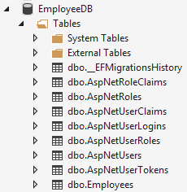  
  
Next Video : **How to register a new user using asp.net core identity**

### Register new user using asp.net core identity

New User Registration view should look as shown below. To be able to register as a new user we need an email address and password.   
  
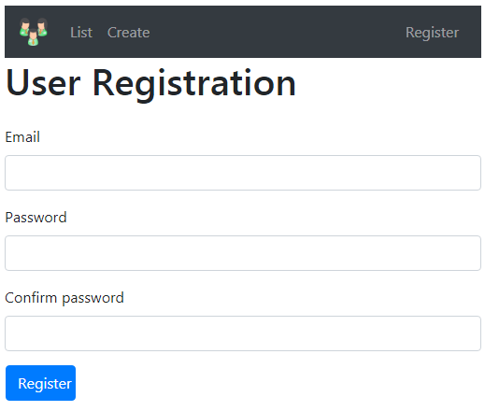  
  
  
**RegisterViewModel Class**  
  
We will use this RegisterViewModel Class as the model for Register view. It carries the information from the view to the controller class. For validation we are using several asp.net core validation attributes. We discussed these validation attributes and model validation in detail in [Parts 42](https://youtu.be/aDRC_IgwmH8) and [43](https://youtu.be/woFHR3iNEEI) of [ASP.NET Core tutorial](https://www.youtube.com/playlist?list=PL6n9fhu94yhVkdrusLaQsfERmL_Jh4XmU).

using System.ComponentModel.DataAnnotations;

namespace EmployeeManagement.ViewModels

{

public class RegisterViewModel

{

[Required]

[EmailAddress]

public string Email { get; set; }

[Required]

[DataType(DataType.Password)]

public string Password { get; set; }

[DataType(DataType.Password)]

[Display(Name = "Confirm password")]

[Compare("Password",

ErrorMessage = "Password and confirmation password do not match.")]

public string ConfirmPassword { get; set; }

}

}

**AccountController**

* All the user account related CRUD operations will be in this AccountController.
* At the moment we just have the Register action method
* We reach this action method by issuing a GET request to /account/register

using Microsoft.AspNetCore.Mvc;

namespace EmployeeManagement.Controllers

{

public class AccountController : Controller

{

        [HttpGet]

public IActionResult Register()

{

return View();

}

}

}

**Register View**

* Place this view in Views/Account folder
* The model for this view is RegisterViewModel which we created above

@model RegisterViewModel

@{

ViewBag.Title = "User Registration";

}

<h1>User Registration</h1>

<div class="row">

<div class="col-md-12">

<**form** method="post">

<**div** **asp-validation-summary**="All" class="text-danger"></**div**>

<div class="form-group">

<**label** **asp-for**="Email"></**label**>

<**input** **asp-for**="Email" class="form-control" />

<**span** **asp-validation-for**="Email" class="text-danger"></**span**>

</div>

<div class="form-group">

<**label** **asp-for**="Password"></**label**>

<**input** **asp-for**="Password" class="form-control" />

<**span** **asp-validation-for**="Password" class="text-danger"></**span**>

</div>

<div class="form-group">

<**label** **asp-for**="ConfirmPassword"></**label**>

<**input** **asp-for**="ConfirmPassword" class="form-control" />

<**span** **asp-validation-for**="ConfirmPassword" class="text-danger"></**span**>

</div>

<button type="submit" class="btn btn-primary">Register</button>

</**form**>

</div>

</div>

**Register Link in the Layout View**   
  
Include a navigation menu item in the Layout view to get to the Register view

<div class="collapse navbar-collapse" id="collapsibleNavbar">

<ul class="navbar-nav">

<li class="nav-item">

<**a** class="nav-link" **asp-controller**="home" **asp-action**="index">List</**a**>

</li>

<li class="nav-item">

<**a** class="nav-link" **asp-controller**="home" **asp-action**="create">Create</**a**>

</li>

</ul>

<ul class="navbar-nav ml-auto">

<li class="nav-item">

<**a** class="nav-link" **asp-controller**="account" **asp-action**="register">

Register

</**a**>

</li>

</ul>

</div>

Next Video :

* Implementing Register action that handles HttpPost to /account/register
* Create a user account using the posted form data and asp.net core identity

### ASP.NET Core Identity UserManager and SignInManager

In this video we will discuss, how to

* Create a new user, using UserManager service provided by asp.net core identity.
* Sign-in a user using SignInManager service provided by asp.net core identity.

This is continuation to [Part 66](https://youtu.be/sPbDrqpme_w). Please watch [Part 66](https://youtu.be/sPbDrqpme_w) from [ASP.NET Core tutorial](https://www.youtube.com/playlist?list=PL6n9fhu94yhVkdrusLaQsfERmL_Jh4XmU) before proceeding.   
  
  
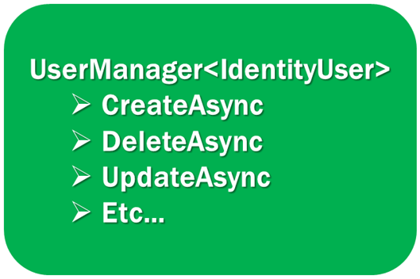  
  
UserManager<IdentityUser> class contains the required methods to manage users in the underlying data store. For example, this class has methods like CreateAsync, DeleteAsync, UpdateAsync to create, delete and update users.   
  
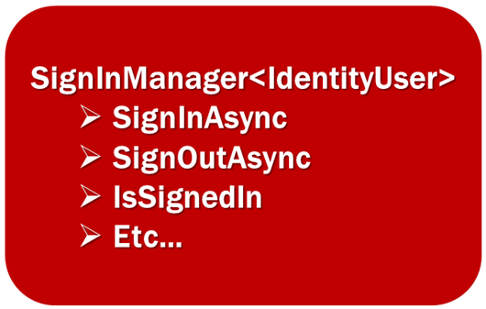  
  
SignInManager<IdentityUser> class contains the required methods for users signin. For example, this class has methods like SignInAsync, SignOutAsync to signin and signout a user.

* Both UserManager and SignInManager services are injected into the AccountController using constructor injection
* Both these services accept a generic parameter. We use the generic parameter to specify the User class that these services should work with.
* At the moment, we are using the built-in IdentityUser class as the argument for the generic parameter.
* The generic parameter on these 2 services is an extension point.
* This means, we can create our own custom user with any additional data that we want to capture about the user and then plug-in this custom class as an argument for the generic parameter instead of the built-in IdentityUser class.
* We will discuss how to do this in our upcoming videos.

using EmployeeManagement.ViewModels;

using Microsoft.AspNetCore.Identity;

using Microsoft.AspNetCore.Mvc;

using System.Threading.Tasks;

namespace EmployeeManagement.Controllers

{

public class AccountController : Controller

{

private readonly UserManager<IdentityUser> userManager;

private readonly SignInManager<IdentityUser> signInManager;

public AccountController(UserManager<IdentityUser> userManager,

SignInManager<IdentityUser> signInManager)

{

this.userManager = userManager;

this.signInManager = signInManager;

}

[HttpGet]

public IActionResult Register()

{

return View();

}

[HttpPost]

public async Task<IActionResult> Register(RegisterViewModel model)

{

if (ModelState.IsValid)

{

// Copy data from RegisterViewModel to IdentityUser

var user = new IdentityUser

{

UserName = model.Email,

Email = model.Email

};

// Store user data in AspNetUsers database table

var result = await userManager.CreateAsync(user, model.Password);

// If user is successfully created, sign-in the user using

// SignInManager and redirect to index action of HomeController

if (result.Succeeded)

{

await signInManager.SignInAsync(user, isPersistent: false);

return RedirectToAction("index", "home");

}

// If there are any errors, add them to the ModelState object

// which will be displayed by the validation summary tag helper

foreach (var error in result.Errors)

{

ModelState.AddModelError(string.Empty, error.Description);

}

}

return View(model);

}

}

}

At this point if you run the project and provide a valid email address and password, the user account should be created in AspNetUsers table in the underlying SQL server database. You could view this data from SQL Server Object Explorer in Visual Studio

### ASP.NET core identity password complexity

In this video we will discuss **how to configure password complexity rules in asp.net core** using asp.net core IdentityOptions class.   
  
By default, asp.net core identity does not allow creating simple passwords to protect our application from automated brute-force attacks. When we try to register a new user account with a simple password like abc, the account creation fails and you will see the following validation errors.   
  
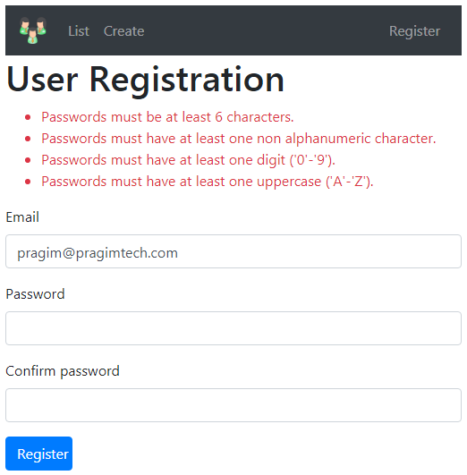  
  
  
**ASP.NET Core Identity Password Default Settings**   
  
In ASP.NET Core Identity, Password Default Settings are specified in the PasswordOptions class. You can find the source code of this class on the asp.net core github repo at the following link. Simply search in the repo for the PasswordOptions class.  
<https://github.com/aspnet/AspNetCore>

public class PasswordOptions

{

public int RequiredLength { get; set; } = 6;

public int RequiredUniqueChars { get; set; } = 1;

public bool RequireNonAlphanumeric { get; set; } = true;

public bool RequireLowercase { get; set; } = true;

public bool RequireUppercase { get; set; } = true;

public bool RequireDigit { get; set; } = true;

}

**How to override password default settings in asp.net core identity**   
  
We could do this by, using the Configure() method of the IServiceCollection interface in the ConfigureServices() method of the Startup class

services.Configure<IdentityOptions>(options =>

{

options.Password.RequiredLength = 10;

options.Password.RequiredUniqueChars = 3;

options.Password.RequireNonAlphanumeric = false;

});

**OR**   
  
We could also do this while adding Identity services

services.AddIdentity<IdentityUser, IdentityRole>(options =>

{

options.Password.RequiredLength = 10;

options.Password.RequiredUniqueChars = 3;

options.Password.RequireNonAlphanumeric = false;

})

.AddEntityFrameworkStores<AppDbContext>();

**ASP.NET Core IdentityOptions**   
  
In this example, we are using the IdentityOptions object to configure PasswordOptions. We could also use this IdentityOptions object to configure

* UserOptions
* SignInOptions
* LockoutOptions
* TokenOptions
* StoreOptions
* ClaimsIdentityOptions

### Show or hide login and logout links based on login status in asp.net core

In this video we will discuss

* How to show or hide LOGIN, LOGOUT and REGISTER links based on whether the user is logged in or not.
* Implementing LOGOUT feature in ASP.NET core.

If the user is not logged-in, display Login and Register links.   
  
  
  
  
If the user is logged-in, hide Login and Register links and display Logout link.   
  
  
  
Inject SignInManager, so we could check if the user is signed-in

@using Microsoft.AspNetCore.Identity

@inject SignInManager<IdentityUser> SignInManager

<div class="collapse navbar-collapse" id="collapsibleNavbar">

<ul class="navbar-nav ml-auto">

@*If the user is signed-in display Logout link*@

@if (SignInManager.IsSignedIn(User))

{

<li class="nav-item">

<**form** method="post" **asp-controller**="account" **asp-action**="logout">

<button type="submit" style="width:auto"

class="nav-link btn btn-link py-0">

Logout @User.Identity.Name

</button>

</**form**>

</li>

}

else

{

<li class="nav-item">

<**a** class="nav-link" **asp-controller**="account" **asp-action**="register">

Register

</**a**>

</li>

<li class="nav-item">

<**a** class="nav-link" **asp-controller**="account" **asp-action**="login">

Login

</**a**>

</li>

}

</ul>

</div>

Use a POST request to log the user out. Using a GET request to log out the user is not recommended because the approach may be abused. A malicious user may trick you into clicking an image element where the src attribute is set to the application logout url. As a result you are unknowingly logged out.   
  
**Logout user in asp.net core**

public class AccountController : Controller

{

private readonly SignInManager<IdentityUser> signInManager;

public AccountController(SignInManager<IdentityUser> signInManager)

{

this.signInManager = signInManager;

}

[HttpPost]

public async Task<IActionResult> Logout()

{

await signInManager.SignOutAsync();

return RedirectToAction("index", "home");

}

}

### Implementing login functionality in asp.net core

In this video we will discuss implementing **login functionality in an asp.net core application** using the asp.net core identity API.   
  
  
To implement the **login functionality in an asp.net core application**, we need to implement the following

* Login View Model
* Login View
* A pair of Login action methods in the AccountController

**LoginViewModel**   
  
To login a user, we need their Email which is the username, password and whether if they want a persistent cookie or session cookie.

public class LoginViewModel

{

[Required]

[EmailAddress]

public string Email { get; set; }

[Required]

[DataType(DataType.Password)]

public string Password { get; set; }

[Display(Name = "Remember me")]

public bool RememberMe { get; set; }

}

**Session Cookie vs Persistent Cookie**   
  
Upon a successful login, a cookie is issued and this cookie is sent with each request to the server. The server uses this cookie to know that the user is already authenticated and logged-in. This cookie can either be a session cookie or a persistent cookie.   
  
A **session cookie** is created and stored within the session instance of the browser. A session cookie does not contain an expiration date and is permanently deleted when the browser window is closed.   
  
A **persistent cookie** on the other hand is not deleted when the browser window is closed. It usually has an expiry date and deleted on the date of expiry.   
  
**Login View**

@model LoginViewModel

@{

ViewBag.Title = "User Login";

}

<h1>User Login</h1>

<div class="row">

<div class="col-md-12">

<**form** method="post">

<**div** **asp-validation-summary**="All" class="text-danger"></**div**>

<div class="form-group">

<**label** **asp-for**="Email"></**label**>

<**input** **asp-for**="Email" class="form-control" />

<**span** **asp-validation-for**="Email" class="text-danger"></**span**>

</div>

<div class="form-group">

<**label** **asp-for**="Password"></**label**>

<**input** **asp-for**="Password" class="form-control" />

<**span** **asp-validation-for**="Password" class="text-danger"></**span**>

</div>

<div class="form-group">

<div class="checkbox">

<**label** **asp-for**="RememberMe">

<**input** **asp-for**="RememberMe" />

@Html.DisplayNameFor(m => m.RememberMe)

</**label**>

</div>

</div>

<button type="submit" class="btn btn-primary">Login</button>

</**form**>

</div>

</div>

**Login Action in AccountController**

using EmployeeManagement.ViewModels;

using Microsoft.AspNetCore.Identity;

using Microsoft.AspNetCore.Mvc;

using System.Threading.Tasks;

namespace EmployeeManagement.Controllers

{

public class AccountController : Controller

{

private readonly SignInManager<IdentityUser> signInManager;

public AccountController(SignInManager<IdentityUser> signInManager)

{

this.signInManager = signInManager;

}

[HttpPost]

public async Task<IActionResult> Logout()

{

await signInManager.SignOutAsync();

return RedirectToAction("index", "home");

}

[HttpGet]

public IActionResult Login()

{

return View();

}

[HttpPost]

public async Task<IActionResult> Login(LoginViewModel model)

{

if (ModelState.IsValid)

{

var result = await signInManager.PasswordSignInAsync(

model.Email, model.Password, model.RememberMe, false);

if (result.Succeeded)

{

return RedirectToAction("index", "home");

}

ModelState.AddModelError(string.Empty, "Invalid Login Attempt");

}

return View(model);

}

}

}

### Authorization in ASP.NET Core

In this video we will discuss, **authorization in ASP.NET Core.**    
  
  
**What is Authorization in ASP.NET Core**

* Authentication is the process of identifying who the user is.
* Authorization is the process of identifying what the user can and cannot do.
* For example, if the logged in user is an administrator he may be able to Create, Read, Update and Delete orders, where as a normal user may only view orders but not Create, Update or Delete orders.
* Authorization in ASP.NET Core MVC is controlled through the AuthorizeAttribute

**Authorize Attribute in ASP.NET Core**   
  
When the Authorize attribute is used in it's simplest form, without any parameters, it only checks if the user is authenticated.   
  
**Authorize Attribute Example**   
  
As the Authorize attribute is applied on the Controller, it is applicable to all the action methods in the controller. The user must be logged in, to access any of the controller action methods.

[Authorize]  
public class HomeController : Controller  
{  
    public ViewResult Details(int? id)  
    {   
    }  
          
    public ViewResult Create()  
    {     
    }  
          
    public ViewResult Edit(int id)  
    {  
    }  
}

Authorize attribute can be applied on individual action methods as well. In the example below, only the Details action method is protected from anonymous access.

public class HomeController : Controller  
{  
    [Authorize]  
    public ViewResult Details(int? id)  
    {  
    }  
  
    public ViewResult Create()  
    {  
    }  
  
    public ViewResult Edit(int id)  
    {  
    }  
}

**AllowAnonymous Attribute in ASP.NET Core**   
  
As the name implies, AllowAnonymous attribute allows anonymous access. We generally use this attribute in combination with the Authorize attribute.  
  
**AllowAnonymous Attribute Example**   
  
As the Authorize attribute is applied at the controller level, all the action methods in the controller are protected from anonymous access. However, since the Details action method is decorated with AllowAnonymous attribute, it will be allowed anonymous access.

[Authorize]  
public class HomeController : Controller  
{  
    [AllowAnonymous]  
    public ViewResult Details(int? id)  
    {  
    }  
  
    public ViewResult Create()  
    {  
    }  
  
    public ViewResult Edit(int id)  
    {  
    }  
}

Please note: If you apply [AllowAnonymous] attribute at the controller level, any [Authorize] attribute attribute on the same controller actions is ignored.   
  
**Apply Authorize attribute globally**   
  
To apply [Authorize] attribute globally on all controllers and controller actions throughout your application modify the code in ConfigureServices method of the Startup class.

public void ConfigureServices(IServiceCollection services)

{

// Other Code

services.AddMvc(config => {

var policy = new AuthorizationPolicyBuilder()

.RequireAuthenticatedUser()

.Build();

config.Filters.Add(new AuthorizeFilter(policy));

});

// Other Code

}

* AuthorizationPolicyBuilder is in Microsoft.AspNetCore.Authorization namespace
* AuthorizeFilter is in Microsoft.AspNetCore.Mvc.Authorization namespace

If you do not have [AllowAnonymous] attribute on the Login actions of the AccountController you will get the following error because the application is stuck in an infinite loop.

HTTP Error 404.15 - Not Found   
  
The request filtering module is configured to deny a request where the query string is too long.   
  
Most likely causes:  
Request filtering is configured on the Web server to deny the request because the query string is too long.

1. You try to access /Account/login
2. Since the [Authorize] attribute is applied globally, you cannot access the URL /Account/login
3. To login you have to go to /Account/login
4. So the application is stuck in this infinite loop and every time we are redirected, the query string ?ReturnUrl=/Account/Login is appended to the URL
5. This is the reason we get the error - Web server denied the request because the query string is too long.

To fix this error, decorate Login() actions in the AccountController with [AllowAnonymous] attribute.   
  
In addition to this simple authorization, asp.net core supports role based, claims based and policy based authorization. We will discuss these authorization techniques in our upcoming videos.

### Redirect user to original url after login in asp.net core

In this video we will discuss, **how to redirect the user to the original requested URL after a successful login**.   
  
**ReturnUrl in ASP.NET Core**   
  
  
What happens when we try to navigate to a URL, to which we do not have access, until we login   
  
By default, ASP.NET Core redirects to the login URL with ReturnUrl query string parameter. The URL that we were trying to access will be the value of the ReturnUrl query string parameter.   
  
  
**ReturnUrl Query String Example**   
  
In this example, ReturnUrl is set to ReturnUrl=/home/create. I was trying to Create a New Employee by navigating to /home/create without first signing in. Since I do not have access to /home/create until I login, ASP.NET core redirected to the login URL which is /Account/Login with the query string parameter ReturnUrl

http://localhost:4901/Account/Login?ReturnUrl=%2Fhome%2Fcreate

The characters %2F are the encoded characters for a forward slash (/). To decode these characters in the URL, you may use the following website.   
  
<https://meyerweb.com/eric/tools/dencoder/>   
  
**Redirect to ReturnUrl after Login**

* ASP.NET Core model binding automatically maps the value
  + from the URL query string parameter ReturnUrl
  + to the Login() action method parameter returnUrl
* ASP.NET Core Redirect(returnUrl) method, redirects the user to the specified returnUrl

[HttpPost]

[AllowAnonymous]

public async Task<IActionResult> Login(LoginViewModel model, string returnUrl)

{

if (ModelState.IsValid)

{

var result = await signInManager.PasswordSignInAsync(model.Email,

model.Password, model.RememberMe, false);

if (result.Succeeded)

{

if (!string.IsNullOrEmpty(returnUrl))

{

return Redirect(returnUrl);

}

else

{

return RedirectToAction("index", "home");

}

}

ModelState.AddModelError(string.Empty, "Invalid Login Attempt");

}

return View(model);

}

There is a serious flaw in the way we have used the ReturnUrl query string parameter. This opens a serious security hole with in our application which is commonly known as open redirect vulnerability.    
  
Next video : **What is open redirect vulnerability and how to fix it in asp.net core**

### Open redirect vulnerability example

In this video we will discuss

* What is Open Redirect Vulnerability
* How to prevent open redirect attacks in asp.net core

**Application Vulnerable to Open Redirect Attacks**   
  
Your application is vulnerable to open redirect attacks if the following 2 conditions are true

1. Your application redirects to a URL that's specified via the request such as the querystring or form data
2. The redirection is performed without checking if the URL is a local URL

**What is Open Redirect Vulnerability**   
  
Most of the web applications redirect users to a login page when they access resources that require authentication. For example, to see the list of all orders, you must be already logged in. If you are not logged in and try to see the list of orders, by navigating to http://example.com/orders/list, you will be redirected to the login page.    
  
The redirection includes a returnUrl query string parameter so that the user can be returned to the originally requested URL after they have successfully logged in.   
http://example.com/Account/Login?ReturnUrl=/orders/list  
  
A malicious user can use this returnUrl query string parameter to initiate an open redirect attack.   
  
**Open Redirect Vulnerability Example**

* The user of your application is tricked into clicking a link in an email where the returnUrl is set to the attackers website.   
    
  http://example.com/account/login?returnUrl=http://exampie.com/account/login (the returnUrl is "exampie.com", instead of "l" there is an "i")
* The user logs in successfully on the authentic site and he is then redirected to the attackers website (http://exampie.com/account/login)
* The login page of the attackers website looks exactly like the authentic site.
* The user logs in again on the attackers website, thinking that the first login attempt was unsuccessful
* The user is then redirected back to the authentic site.
* During this entire process, the user does not even know his credentials are stolen.

**Prevent open redirect attacks in ASP.NET Core**   
  
We have an open redirect vulnerability because, the URL is supplied to the application from the query string. We are simply redirecting to that URL without any validation which is what is making our application vulnerable to open redirect attacks.   
  
To prevent open redirect attacks, check if the provided URL is a local URL or you are only redirecting to known trusted websites.   
  
ASP.NET Core has built-in support for local redirection. Simply use the LocalRedirect() method. If a non-local URL is specified an exception is thrown.

public IActionResult Login(string returnUrl)

{

return LocalRedirect(returnUrl);

}

To check if the provided URL is a local URL, use IsLocalUrl() method.

public IActionResult Login(string returnUrl)

{

if (Url.IsLocalUrl(returnUrl))

{

return Redirect(returnUrl);

}

else

{

return RedirectToAction("index", "home");

}

}

### ASP.NET Core client side validation

In this video we will discuss **how to implement client side validation in asp.net core.**   
  
**Server Side Validation in ASP.NET Core**   
  
We discussed implementing, server side validation in [Parts 42](https://youtu.be/aDRC_IgwmH8) and [43](https://youtu.be/woFHR3iNEEI) of [ASP.NET Core tutorial](https://www.youtube.com/playlist?list=PL6n9fhu94yhVkdrusLaQsfERmL_Jh4XmU). Server side validation is implemented by using validation attributes such as Required, StringLength etc.    
  
As the name implies, server side validation is done on the server. So there is a round trip between the client browser and the web server. The request has to be sent over the network to the web server for processing. This means if the network is slow or if the server is busy processing other requests, the end user may have to wait a few seconds and it also increases load on the server.    
  
This validation can be performed on the client machine itself, which means there is no round trip to the server, no waiting time, client has instant feedback and the load on the server is also reduced to a great extent.   
  
  
**Server Side Validation Example**   
  
Consider the following login page   
  
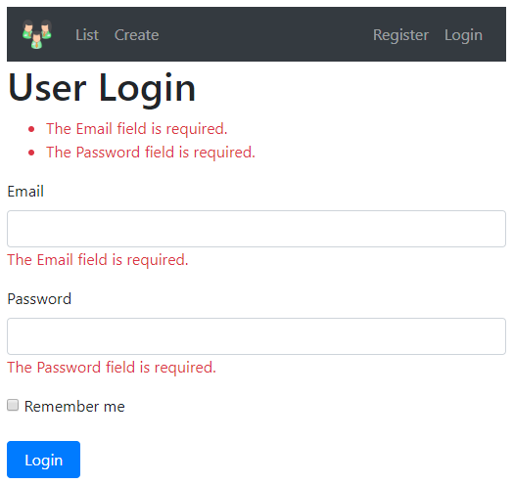  
  
To make the Email and Password fields required, we decorate the respective model properties with the [Required] attribute. We discussed how to use these validation attributes and implement server side model validation in our previous videos in this series. These same validation attributes are also used to implement client side validation in asp.net core.

public class LoginViewModel

{

    [Required]

public string Email { get; set; }

    [Required]

public string Password { get; set; }

}

**Client Side Validation**   
  
There are 2 approaches that you could take to implement client side validation in asp.net core.   
  
**Approach 1 :** Write your own custom JavaScript code to implement client-side validation which is obviously tedious and time consuming.

**Approach 2 :** Use the unobtrusive client-side validation libraries provided by asp.net core.   
  
With the second approach, we do not have to write a single line of code. All we have to do is include the following 3 scripts in the order specified.

<script src="~/lib/jquery/jquery.js"></script>

<script src="~/lib/jquery-validate/jquery.validate.js"></script>

<script src="~/lib/jquery-validation-unobtrusive/jquery.validate.unobtrusive.js"></script>

You may use Library Manager to install client side libraries. Library Manager is discussed in [Part 34](https://youtu.be/5qzzjvZ4w0c) of [ASP.NET Core tutorial](https://www.youtube.com/playlist?list=PL6n9fhu94yhVkdrusLaQsfERmL_Jh4XmU).   
  
**What does "Unobtrusive Validation" Mean**   
  
**Unobtrusive Validation** allows us to take the already-existing server side validation attributes and use them to implement client-side validation. We do not have to write a single line of custom JavaScript code. All we need is the above 3 script files in the order specified.   
  
The unobtrusive validation is done using the jquery.validate.unobtrusive.js library. This library is built on top of jquery.validate.js library, which in turns uses jQuery. This is the reason we need to import these 3 libraries in the order specified.   
  
**How does client side validation work in ASP.NET Core**  
  
The Email property is decorated with [Required] attribute. To generate input field for Email, we use asp.net core input tag helper

**<input asp-for="Email"/>**

ASP.NET Core tag helpers work in combination with the model validation attributes and generate the following HTML. Notice in the generated HTML we have data-* attributes.

<input id="Email" name="Email" type="email" data-val="true"

data-val-required="The Email field is required." />

The data-* attributes allow us to add extra information to an HTML element. These data-* attributes carry all the information required to perform the client-side validation. It is the unobtrusive library (i.e jquery.validate.unobtrusive.js) that reads these data-val attributes and performs the client side validation.   
  
**Unobtrusive validation not working in ASP.NET Core**   
  
If the unobtrusive client-side validation is not working, make sure you check the following.   
  
Make sure browser support for JavaScript is not disabled   
  
Make sure the following client-side validation libraries are loaded in the order specified

* jquery.js
* jquery.validate.js
* jquery.validate.unobtrusive.js

Make sure these validation libraries are loaded for the environment you are testing against. Development, Staging, Production etc.   
  
If there's another reason why client side validation is not working, please leave it as a comment so it could help others

### ASP.NET core remote validation

**Suggested Videos**  
[Part 72 - Redirect user to original url after login in asp.net core](https://youtu.be/-asykt9Zo_w) | [Text](https://csharp-video-tutorials.blogspot.com/2019/06/redirect-user-to-original-url-after.html) | [Slides](https://csharp-video-tutorials.blogspot.com/2019/06/redirect-user-to-original-url-after_17.html)  
[Part 73 - Open redirect vulnerability example](https://youtu.be/0q0CZTliQ7A) | [Text](https://csharp-video-tutorials.blogspot.com/2019/06/open-redirect-vulnerability-example.html) | [Slides](https://csharp-video-tutorials.blogspot.com/2019/06/open-redirect-vulnerability-example_18.html)   
[Part 74 - ASP.NET Core client side validation](https://youtu.be/PUX3PzyBofg) | [Text](https://csharp-video-tutorials.blogspot.com/2019/06/aspnet-core-client-side-validation.html) | [Slides](https://csharp-video-tutorials.blogspot.com/2019/06/aspnet-core-client-side-validation_19.html)   
  
In this video we will discuss **Remote Validation in ASP.NET Core** with an example.   
  
**What is Remote Validation in ASP.NET Core**  
  
**Remote validation** allows a controller action method to be called using client side script. This is very useful when you want to call a server side method without a full page post back.   
  
  
**Remote validation example**   
  
Consider the following User Registration Page   
  
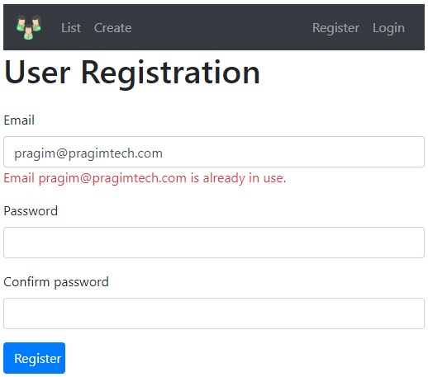  
  
  
Checking if the provided email is already taken by another user can only be done on the server. The following IsEmailInUse() controller action method checks if the provided email is in use.

[AcceptVerbs("Get", "Post")]

[AllowAnonymous]

public async Task<IActionResult> IsEmailInUse(string email)

{

    var user = await userManager.FindByEmailAsync(email);

    if (user == null)

    {

        return Json(true);

    }

    else

    {

        return Json($"Email {email} is already in use.");

    }

* This method should respond to both HTTP GET and POST. This is the reason we specified both the HTTP verbs (Get and Post) using [AcceptVerbs] attribute.
* ASP.NET Core MVC uses jQuery remote() method which in turn issues an AJAX call to invoke the server side method.
* The jQuery remote() method expects a JSON response, this is the reason we are returning JSON response from the server-side method (IsEmailInUse)

**ASP.NET core remote attribute**   
  
The following is the model class for the *User Registration View*. Notice, we have decorated the Email property with the [Remote] attribute pointing it to the action method that should be invoked when the email value changes.

public class RegisterViewModel

{

    [Required]

    [EmailAddress]

[Remote(action: "IsEmailInUse", controller: "Account")]

public string Email { get; set; }

// Other properties

}

**ASP.NET core remote validation not working**   
  
The following *3 client-side libraries are required in the order specified* for the remote validation to work. If any of them are missing or not loaded in the order specified, remote validation will not work.

<script src="~/lib/jquery/jquery.js"></script>

<script src="~/lib/jquery-validate/jquery.validate.js"></script>

<script src="~/lib/jquery-validation-unobtrusive/jquery.validate.unobtrusive.js"></script>

### Custom validation attribute in asp.net core

In this video we will discuss **how to create a custom validation attribute in asp.net core.**  
  
**ASP.NET Core built-in attributes**  
  
For most use cases asp.net core has several built-in attributes for model validation. We discussed some of these attributes in [Parts 42](https://youtu.be/aDRC_IgwmH8) and [43](https://youtu.be/woFHR3iNEEI) of [ASP.NET Core tutorial](https://www.youtube.com/playlist?list=PL6n9fhu94yhVkdrusLaQsfERmL_Jh4XmU). Some of the built-in attributes are listed below.

* Required
* Range
* StringLength
* Compare
* Regular Expression

**Custom Attribute in ASP.NET Core**   
  
If you have a complex validation requirement that you cannot implement using the built-in attributes, you can create a **custom validation attribute** and reuse it in your project or even in multiple projects if you create it in a separate class library project.   
  
**Custom Validation Attribute Example**   
  
Consider the following *User Registration Page*. Our business requirement is to only allow email address where the domain name is *pragimtech.com*. If any other domain name is used, we want to display a validation error. We could achieve this using the built-in regular expression validator, but let's create a **custom validator**.   
  
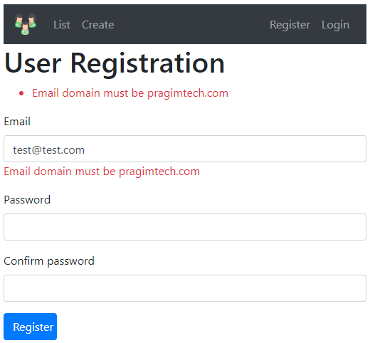  
  
**ValidationAttribute class in ASP.NET Core**   
  
To create a custom validation attribute, create a class that derives from the built-in abstract *ValidationAttribute* class and override *IsValid()* method.

public class ValidEmailDomainAttribute : ValidationAttribute

{

private readonly string allowedDomain;

public ValidEmailDomainAttribute(string allowedDomain)

{

this.allowedDomain = allowedDomain;

}

public override bool IsValid(object value)

{

string[] strings = value.ToString().Split('@');

return strings[1].ToUpper() == allowedDomain.ToUpper();

}

}

**Using Custom Validation Attribute in ASP.NET Core**

public class RegisterViewModel

{

[ValidEmailDomain(allowedDomain: "pragimtech.com",

ErrorMessage = "Email domain must be pragimtech.com")]

public string Email { get; set; }

// Other Properties

}

* Use the **custom validation attribute** just like any other built-in validation attribute.
* Email property is decorated with ValidEmailDomain attribute which is our **custom validation attribute**.
* AllowedDomain property specifies the email domain that we want to validate against.
* ErrorMessage property specifies the error message that should be displayed if the validation fails.
* The ErrorMessage property is inherited from the built-in base class ValidationAttribute.
* The validation error message is then picked up and displayed by the built-in validation tag helper.

### Extend IdentityUser in ASP.NET Core

**Bitan video, ovde pokazuje kako da se najlakse zameni klasa neka u celom projektu ( ctrl + shift + F)**

**I opet radi Migraciju, isto bitno!!**  
  
In this video we will discuss **how to extend the built-in IdentityUser class in ASP.NET Core**.  
  
**Why should we extend IdentityUser class**  
  
The built-in IdentityUser class has very limited set of properties like Id, Username, Email, PasswordHash etc. The source code of this class is shown below.

public class IdentityUser<TKey> where TKey : IEquatable<TKey>

{

    public IdentityUser() { }

    public IdentityUser(string userName) : this()

    {

        UserName = userName;

    }

    [PersonalData]

    public virtual TKey Id { get; set; }

    [ProtectedPersonalData]

    public virtual string UserName { get; set; }

    public virtual string NormalizedUserName { get; set; }

    [ProtectedPersonalData]

    public virtual string Email { get; set; }

    public virtual string NormalizedEmail { get; set; }

    [PersonalData]

    public virtual bool EmailConfirmed { get; set; }

    public virtual string PasswordHash { get; set; }

    public virtual string SecurityStamp { get; set; }

    public virtual string ConcurrencyStamp { get; set; } = Guid.NewGuid().ToString();

    [ProtectedPersonalData]

    public virtual string PhoneNumber { get; set; }

    [PersonalData]

    public virtual bool PhoneNumberConfirmed { get; set; }

    [PersonalData]

    public virtual bool TwoFactorEnabled { get; set; }

    public virtual DateTimeOffset? LockoutEnd { get; set; }

    public virtual bool LockoutEnabled { get; set; }

    public virtual int AccessFailedCount { get; set; }

    public override string ToString()

        => UserName;

}

What if I want to store additional data about the user like Gender, City, Country etc. The built-in IdentityUser class does not have these properties. To store custom user data like Gender, City, Country etc, extend the IdentityUser class.   
  
**Extend IdentityUser Class**   
  
You can name the class that extends the IdentityUser class anything you want, but it is customary to name it ApplicationUser. In the example below, ApplicationUser class extends the IdentityUser class. We have included just one custom property City, but you can include as many properties as you want.

public class ApplicationUser : IdentityUser

{

public string City { get; set; }

}

Find all references of IdentityUser class and replace it with our custom ApplicationUser class. The easiest way to do this is to, right click on the IdentityUser class and then select *"Find All References"* from the context menu. Navigate to each reference in the list and replace IdentityUser class with ApplicationUser class.   
  
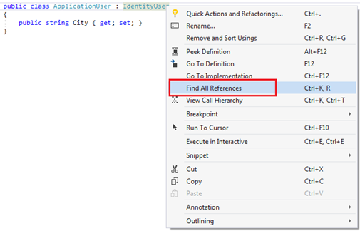  
  
Specify ApplicationUser class as the generic argument for the IdentityDbContext class   
  
This is how the IdentityDbContext class knows it has to work with our custom user class (in this case ApplicationUser class) instead of the default built-in IdentityUser class.

public class AppDbContext : IdentityDbContext<ApplicationUser>

{

public AppDbContext(DbContextOptions<AppDbContext> options)

: base(options)

{ }

public DbSet<Employee> Employees { get; set; }

protected override void OnModelCreating(ModelBuilder modelBuilder)

{

base.OnModelCreating(modelBuilder);

modelBuilder.Seed();

}

}

**Generate a new migration to add columns to AspNetUsers table**

Add-Migration Extend_IdentityUser

The above command generates the required migration code to add City column to AspNetUsers table.

public partial class Extend_IdentityUser : Migration

{

protected override void Up(MigrationBuilder migrationBuilder)

{

migrationBuilder.AddColumn<string>(

name: "City",

table: "AspNetUsers",

nullable: true);

}

protected override void Down(MigrationBuilder migrationBuilder)

{

migrationBuilder.DropColumn(

name: "City",

table: "AspNetUsers");

}

}

Next, apply the migration to the database using the following command

Update-Database

**Extending IdentityUser - Add-Migration Not Working**  
  
If ApplicationUser class (the class that extends IdentityUser class) is not specified as the generic argument for IdentityDbContext class, Add-Migration command does not work. It does not generate the required migration code to add the additional columns to the AspNetUsers identity table.   
  
To fix this, specify ApplicationUser class as the generic argument for IdentityDbContext class.

public class AppDbContext : IdentityDbContext<ApplicationUser>

{

public AppDbContext(DbContextOptions<AppDbContext> options)

: base(options)

{ }

public DbSet<Employee> Employees { get; set; }

protected override void OnModelCreating(ModelBuilder modelBuilder)

{

base.OnModelCreating(modelBuilder);

modelBuilder.Seed();

}

}

If you get the following exception, the most likely cause is somewhere with in your application you are still using IdentityUser class instead of the ApplicationUser class.

No service for type 'Microsoft.AspNetCore.Identity.SignInManager`1[Microsoft.AspNetCore.Identity.IdentityUser]' has been registered.

In Visual Studio, search for IdentityUser class throughout your application using *CTRL + SHIFT + F*   
  
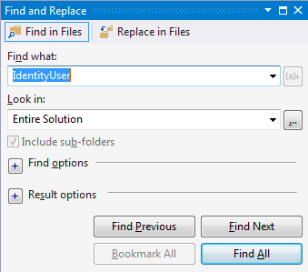  
  
Replace IdentityUser class with ApplicationUser class and rerun the project.   
  
**Storing custom data in AspNetUsers table**   
  
We register a new user using the following *Register* view.   
  
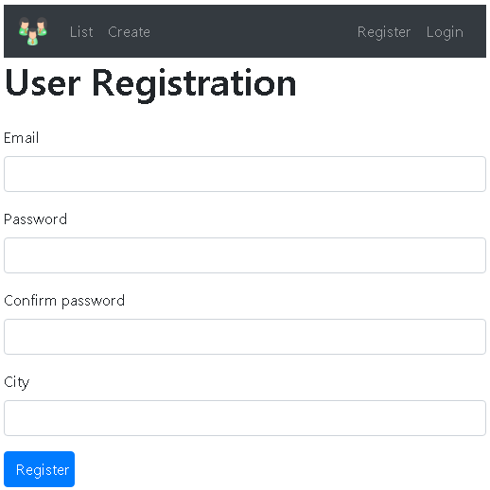  
  
To be able to store data for the custom City column in AspNetUsers table we need to alter

* RegisterViewModel class
* Register View
* Register action in the AccountController

**RegisterViewModel class**   
  
This is the model class for the *Register* view. Modify it to include City property.

public class RegisterViewModel  
{  
    // Other Properties  
  
    public string City { get; set; }  
}

**Register View**   
  
On the *Register* view, include a field to capture a value for City.

@model RegisterViewModel

@{

ViewBag.Title = "User Registration";

}

<h1>User Registration</h1>

<div class="row">

<div class="col-md-12">

<**form** method="post">

<**div** **asp-validation-summary**="All" class="text-danger"></**div**>

<div class="form-group">

<**label** **asp-for**="Email"></**label**>

<**input** **asp-for**="Email" class="form-control" />

<**span** **asp-validation-for**="Email" class="text-danger"></**span**>

</div>

@*Other Fields*@

<div class="form-group">

<**label** **asp-for**="City"></**label**>

<**input** **asp-for**="City" class="form-control" />

</div>

<button type="submit" class="btn btn-primary">Register</button>

</**form**>

</div>

</div>

**AccountController - Register action**

* Populate City property of ApplicationUser instance which is then passed to the CreateAsync() method of UserManager class.
* The data in the ApplicationUser instance is then saved to the AspNetUsers table by the IdentityDbContext class.

[HttpPost]

[AllowAnonymous]

public async Task<IActionResult> Register(RegisterViewModel model)

{

if (ModelState.IsValid)

{

var user = new ApplicationUser

{

UserName = model.Email,

Email = model.Email,

City = model.City

};

var result = await userManager.CreateAsync(user, model.Password);

if (result.Succeeded)

{

await signInManager.SignInAsync(user, isPersistent: false);

return RedirectToAction("index", "home");

}

foreach (var error in result.Errors)

{

ModelState.AddModelError(string.Empty, error.Description);

}

}

return View(model);

}

### Creating roles in asp.net core

**Suggested Videos**  
[Part 75 - ASP.NET core remote validation](https://youtu.be/2jZc11l67Zk) | [Text](https://csharp-video-tutorials.blogspot.com/2019/06/aspnet-core-remote-validation.html) | [Slides](https://csharp-video-tutorials.blogspot.com/2019/06/aspnet-core-remote-validation-slides.html)  
[Part 76 - Custom validation attribute in asp.net core](https://youtu.be/o_AH2MGti0A) | [Text](https://csharp-video-tutorials.blogspot.com/2019/06/custom-validation-attribute-in-aspnet.html) | [Slides](https://csharp-video-tutorials.blogspot.com/2019/06/custom-validation-attribute-in-aspnet_25.html)   
[Part 77 - Extend IdentityUser in ASP.NET Core](https://youtu.be/NV734cJdZts) | [Text](https://csharp-video-tutorials.blogspot.com/2019/06/extend-identityuser-in-aspnet-core.html) | [Slides](https://csharp-video-tutorials.blogspot.com/2019/06/extend-identityuser-in-aspnet-core_26.html)  
  
In this video we will discuss **creating roles in asp.net core using the ASP.NET Core Identity API**.   
  
**RoleManager in ASP.NET Core**

* To create a user in asp.net core we use *UserManager* class. Similarly, to create a role, we use *RoleManager* class provided by asp.net core
* The built-in *IdentityRole* class represents a **Role**
* *RoleManager* class performs all the CRUD operations i.e Creating, Reading, Updating and Deleting roles from the underlying database table *AspNetRoles*
* To tell the *RoleManager* class to work with *IdentityRole* class, we specify *IdentityRole* class as the generic argument to *RoleManager*
* *RoleManager* is made available to any controller or view by asp.net core dependency injection system

public class AdministrationController : Controller  
{  
    private readonly RoleManager<IdentityRole> roleManager;  
  
    public AdministrationController(RoleManager<IdentityRole> roleManager)  
    {  
        this.roleManager = roleManager;  
    }  
}

**Controller code to create a new role**   
  
The code is commented where necessary and is self-explanatory. You get a validation error, if you try to create a role with the same name that already exists.

using EmployeeManagement.ViewModels;

using Microsoft.AspNetCore.Identity;

using Microsoft.AspNetCore.Mvc;

using System.Threading.Tasks;

namespace EmployeeManagement.Controllers

{

public class AdministrationController : Controller

{

private readonly RoleManager<IdentityRole> roleManager;

public AdministrationController(RoleManager<IdentityRole> roleManager)

{

this.roleManager = roleManager;

}

        [HttpGet]

public IActionResult CreateRole()

{

return View();

}

        [HttpPost]

public async Task<IActionResult> CreateRole(CreateRoleViewModel model)

{

if (ModelState.IsValid)

{

// We just need to specify a unique role name to create a new role

                IdentityRole identityRole = new IdentityRole

{

Name = model.RoleName

};

// Saves the role in the underlying AspNetRoles table

                IdentityResult result = await roleManager.CreateAsync(identityRole);

if (result.Succeeded)

{

return RedirectToAction("index", "home");

}

foreach (IdentityError error in result.Errors)

{

ModelState.AddModelError("", error.Description);

}

}

return View(model);

}

}

}

**Create Role View Model**   
  
In ASP.NET core to create a role, all we need is a unique name for the role. We decorated the *RoleName* property with the *[Required]* attribute as it is a required field.

using System.ComponentModel.DataAnnotations;

namespace EmployeeManagement.ViewModels

{

public class CreateRoleViewModel

{

        [Required]

[Display(Name = "Role")]

public string RoleName { get; set; }

}

}

**Create Role View**

@model CreateRoleViewModel

@{

ViewBag.Title = "Create New Role";

}

<form asp-action="CreateRole" method="post" class="mt-3">

<div asp-validation-summary="All" class="text-danger">

</div>

<div class="form-group row">

<label asp-for="RoleName" class="col-sm-2 col-form-label"></label>

<div class="col-sm-10">

<input asp-for="RoleName" class="form-control" placeholder="Name">

<span asp-validation-for="RoleName" class="text-danger"></span>

</div>

</div>

<div class="form-group row">

<div class="col-sm-10">

<button type="submit" class="btn btn-primary" style="width:auto">

Create Role

</button>

</div>

</div>

</form>

### Get list of roles in asp.net core

**Suggested Videos**  
[Part 76 - Custom validation attribute in asp.net core](https://youtu.be/o_AH2MGti0A) | [Text](https://csharp-video-tutorials.blogspot.com/2019/06/custom-validation-attribute-in-aspnet.html) | [Slides](https://csharp-video-tutorials.blogspot.com/2019/06/custom-validation-attribute-in-aspnet_25.html)  
[Part 77 - Extend IdentityUser in ASP.NET Core](https://youtu.be/NV734cJdZts) | [Text](https://csharp-video-tutorials.blogspot.com/2019/06/extend-identityuser-in-aspnet-core.html) | [Slides](https://csharp-video-tutorials.blogspot.com/2019/06/extend-identityuser-in-aspnet-core_26.html)   
[Part 78 - Creating roles in asp.net core](https://youtu.be/TuJd2Ez9i3I) | [Text](https://csharp-video-tutorials.blogspot.com/2019/07/creating-roles-in-aspnet-core.html) | [Slides](https://csharp-video-tutorials.blogspot.com/2019/07/creating-roles-in-aspnet-core-slides.html)  
  
In this video we will discuss **how to retrieve and display all roles in asp.net core using the Identity API.**   
  
We want to display

* Role ID
* Role Name and
* A pair of buttons to Edit and Delete a role

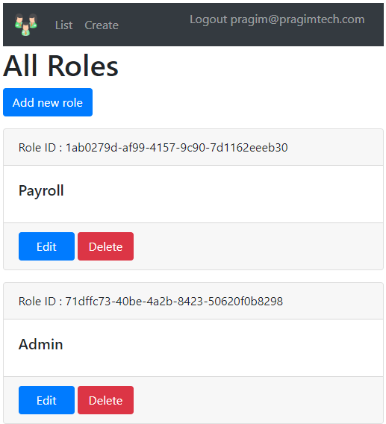  
  
  
**Roles property of RoleManager class**

* **Roles** property of RoleManager class returns the list of all IdentityRole objects
* Pass the list of IdentityRole objects to the view for display

[HttpGet]  
public IActionResult ListRoles()  
{  
    var roles = roleManager.Roles;  
    return View(roles);  
}

Here is the complete controller code

using Microsoft.AspNetCore.Identity;

using Microsoft.AspNetCore.Mvc;

namespace EmployeeManagement.Controllers

{

public class AdministrationController : Controller

{

private readonly RoleManager<IdentityRole> roleManager;

public AdministrationController(RoleManager<IdentityRole> roleManager)

{

this.roleManager = roleManager;

}

        [HttpGet]

public IActionResult ListRoles()

{

var roles = roleManager.Roles;

return View(roles);

}

// Rest of the code

}

}

**List Roles View**

* ID property of the IdentityRole object returns the role ID
* Name property of the IdentityRole object returns the role Name
* We are using Bootstrap 4 cards for styling the list of roles

@model IEnumerable<IdentityRole>

@{

ViewBag.Title = "All Roles";

}

<h1>All Roles</h1>

@if (Model.Any())

{

<**a** class="btn btn-primary mb-3" style="width:auto" **asp-action**="CreateRole"

**asp-controller**="administration">Add new role</**a**>

foreach (var role in Model)

{

<div class="card mb-3">

<div class="card-header">

Role Id : @role.Id

</div>

<div class="card-body">

<h5 class="card-title">@role.Name</h5>

</div>

<div class="card-footer">

<a href="#" class="btn btn-primary">Edit</a>

<a href="#" class="btn btn-danger">Delete</a>

</div>

</div>

}

}

else

{

<div class="card">

<div class="card-header">

No roles created yet

</div>

<div class="card-body">

<h5 class="card-title">

Use the button below to create a role

</h5>

<**a** class="btn btn-primary" style="width:auto"

**asp-controller**="administration" **asp-action**="CreateRole">

Create Role

</**a**>

</div>

</div>

}

### Edit role in asp.net core

**Suggested Videos**  
[Part 77 - Extend IdentityUser in ASP.NET Core](https://youtu.be/NV734cJdZts) | [Text](https://csharp-video-tutorials.blogspot.com/2019/06/extend-identityuser-in-aspnet-core.html) | [Slides](https://csharp-video-tutorials.blogspot.com/2019/06/extend-identityuser-in-aspnet-core_26.html)  
[Part 78 - Creating roles in asp.net core](https://youtu.be/TuJd2Ez9i3I) | [Text](https://csharp-video-tutorials.blogspot.com/2019/07/creating-roles-in-aspnet-core.html) | [Slides](https://csharp-video-tutorials.blogspot.com/2019/07/creating-roles-in-aspnet-core-slides.html)   
[Part 79 - Get list of roles in asp.net core](https://youtu.be/KGIT8P29jf4) | [Text](https://csharp-video-tutorials.blogspot.com/2019/07/get-list-of-roles-in-aspnet-core.html) | [Slides](https://csharp-video-tutorials.blogspot.com/2019/07/get-list-of-roles-in-aspnet-core-slides.html)  
  
In this video we will discuss **how to edit an existing role in asp.net core using the Identity API.**  
  
**Navigating to Edit Role View**  
  
  
The following view displays the list of all roles.    
  
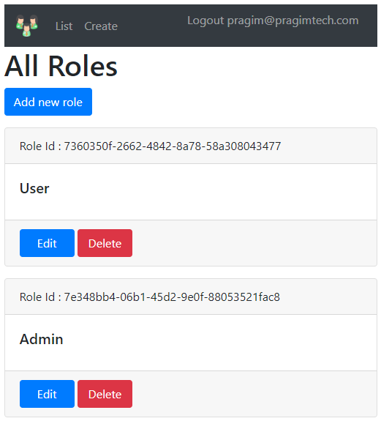  
  
  
When *Edit* button on one of the roles is clicked, we want to go to *EditRole* action in the *AdministrationController*. We are using asp-action and asp-controller tag helpers to do that. We also want to pass the *ID* of the role to edit. We pass the Role ID using asp-route-id tag helper.

<**a** **asp-controller**="Administration" **asp-action**="EditRole"

**asp-route-id**="@role.Id" class="btn btn-primary">

Edit

</**a**>

asp-route-id tag helper includes the Role ID in the URL

/Administration/EditRole/7360350f-2662-4842-8a78-58a308043477

**Edit Role View**   
  
We want the **Edit Role View** to be as shown below.   
  
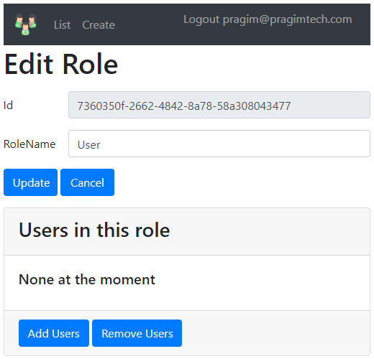

* Role ID is non-editable, so keep the input element disabled
* Only Role Name is editable
* Display the list of Users in the Role

**Edit Role View Model**   
  
The following *EditRoleViewModel* class carries the data *EditRole* view needs. *Users* property holds the list of Users in this role. The constructor initializes *Users* property so we do not get NULL reference exceptions.

using System.Collections.Generic;

using System.ComponentModel.DataAnnotations;

namespace EmployeeManagement.ViewModels

{

public class EditRoleViewModel

{

public EditRoleViewModel()

{

Users = new List<string>();

}

public string Id { get; set; }

[Required(ErrorMessage = "Role Name is required")]

public string RoleName { get; set; }

public List<string> Users { get; set; }

}

}

**Edit Role Action Methods**

// Role ID is passed from the URL to the action

[HttpGet]

public async Task<IActionResult> EditRole(string id)

{

// Find the role by Role ID

var role = await roleManager.FindByIdAsync(id);

if (role == null)

{

ViewBag.ErrorMessage = $"Role with Id = {id} cannot be found";

return View("NotFound");

}

var model = new EditRoleViewModel

{

Id = role.Id,

RoleName = role.Name

};

// Retrieve all the Users

foreach (var user in userManager.Users)

{

// If the user is in this role, add the username to

// Users property of EditRoleViewModel. This model

// object is then passed to the view for display

if (await userManager.IsInRoleAsync(user, role.Name))

{

model.Users.Add(user.UserName);

}

}

return View(model);

}

// This action responds to HttpPost and receives EditRoleViewModel

[HttpPost]

public async Task<IActionResult> EditRole(EditRoleViewModel model)

{

var role = await roleManager.FindByIdAsync(model.Id);

if (role == null)

{

ViewBag.ErrorMessage = $"Role with Id = {model.Id} cannot be found";

return View("NotFound");

}

else

{

role.Name = model.RoleName;

// Update the Role using UpdateAsync

var result = await roleManager.UpdateAsync(role);

if (result.Succeeded)

{

return RedirectToAction("ListRoles");

}

foreach (var error in result.Errors)

{

ModelState.AddModelError("", error.Description);

}

return View(model);

}

}

**Edit Role View**

@model EditRoleViewModel

@{

ViewBag.Title = "Edit Role";

}

<h1>Edit Role</h1>

<**form** method="post" class="mt-3">

<div class="form-group row">

<**label** **asp-for**="Id" class="col-sm-2 col-form-label"></**label**>

<div class="col-sm-10">

<**input** **asp-for**="Id" disabled class="form-control">

</div>

</div>

<div class="form-group row">

<**label** **asp-for**="RoleName" class="col-sm-2 col-form-label"></**label**>

<div class="col-sm-10">

<**input** **asp-for**="RoleName" class="form-control">

<**span** **asp-validation-for**="RoleName" class="text-danger"></**span**>

</div>

</div>

<**div** **asp-validation-summary**="All" class="text-danger"></**div**>

<div class="form-group row">

<div class="col-sm-10">

<button type="submit" class="btn btn-primary">Update</button>

<**a** **asp-action**="ListRoles" class="btn btn-primary">Cancel</**a**>

</div>

</div>

<div class="card">

<div class="card-header">

<h3>Users in this role</h3>

</div>

<div class="card-body">

@if (Model.Users.Any())

{

foreach (var user in Model.Users)

{

<h5 class="card-title">@user</h5>

}

}

else

{

<h5 class="card-title">None at the moment</h5>

}

</div>

<div class="card-footer">

<a href="#" class="btn btn-primary" style="width:auto">Add Users</a>

<a href="#" class="btn btn-primary" style="width:auto">Remove Users</a>

</div>

</div>

</**form**>

# Shortcuts

-**Chrome** ignores the cache and **will** load all resources from the web page again **shift+ctrl+R**

**-Find and Replace CTRL+SHIFT+F, samo find je CTRL+F**

-Brisanje svih breakpointa **Ctrl+Shift+F9**

-Da prelazis sa dokumenta na dokument u visual studiu**: Ctrl+Tab**

-Edit.InsertSnippet **Ctrl+K, Ctrl+X**

-Edit.SelectAll **Ctrl+A**

-View.ZoomIn **Ctrl+Shift + .**

-View.ZoomOut **Ctrl+Shift + ,**

-Edit.DocumentEnd **Ctrl+End**

-Edit.DocumentStart **Ctrl+Home**

-Edit.FormatDocument **Ctrl+K, Ctrl+D**

-Edit.FormatSelection **Ctrl+K, Ctrl+F**

-Edit.SelectCurrentWord **Ctrl+W**

-Edit.SelectionCancel **Escape**

-Edit.CommentSelection **Ctrl+K, Ctrl+C**

-Edit.UncommentSelection **Ctrl+K, Ctrl+U**

-Edit.WordNext  **Ctrl+Right Arrow**

-Edit.WordNextExtend **Ctrl+Shift+Right Arrow**

-Edit.WordNextExtendColumn **Ctrl+Shift+Alt+Right Arrow**

-Edit.WordPrevious **Ctrl+Left Arrow**

-Edit.WordPreviousExtend **Ctrl+Shift+Left Arrow**

WORD shortcut za povecavanje I smanjivanje fonta

**-Ctrl+shift + >** za povecavanje

**Ctrl+shift + <** za smanjivanje

# Extension method

Imamo neki string I hocemo da pozivamo metodu ovako:

“nekistring”.NekaMetoda(); A ne ovako; Klasa primer1 = new Klasa();

Primer1.NekaMetoda();

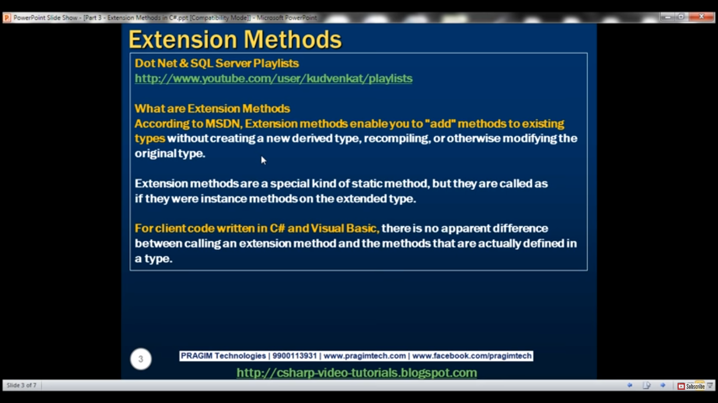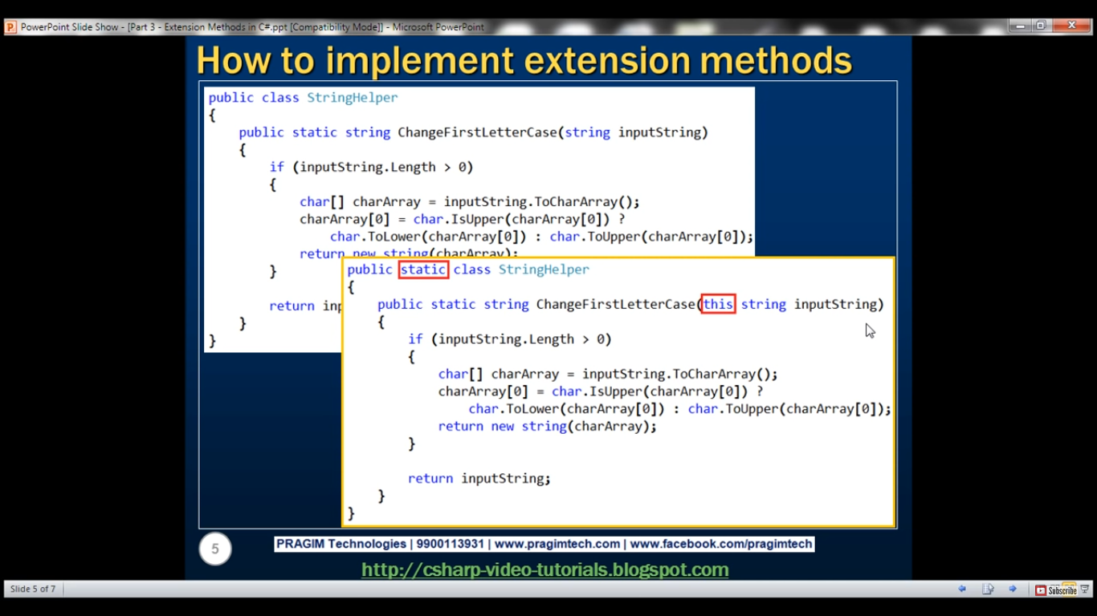

# VIEWDATA sa listom objekta

Kontroler:

public ActionResult Index()

{

IList<Student> studentList = new List<Student>();

studentList.Add(new Student(){ StudentName = "Bill" });

studentList.Add(new Student(){ StudentName = "Steve" });

studentList.Add(new Student(){ StudentName = "Ram" });

ViewData["students"] = studentList;

return View();

}

VIEW:

<ul>

@foreach (var std in ViewData["students"] as IList<Student>)

{

<li>

@std.StudentName

</li>

}

</ul>

Points to Remember :

1. ViewData transfers data from the Controller to View, not vice-versa.
2. ViewData is derived from ViewDataDictionary which is a dictionary type.
3. ViewData's life only lasts during current http request. ViewData values will be cleared if redirection occurs.
4. ViewData value must be type cast before use.
5. ViewBag internally inserts data into ViewData dictionary. So the key of ViewData and property of ViewBag must **NOT** match.

# Dodavanje dugmica za sortiranje I paginacija:

Imas lepo uradjeno kod Dulejana na kursu

Promene u kontroloru:

public ActionResult Index(string sortOrder)

{

ViewBag.NameSortParm = String.IsNullOrEmpty(sortOrder) ? "name_desc" : "";

ViewBag.DateSortParm = sortOrder == "Date" ? "date_desc" : "Date";

var students = from s in db.Students

select s;

switch (sortOrder)

{

case "name_desc":

students = students.OrderByDescending(s => s.LastName);

break;

case "Date":

students = students.OrderBy(s => s.EnrollmentDate);

break;

case "date_desc":

students = students.OrderByDescending(s => s.EnrollmentDate);

break;

default:

students = students.OrderBy(s => s.LastName);

break;

}

return View(students.ToList());

}

Promene u view-u:

<table class="table">

<tr>

<th>

@Html.ActionLink("Last Name", "Index", new { sortOrder = ViewBag.NameSortParm })

</th>

<th>First Name

</th>

<th>

@Html.ActionLink("Enrollment Date", "Index", new { sortOrder = ViewBag.DateSortParm })

</th>

<th></th>

</tr>

Paginacija, objasnjena detaljno   
https://docs.microsoft.com/en-us/aspnet/mvc/overview/getting-started/getting-started-with-ef-using-mvc/sorting-filtering-and-paging-with-the-entity-framework-in-an-asp-net-mvc-application

# Async index metod

public async Task<ActionResult> Index()

{

var departments = db.Departments.Include(d => d.Administrator);

return View(await departments.ToListAsync());

}

Four changes were applied to enable the Entity Framework database query to execute asynchronously:

* The method is marked with the async keyword, which tells the compiler to generate callbacks for parts of the method body and to automatically create the Task<ActionResult> object that is returned.
* The return type was changed from ActionResult to Task<ActionResult>. The Task<T> type represents ongoing work with a result of type T.
* The await keyword was applied to the web service call. When the compiler sees this keyword, behind the scenes it splits the method into two parts. The first part ends with the operation that is started asynchronously. The second part is put into a callback method that is called when the operation completes.
* The asynchronous version of the ToList extension method was called.

Why is the departments.ToList statement modified but not the departments = db.Departments statement? The reason is that only statements that cause queries or commands to be sent to the database are executed asynchronously. The departments = db.Departments statement sets up a query but the query is not executed until the ToList method is called. Therefore, only the ToList method is executed asynchronously.

In the Details method and the HttpGet Edit and Delete methods, the Find method is the one that causes a query to be sent to the database, so that's the method that gets executed asynchronously:

C#

public async Task<ActionResult> Details(int? id)

{

if (id == null)

{

return new HttpStatusCodeResult(HttpStatusCode.BadRequest);

}

Department department = await db.Departments.FindAsync(id);

if (department == null)

{

return HttpNotFound();

}

return View(department);

}

In the Create, HttpPost Edit, and DeleteConfirmed methods, it is the SaveChanges method call that causes a command to be executed, not statements such as db.Departments.Add(department) which only cause entities in memory to be modified.

C#

public async Task<ActionResult> Create(Department department)

{

if (ModelState.IsValid)

{

db.Departments.Add(department);

await db.SaveChangesAsync();

return RedirectToAction("Index");

}

# Entity Framework Core(hard)

Reverse engineer your model

Now it's time to create the EF model based on your existing database.

* **Tools –> NuGet Package Manager –> Package Manager Console**
* Run the following command to create a model from the existing database:

Scaffold-DbContext "Server=(localdb)\mssqllocaldb;Database=Blogging;Trusted_Connection=True;" Microsoft.EntityFrameworkCore.SqlServer -OutputDir Models

If you receive an error stating The term 'Scaffold-DbContext' is not recognized as the name of a cmdlet, then close and reopen Visual Studio.

**Register your context with dependency injection**

The concept of dependency injection is central to ASP.NET Core. Services (such as BloggingContext) are registered with dependency injection during application startup. Components that require these services (such as your MVC controllers) are then provided these services via constructor parameters or properties. For more information on dependency injection see the [Dependency Injection](http://docs.asp.net/en/latest/fundamentals/dependency-injection.html) article on the ASP.NET site.

**Register and configure your context in Startup.cs**

To make BloggingContext available to MVC controllers, register it as a service.

* Open **Startup.cs**
* Add the following using statements at the start of the file

C#

using EFGetStarted.AspNetCore.ExistingDb.Models;

using Microsoft.EntityFrameworkCore;

Now you can use the AddDbContext(...) method to register it as a service.

* Locate the ConfigureServices(...) method
* Add the following highlighted code to register the context as a service

C#

// This method gets called by the runtime. Use this method to add services to the container.

public void ConfigureServices(IServiceCollection services)

{

services.Configure<CookiePolicyOptions>(options =>

{

// This lambda determines whether user consent for non-essential cookies is needed for a given request.

options.CheckConsentNeeded = context => true;

options.MinimumSameSitePolicy = SameSiteMode.None;

});

services.AddMvc().SetCompatibilityVersion(CompatibilityVersion.Version_2_1);

### Dependency injection za Startup

ovaj deo dole se dodaje

var connection = @"Server=(localdb)\mssqllocaldb;Database=Blogging;Trusted_Connection=True;ConnectRetryCount=0";

services.AddDbContext<BloggingContext>(options => options.UseSqlServer(connection));

}

Tip

In a real application you would typically put the connection string in a configuration file or environment variable. For the sake of simplicity, this tutorial has you define it in code. For more information, see [Connection Strings](https://docs.microsoft.com/en-us/ef/core/miscellaneous/connection-strings).

# Entity Framework sa MVC 5

Kako u C# klasi, Modelu iskucati primarni kljuc

Ukoliko je code-first, kad pravis klasu ukoliko imas property ID ili (imeklaseID) primer: EnrollmentID, onda EF to shvata kao primarni kljuc

Kako u C# klasi, Modelu iskucati ForeignKey:

Entity Framework interprets a property as a foreign key property if it's named <navigation property name><primary key property name> (for example, StudentID for the Student navigation property since the Student entity's primary key is ID). Foreign key properties can also be named the same simply <primary key property name> (for example, CourseID since the Course entity's primary key is CourseID).

## Querying in EF Core

using (var db = new BloggingContext())

{

var blogs = db.Blogs

.Where(b => b.Rating > 3)

.OrderBy(b => b.Url)

.ToList();

}

Da se spoje 2 tabele:

using (var context = new BloggingContext())

{

var blogs = context.Blogs

.Include(blog => blog.Posts)

.ToList();

}  
Da se spoje vise tabela:  
using (var context = new BloggingContext())

{

var blogs = context.Blogs

.Include(blog => blog.Posts)

.Include(blog => blog.Owner)

.ToList();

}

### Including multiple levels

You can drill down through relationships to include multiple levels of related data using the ThenInclude method. The following example loads all blogs, their related posts, and the author of each post.

C#

using (var context = new BloggingContext())

{

var blogs = context.Blogs

.Include(blog => blog.Posts)

.ThenInclude(post => post.Author)

.ToList();

}

You can combine all of this to include related data from multiple levels and multiple roots in the same query.

C#

using (var context = new BloggingContext())

{

var blogs = context.Blogs

.Include(blog => blog.Posts)

.ThenInclude(post => post.Author)

.ThenInclude(author => author.Photo)

.Include(blog => blog.Owner)

.ThenInclude(owner => owner.Photo)

.ToList();

}

### Da se iz tabele izvuku samo 2 polja

LINQ QUERY SYNTAX

using (var ctx = new SchoolDBEntities())

{

var anonymousObjResult = from s in ctx.Students

where s.StandardId == 1

select new {

Id = st.StudentId,

Name = st.StudentName

};

foreach (var obj in anonymousObjResult)

{

Console.Write(obj.Name);

}

LING METHOD SYNTAX

using (var ctx = new SchoolDBEntities())

{

var anonymousObjResult = ctx.Students

.Where(st => st.Standard == 1)

.Select(st => new {

Id = st.StudentId,

Name = st.StudentName });

foreach (var obj in anonymousObjResult)

{

Console.Write(obj.Name);

}

}

### Saving Data

Data is created, deleted, and modified in the database using instances of your entity classes. See [Saving Data](https://docs.microsoft.com/en-us/ef/core/saving/index) to learn more.

C#

using (var db = new BloggingContext())

{

var blog = new Blog { Url = "http://sample.com" };

db.Blogs.Add(blog);

db.SaveChanges();

}

### Updating Data

EF will automatically detect changes made to an existing entity that is tracked by the context. This includes entities that you load/query from the database, and entities that were previously added and saved to the database.

Simply modify the values assigned to properties and then call SaveChanges.

C#

using (var context = new BloggingContext())

{

var blog = context.Blogs.First();

blog.Url = "http://sample.com/blog";

context.SaveChanges();

### Deleting Data

Use the DbSet.Remove method to delete instances of your entity classes.

If the entity already exists in the database, it will be deleted during SaveChanges. If the entity has not yet been saved to the database (that is, it is tracked as added) then it will be removed from the context and will no longer be inserted when SaveChanges is called.

C#

using (var context = new BloggingContext())

{

var blog = context.Blogs.First();

context.Blogs.Remove(blog);

context.SaveChanges();

}

# Instalacija Bootstrap Libman

Install and use Bootstrap in ASP.NET Core   
**Tools to install client-side packages**   
  
There are many tools that we can use with Visual Studio to install client-side packages like Bootstrap and jQuery. For example we could use tools like Bower, NPM, WebPack etc.   
  
  
However, we are not going to use any of these tools. We will instead use **Library Manager** (LibMan for short). Library Manager is a light-weight, client-side library acquisition tool. It downloads client-side libraries and frameworks from the file system or from a CDN (Content Delivery Network).   
  
To be able to use LibMan you should have Visual Studio 2017 version 15.8 or later  
  
**Check and Upgrade Visual Studio Version**   
  
**To check the version of Visual Studio you have**

* Click on the "Help" menu item and
* Select "About Microsoft Visual Studio" from the context menu
* The window that appears, displays the version of Visual Studio you have
* On my machine I have 15.9.4

  
  
If you have an older version of Visual Studio 2017, you can easily update it.    
  
**To update visual studio version**

* Click on the "Help" menu item and
* Select "Check for Updates" from the context menu
* The subsequent window that appears display your current version and the latest available version.
* Simply click the "Update" button

  
  
**Install Bootstrap Using LibMan**

* Right click on the "Project Name" in Solution Explorer and Select Add > Client-Side Library. In the "Add Client-Side Library" window that opens
* Leave the default provider which is cdnjs
* In the "Library" text box, type "twitter-bootstrap". Upon selecting the matching entry, it tries to install the latest version. However, you can manually type the version you want. You also have intellisense support. We will install the lates Bootstrap version 4.
* You can either include "All the library file" or "Just the files you need"
* In the "Target Location" text box specify the folder where you want the library files to be copied. Recollect, by default static files are only served from WWWRoot folder.
* Click the "Install" Button

  
  
**libman.json file**   
  
**libman.json** is the Library Manager manifest file. Notice in the manifest file we have an entry for the Bootstrap client-side library that we just installed. We can also directly edit the manifest file to install client-side packages, instead of using the user interface provided by LibMan.   
  
**Clean and Restore Client-Side Libraries**   
  
To clean library files, right click on libman.json file and select "Clean Client-Side Libraries" from the context menu. The clean operation deletes the library files from the destination folder. However, the entries in libman.json will not be deleted.   
  
To restore the deleted files, right click on libman.json file and select "Restore Client-Side Libraries" from the context menu. The restore operation will download and copy the library files into the specified destination folder.   
  
  
  
**Uninstall or Update a Client-Side Library**

* Open libman.json file
* Click on the client-side library you want to uninstall
* A light bulb icon appears
* Click on the light bulb icon and you will have options to either update or uninstall that specific client-side library

  
  
Alternatively, you can also just delete the client-side library entry in libman.json file and upon saving the file, the respective client-side library will be uninstalled.   
  
Similarly, to upgrade or downgrade a client-side library, you can directly change the version number in libman.json file. Upon saving the file, the respective client-side library is updated to the version specified. You will also have intellisense when editing the version number in visual studio.   
  
  
  
**Site Specific CSS**   
  
We will be placing all our site specific CSS in a separate stylesheet. Add a stylesheet with name site.css to the "css" folder. We already created this "css" in "wwwroot" folder.   
  
**Copy and paste the following .btn class in site.css**   
  
.btn {  
    width: 75px;  
}   
  
**Using Bootstrap in ASP.NET Core Application**   
  
To start using Bootstrap in your asp.net core application, include a reference to the Boostrap.css file in the layout file _Layout.cshtml. Also include a reference to our custom stylesheet site.css.   
  
**The following is the code in _Layout.cshtml**

<html>

<head>

<meta name="viewport" content="width=device-width" />

<link href="~/lib/bootstrap/css/bootstrap.css" rel="stylesheet" />

<link href="~/css/site.css" rel="stylesheet" />

<title>@ViewBag.Title</title>

</head>

<body>

<div class="container">

@RenderBody()

</div>

@if (IsSectionDefined("Scripts"))

{

@RenderSection("Scripts", required: false)

}

</body>

</html>

**Please note :** We are using the Bootstrap "container" class for positioning elements on the page.   
  
**Styling Details.cshtml View**   
  
We are using Bootstrap 4 styling class to position and style elements on the page.

@model HomeDetailsViewModel

@{

ViewBag.Title = "Employee Details";

}

<div class="row justify-content-center m-3">

<div class="col-sm-8">

<div class="card">

<div class="card-header">

<h1>@Model.Employee.Name</h1>

</div>

<div class="card-body text-center">

<img class="card-img-top" src="~/images/noimage.jpg" />

<h4>Employee ID : @Model.Employee.Id</h4>

<h4>Email : @Model.Employee.Email</h4>

<h4>Department : @Model.Employee.Department</h4>

</div>

<div class="card-footer text-center">

<a href="#" class="btn btn-primary">Back</a>

<a href="#" class="btn btn-primary">Edit</a>

<a href="#" class="btn btn-danger">Delete</a>

</div>

</div>

</div>

</div>

@section Scripts {

<script src="~/js/CustomScript.js"></script>

}

**Styling Index.cshtml View**   
  
We are using Bootstrap 4 styling class to position and style elements on the page.

@model IEnumerable<Employee>

@{

ViewBag.Title = "Employee List";

}

<div class="card-deck">

@foreach (var employee in Model)

{

<div class="card m-3">

<div class="card-header">

<h3>@employee.Name</h3>

</div>

<img class="card-img-top" src="~/images/noimage.jpg" />

<div class="card-footer text-center">

<a href="#" class="btn btn-primary">View</a>

<a href="#" class="btn btn-primary">Edit</a>

<a href="#" class="btn btn-danger">Delete</a>

</div>

</div>

}

</div>

# Bootstrap kudvenkat

Prednosti bootstrap:

-Podrzava responsive aplikacije

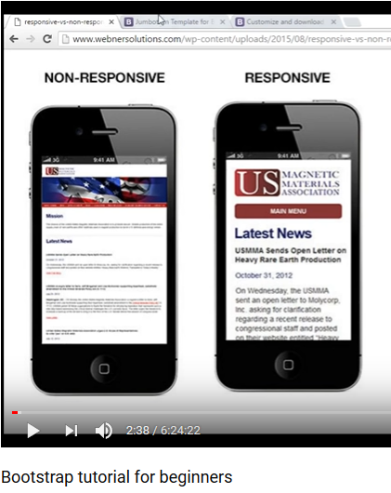

-Stedi vreme developera

-Konzistentan ??

-Customize, mogu da se skinu samo verziju Bootstrap za recimo dropdown I table, a ostale funkcije da se ne skinu

-Support is large

Bootstrap.js mora da ima I Jquery referencirano u projektu da bi radilo

Instalacija-podesavanje Bootstrapa

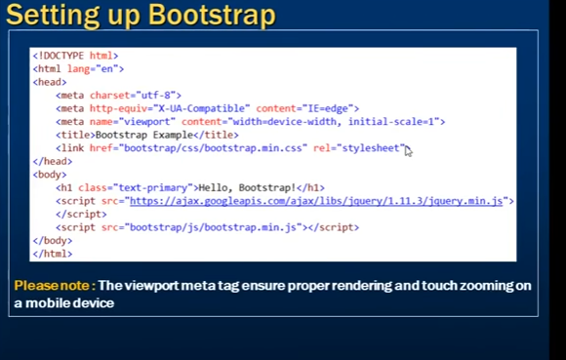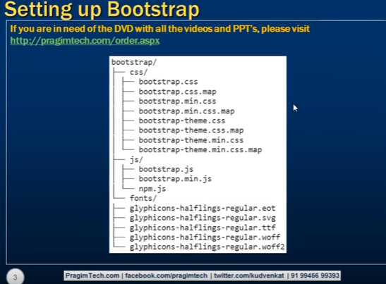

### Gryd Systems

Gryd system se sastoji iz 12 kolona

Snipet za ovo:  
  
<div class="container">

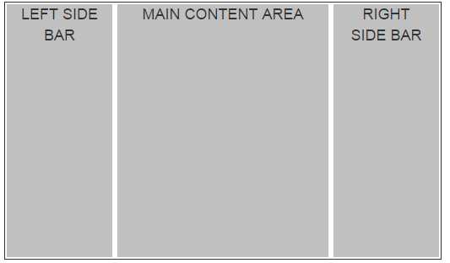

    <div class="row">

        <div class="col-md-2">

            <div class="customDiv">LEFT SIDE BAR</div>

        </div>

        <div class="col-md-8">

            <div class="customDiv">MAIN CONTENT AREA</div>

        </div>

        <div class="col-md-2">

            <div class="customDiv">RIGHT SIDE BAR</div>

        </div>

    </div>

</div>  
  
class custom div je samo za css da bude kao gore siv I margine..

Da se na md medium device, smal device, lg– large prikazuje grid u zavisnosti koja je rezolucija, stave se sva 3 taga: ovako, I on prepozna koja je rezolucija I izabere

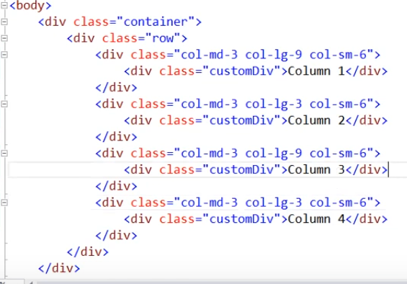

Col-md-3 offset da se pomeri za 3 kolone, tj da ne racuna prve 3- OFFSET

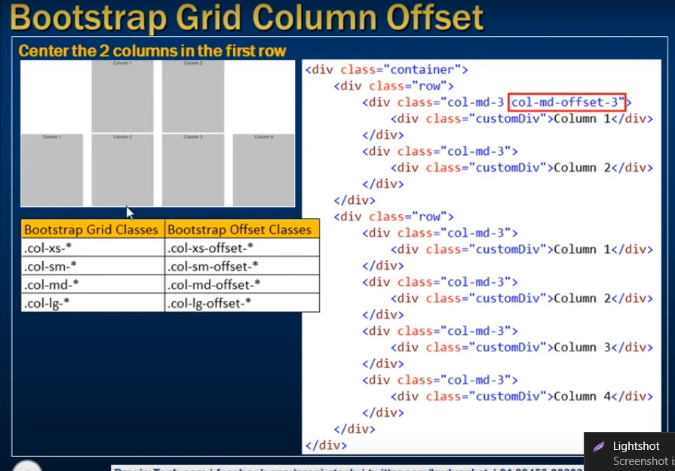

DA SLIKA BUDE RESPONSIVE SAMO TREBA DA JOJ SE DODA KLASA:

<img src=”bla” class =”col-md-4 **img-responsive**”/>

primer slika I kod:

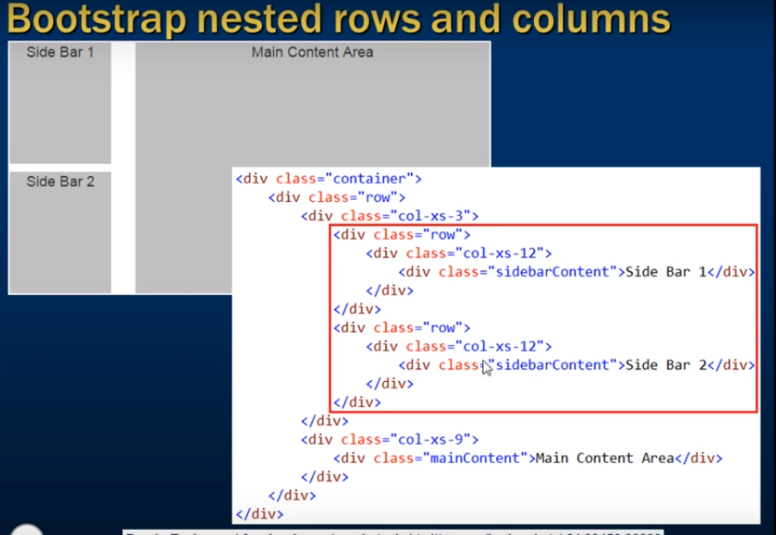

### Slike I bootstrap

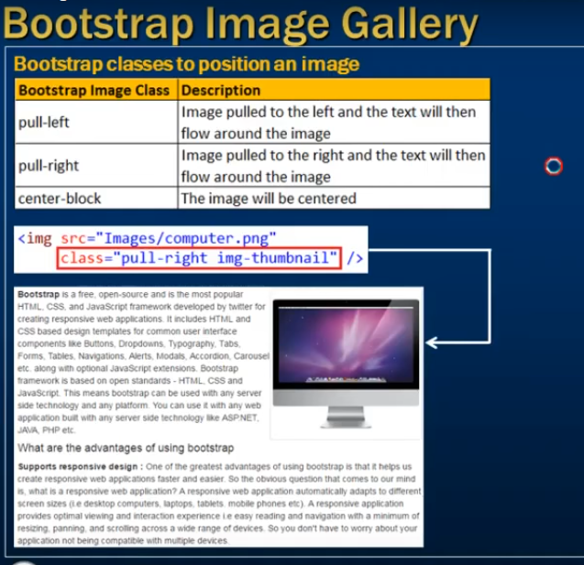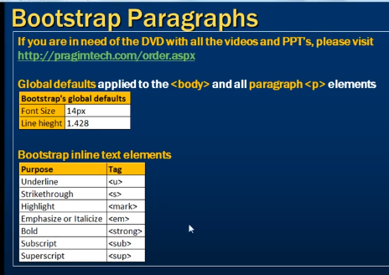

### Liste:

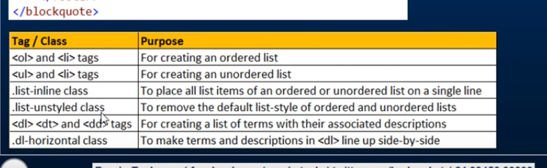

Lista kao linkovi

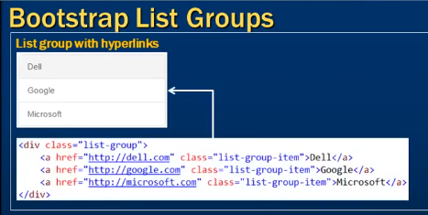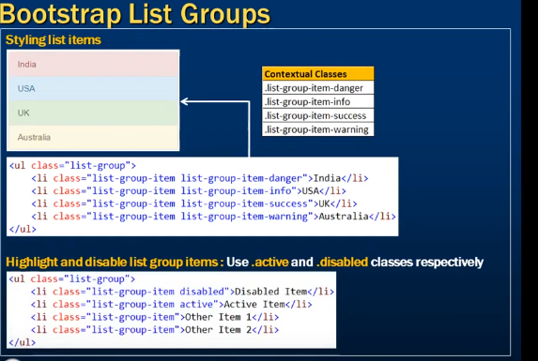

### Za prikazivanje programerskog koda:

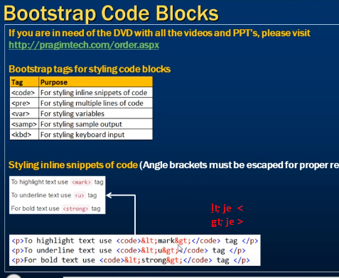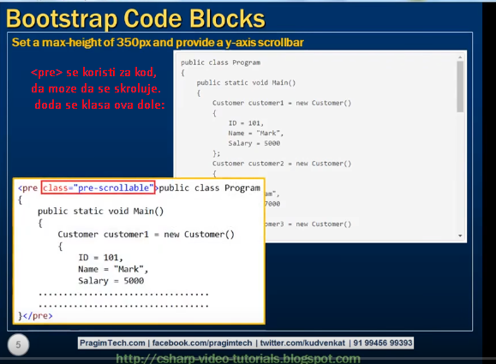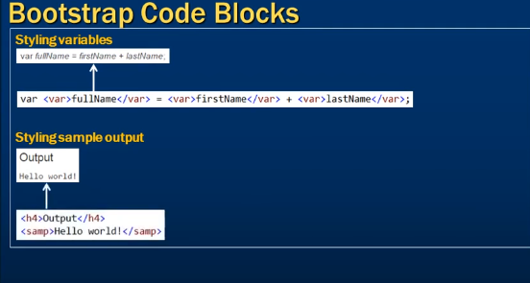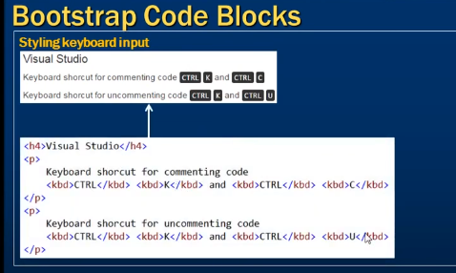

### Bootstrap I Tabele:

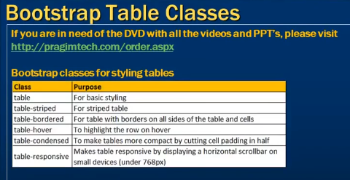

### Bootstrap I buttons - dugmici:

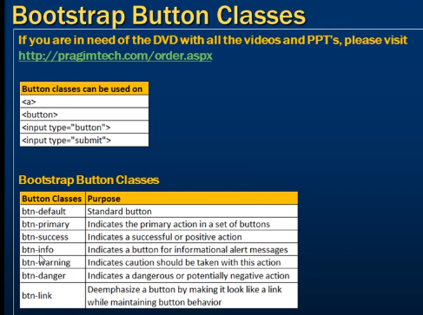

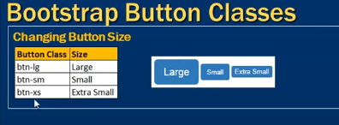

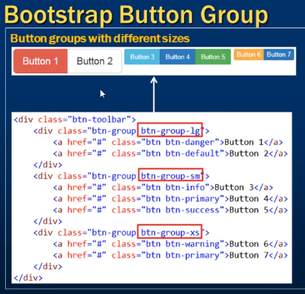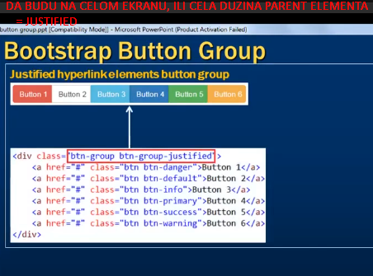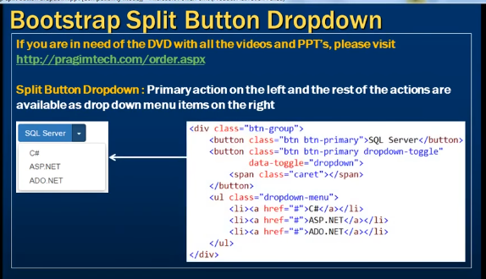

### Glyphicon, koriscenje:

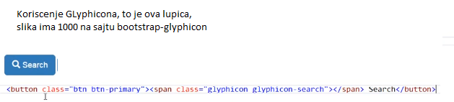

### Dropdown

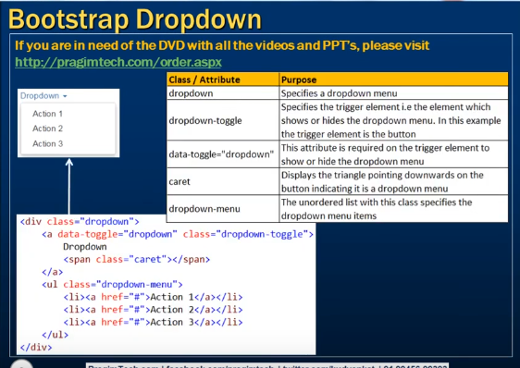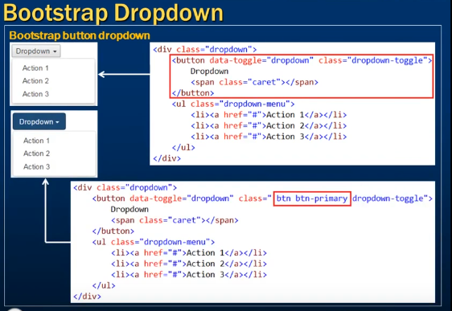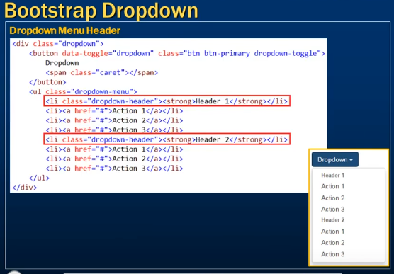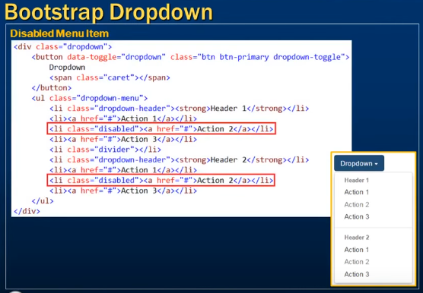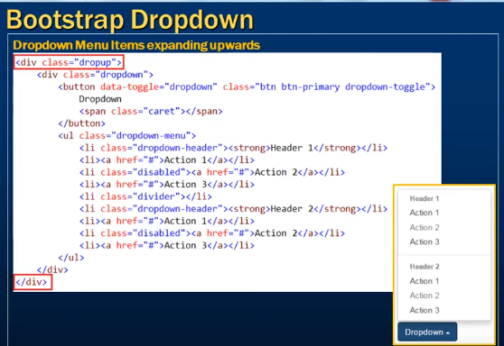

### Bootstrap I forme:

Login forma:

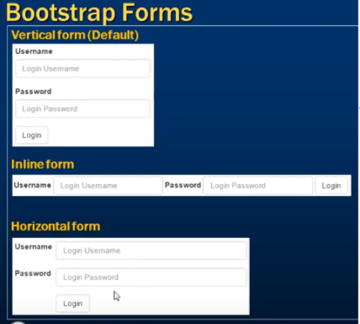

Vertikal form: skini sliku pa pogledaj kod ako treba

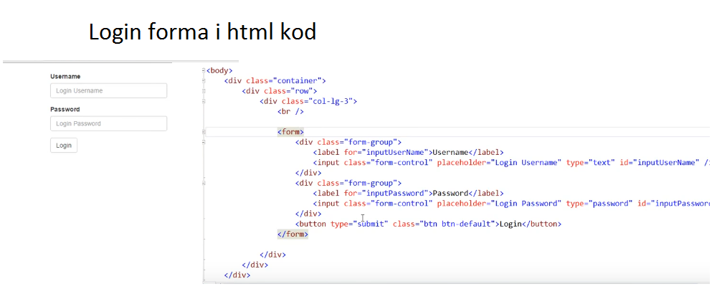

Horizontalna forma ( labele levo a text boxovi desno od labela. Kod)

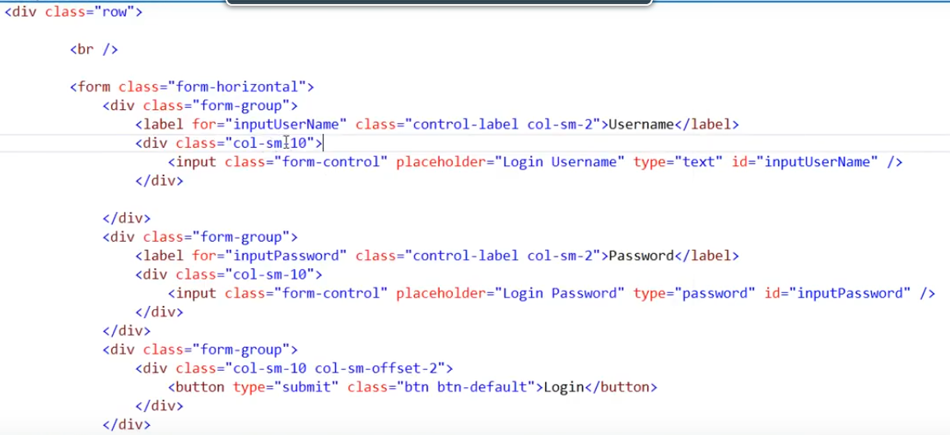

### Form controls(input, textarea, checkbox, radio, select)

Type attribute kaze bootstrapu kako da stilizuje kontrolu  
  
PRIMER ZA :

TEXT AREA:  
  
<div class="form-group">

    <label for="inputDescription">Product Description</label>

    <textarea class="form-control" id="inputDescription" rows="5"

                placeholder="Full Product Description"></textarea>

</div>

Checkbox:

<div class="checkbox">

    <label>

        <input type="checkbox" value="option1">

        Option 1

    </label>

</div>

<div class="checkbox">

    <label>

        <input type="checkbox" value="option2">

        Option 2

    </label>

</div>

<div class="checkbox disabled">

    <label>

        <input type="checkbox" value="option3" disabled>

        Option 3

    </label>

</div>

Da ckeckbox budu u liniji

<label class="checkbox-inline">

    <input type="checkbox" value="option1">Option 1

</label>

<label class="checkbox-inline">

    <input type="checkbox" value="option2">Option 2

</label>

<label class="checkbox-inline">

    <input type="checkbox" value="option3">Option 3

</label>

Radio button, ali samo 1 da se bira, klasa radioGroup

<div class="radio">

    <label>

        <input type="radio" name="radioGroup" id="opt1" value="1">

        Option 1

    </label>

</div>

<div class="radio">

    <label>

        <input type="radio" name="radioGroup" id="opt2" value="2">

        Option 2

    </label>

</div>

<div class="radio disabled">

    <label>

        <input type="radio" name="radioGroup" id="opt3" value="3" disabled>

        Option 3

    </label>

</div>

If you want the radio buttons to appear side-by-side on the same line, use radio-inline class   


<label class="radio-inline">

    <input type="radio" name="radioGroup" id="opt1" value="1">

    Option 1

</label>

<label class="radio-inline">

    <input type="radio" name="radioGroup" id="opt2" value="2">

    Option 2

</label>

<label class="radio-inline">

    <input type="radio" name="radioGroup" id="opt3" value="3" disabled>

    Option 3

</label>

DROPDOWN:

<select class="form-control">

    <option>Option 1</option>

    <option>Option 2</option>

    <option>Option 3</option>

    <option>Option 4</option>

    <option>Option 5</option>

</select>

### Disabled and read only form controls

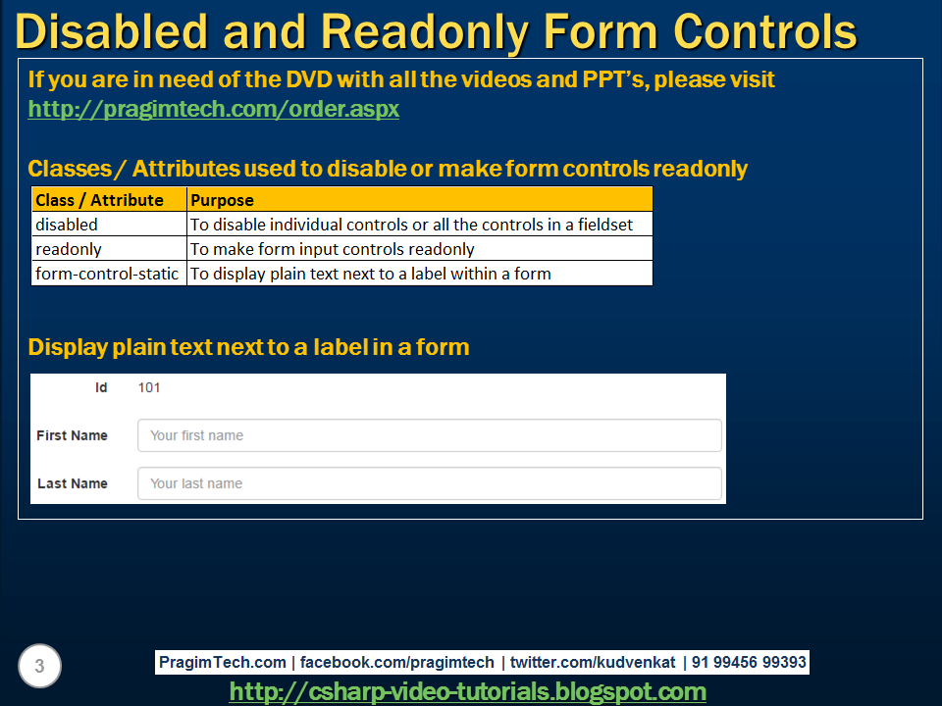

Disabled I readonly su isti na izgled, sa readonly ne pretvara se kursor u znak za stop

Form-control-static za prikaz poravnatog sa labelom readonly texta, 101 gore:

Primer: <p class= ”Form-control-static “> 101 </p>

### Bootstrap Form- Validation State

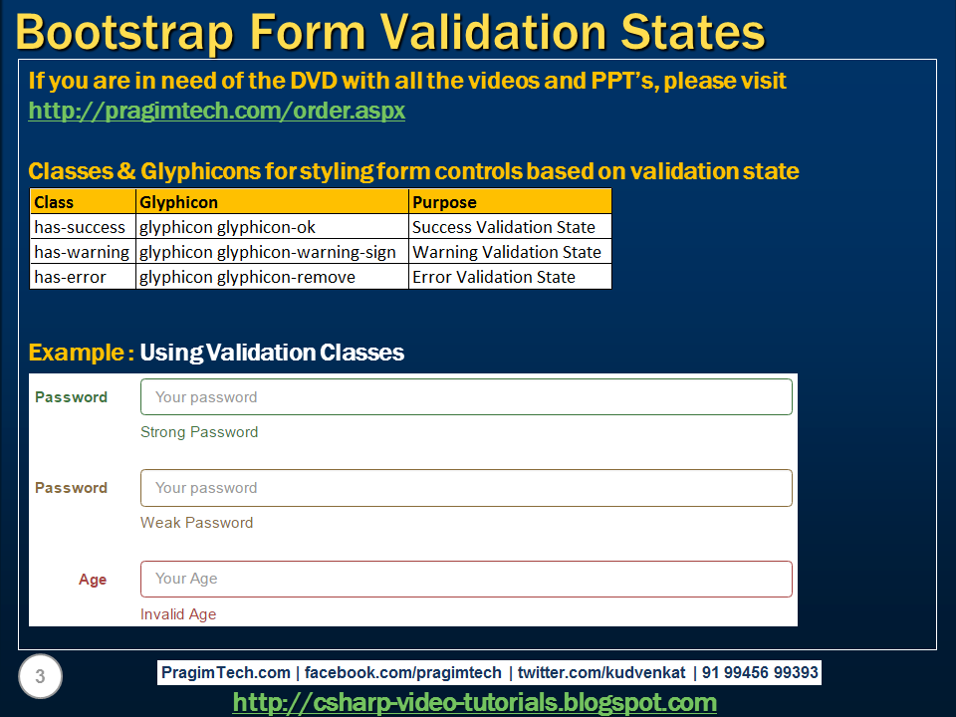

Sa slicicama ovim desno kod:

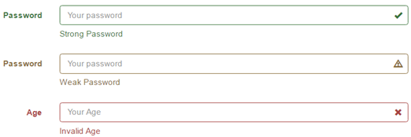

<form class="form-horizontal">

    <div class="form-group has-success has-feedback">

        <label class="col-xs-2 control-label" for="txtStrongPassword">Password</label>

        <div class="col-xs-10">

            <input type="password" id="txtStrongPassword" class="form-control"

                    placeholder="Your password">

            <span class="glyphicon glyphicon-ok form-control-feedback"></span>

            <span class="help-block">Strong Password</span>

        </div>

    </div>

    <div class="form-group has-warning has-feedback">

        <label class="col-xs-2 control-label" for="txtWeakPassword">Password</label>

        <div class="col-xs-10">

            <input type="password" id="txtWeakPassword" class="form-control"

                    placeholder="Your password">

            <span class="glyphicon glyphicon-warning-sign form-control-feedback"></span>

            <span class="help-block">Weak Password</span>

        </div>

    </div>

    <div class="form-group has-error has-feedback">

        <label class="col-xs-2 control-label" for="txtAge">Age</label>

        <div class="col-xs-10">

            <input type="number" id="txtAge" class="form-control"

                    placeholder="Your Age">

            <span class="glyphicon glyphicon-remove form-control-feedback"></span>

            <span class="help-block">Invalid Age</span>

        </div>

    </div>

</form>

Image Carousel: kod



<!doctype html>

<html>

<head>

    <meta name="viewport" content="width=device-width, initial-scale=1">

    <title>Bootstrap tutorial for begineers</title>

    <link href="bootstrap/css/bootstrap.min.css" rel="stylesheet">

    <link href="CustomStyles.css" rel="stylesheet" />

</head>

<body>

    <div class="container">

        <div class="row">

            <div class="col-md-8 col-md-offset-2">

                <div id="imageCarousel" class="carousel slide" data-interval="2000"

                     data-ride="carousel" data-pause="hover" data-wrap="true">

                    <ol class="carousel-indicators">

                        <li data-target="#imageCarousel" data-slide-to="0" class="active"></li>

                        <li data-target="#imageCarousel" data-slide-to="1"></li>

                        <li data-target="#imageCarousel" data-slide-to="2"></li>

                        <li data-target="#imageCarousel" data-slide-to="3"></li>

                    </ol>

                    <div class="carousel-inner">

                        <div class="item active">

                            <img src="Images/Desert.jpg" class="img-responsive">

                            <div class="carousel-caption">

                                <h3>Desert</h3>

                                <p>Desert Image Description</p>

                            </div>

                        </div>

                        <div class="item">

                            <img src="Images/Jellyfish.jpg" class="img-responsive">

                            <div class="carousel-caption">

                                <h3>Jellyfish</h3>

                                <p>Jellyfish Image Description</p>

                            </div>

                        </div>

                        <div class="item">

                            <img src="Images/Lighthouse.jpg" class="img-responsive">

                            <div class="carousel-caption">

                                <h3>Lighthouse</h3>

                                <p>Lighthouse Image Description</p>

                            </div>

                        </div>

                        <div class="item">

                            <img src="Images/Penguins.jpg" class="img-responsive">

                            <div class="carousel-caption">

                                <h3>Penguins</h3>

                                <p>Penguins Image Description</p>

                            </div>

                        </div>

                    </div>

                    <a href="#imageCarousel" class="carousel-control left" data-slide="prev">

                        <span class="glyphicon glyphicon-chevron-left"></span>

                    </a>

                    <a href="#imageCarousel" class="carousel-control right" data-slide="next">

                        <span class="glyphicon glyphicon-chevron-right"></span>

                    </a>

                </div>

            </div>

        </div>

    </div>

    <script src="https://ajax.googleapis.com/ajax/libs/jquery/1.11.3/jquery.min.js">

    </script>

    <script src="bootstrap/js/bootstrap.min.js"></script>

</body>

</html>

CAROUSEL SA 3 Kolone:

The carousel has 3 slides and each slide has 3 columns with one image in each column. The carousel moves from the images in one slide to another.   
  
  
  
**Here is the code used in the demo**

<!doctype html>

<html>

<head>

    <meta name="viewport" content="width=device-width, initial-scale=1">

    <title>Bootstrap tutorial for begineers</title>

    <link href="bootstrap/css/bootstrap.min.css" rel="stylesheet">

    <link href="CustomStyles.css" rel="stylesheet" />

</head>

<body>

    <br />

    <div class="container">

        <div class="row">

            <div class="col-xs-12">

                <div id="imageCarousel" class="carousel slide" data-interval="2000"

                     data-ride="carousel" data-pause="hover" data-wrap="true">

                    <ol class="carousel-indicators">

                        <li data-target="#imageCarousel" data-slide-to="0" class="active"></li>

                        <li data-target="#imageCarousel" data-slide-to="1"></li>

                        <li data-target="#imageCarousel" data-slide-to="2"></li>

                    </ol>

                    <div class="carousel-inner">

                        <div class="item active">

                            <div class="row">

                                <div class="col-xs-4">

                                    <img src="Images/Desert.jpg" class="img-responsive">

                                    <div class="carousel-caption">

                                        <h3>Desert</h3>

                                        <p>Desert Image Description</p>

                                    </div>

                                </div>

                                <div class="col-xs-4">

                                    <img src="Images/Jellyfish.jpg" class="img-responsive">

                                    <div class="carousel-caption">

                                        <h3>Jellyfish</h3>

                                        <p>Jellyfish Image Description</p>

                                    </div>

                                </div>

                                <div class="col-xs-4">

                                    <img src="Images/Penguins.jpg" class="img-responsive">

                                    <div class="carousel-caption">

                                        <h3>Penguins</h3>

                                        <p>Penguins Image Description</p>

                                    </div>

                                </div>

                            </div>

                        </div>

                        <div class="item">

                            <div class="row">

                                <div class="col-xs-4">

                                    <img src="Images/Lighthouse.jpg" class="img-responsive">

                                    <div class="carousel-caption">

                                        <h3>Lighthouse</h3>

                                        <p>Lighthouse Image Description</p>

                                    </div>

                                </div>

                                <div class="col-xs-4">

                                    <img src="Images/Hydrangeas.jpg" class="img-responsive">

                                    <div class="carousel-caption">

                                        <h3>Hydrangeas</h3>

                                        <p>Hydrangeas Image Description</p>

                                    </div>

                                </div>

                                <div class="col-xs-4">

                                    <img src="Images/Koala.jpg" class="img-responsive">

                                    <div class="carousel-caption">

                                        <h3>Koala</h3>

                                        <p>Koala Image Description</p>

                                    </div>

                                </div>

                            </div>

                        </div>

                        <div class="item">

                            <div class="row">

                                <div class="col-xs-4">

                                    <img src="Images/tulips.jpg" class="img-responsive">

                                    <div class="carousel-caption">

                                        <h3>Tulips</h3>

                                        <p>Tulips Image Description</p>

                                    </div>

                                </div>

                                <div class="col-xs-4">

                                    <img src="Images/Chrysanthemum.jpg" class="img-responsive">

                                    <div class="carousel-caption">

                                        <h3>Chrysanthemum</h3>

                                        <p>Chrysanthemum Image Description</p>

                                    </div>

                                </div>

                                <div class="col-xs-4">

                                    <img src="Images/stripes.jpg" class="img-responsive">

                                    <div class="carousel-caption">

                                        <h3>Stripes</h3>

                                        <p>Stripes Image Description</p>

                                    </div>

                                </div>

                            </div>

                        </div>

                    </div>

                    <a href="#imageCarousel" class="carousel-control left" data-slide="prev">

                        <span class="glyphicon glyphicon-chevron-left"></span>

                    </a>

                    <a href="#imageCarousel" class="carousel-control right" data-slide="next">

                        <span class="glyphicon glyphicon-chevron-right"></span>

                    </a>

                </div>

            </div>

        </div>

    </div>

    <script src="https://ajax.googleapis.com/ajax/libs/jquery/1.11.3/jquery.min.js">

    </script>

    <script src="bootstrap/js/bootstrap.min.js"></script>

</body>

</html>

Accordion:

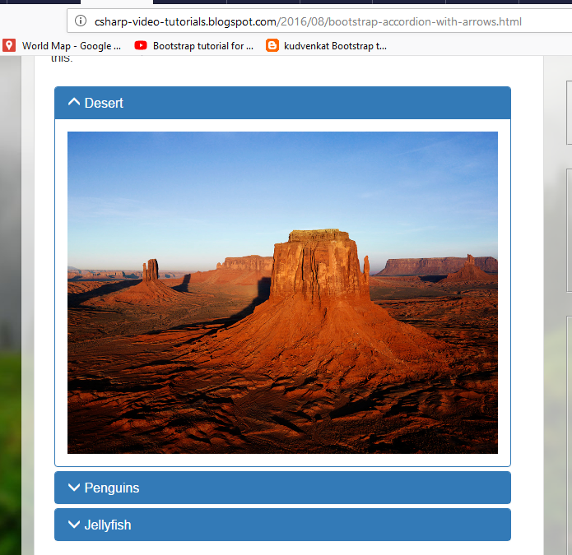

<http://csharp-video-tutorials.blogspot.com/2016/08/bootstrap-accordion-with-arrows.html>

# Sql server kudvenkat